Precision Xceed Pro Hospital Blood Glucose Monitoring System
Medtraining.org Lecture Document

- Only use test strips from the packet that was scanned to ensure the integrity of the test results and test strip. The bar code label holds information about lot number, calibration, expiration date and expected control solutions ranges.
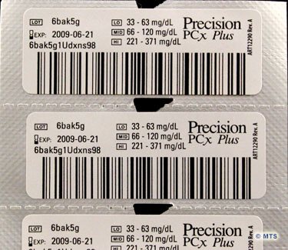
- Blood sources that are acceptable
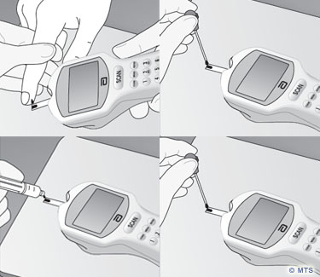
a. arterial
b. capillary
c. neonatal capillary (heel stick)
d. venous
- The Alameda Health System Reference Clinical Lab Range Chart is for glucose reference ranges on fasting patients only.
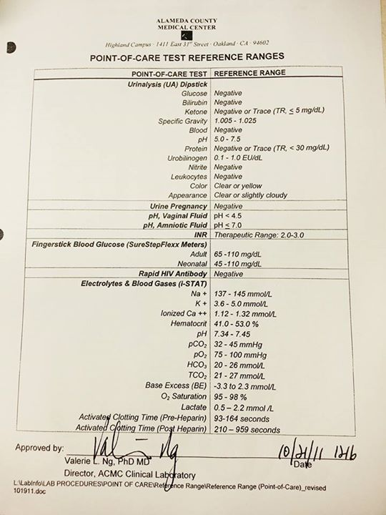
- The Test Strip is inserted into the Port Protector on the front of the Precision Exceed Pro with the contact bars facing up and inward. As illustrated in image C.
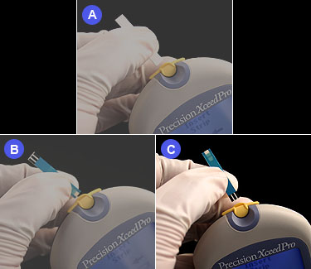
- It is against AHS policy sharing your ID badge number with another staff member for patient testing or for QC testing.

