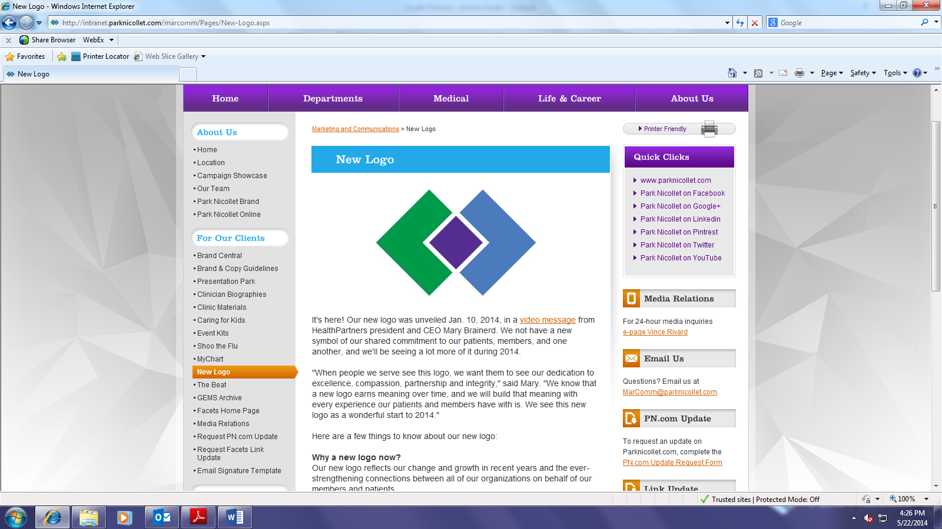

**Park Nicollet Health Services**

**6500 Excelsior Boulevard**

**St. Louis Park MN 55426**

**Continuing Education Completion Certificate**

**Video 3 and quiz (passing grade >80%)**

**“**Avoiding Phlebotomy Related Lawsuits***”***

Center for Phlebotomy Education

1. **Credit Hours (ASCLS PACE approved)**

**Objectives:**

1. **Identify the most common injuries poor phlebotomy technique inflicts upon patients.**
2. **Associate errors in technique, judgment and supervision with phlebotomy related injuries.**
3. **Describe the anatomy of the antecubital area in regards to veins, arteries, and nerves.**
4. **Define the limits to needle manipulation according to CLSI standards.**

**Participant __________________________________________________**

**Date Completed _________________**

*This certifies that the participant has watched the video and passed the quiz with a >80% passing grade. This program meets the educational standards of Laboratory, Park Nicollet Health Services. It is the responsibility of each participant to determine if the program meets the criteria for licensure or recertification for their discipline.*

*Pam Burby MT(ASCP), Patti Richardson MT(ASCP),*

*Lab Education Coordinators*