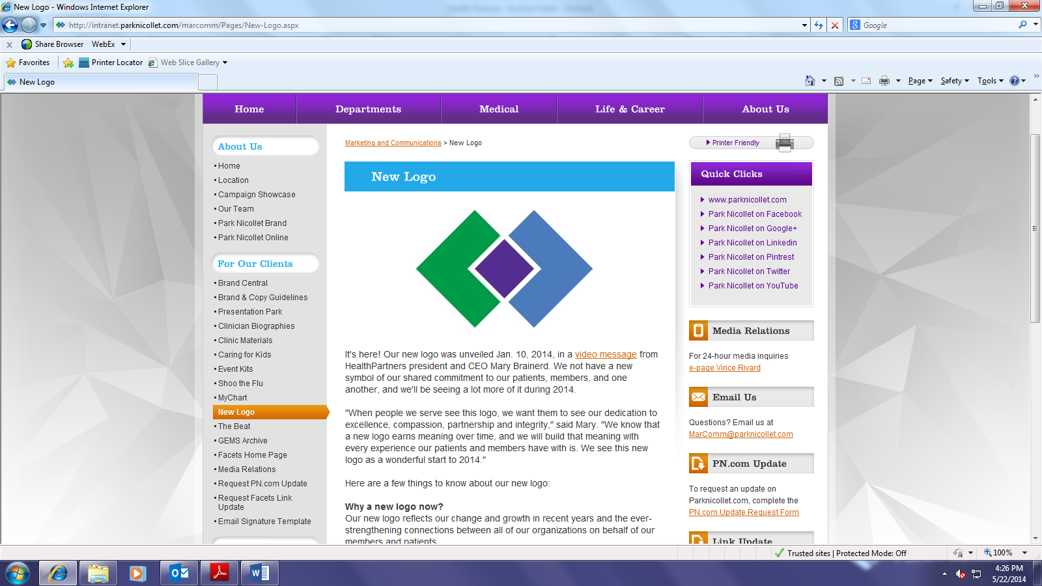

**Park Nicollet Health Services**

**6500 Excelsior Boulevard**

**St. Louis Park MN 55426**

**Continuing Education Completion Certificate**

**Video and quiz (passing grade >80%)**

**“**Basic Venipuncture***”***

Center for Phlebotomy Education

1. **Credit Hours (ASCLS PACE approved)**

**Objectives:**

1. **Describe the procedure for performing venipunctures according to CLSI standards.**
2. **Define the limits of needle manipulation according to CLSI standards**
3. **Describe the anatomy of the antecubial area in regards to veins, arteries and nerves.**
4. **Discuss the appropriate use of winged-collection sets.**

**Participant __________________________________________________**

**Date Completed _________________**

*This certifies that the participant has watched the video and passed the quiz with a >80% passing grade. This program meets the educational standards of Laboratory, Park Nicollet Health Services. It is the responsibility of each participant to determine if the program meets the criteria for licensure or recertification for their discipline.*

*Pam Burby MT(ASCP), Patti Richardson MT(ASCP),*

*Lab Education Coordinators*