SECTION: MICROBIOLOGY
DOCUMENT TYPE: Procedure
TITLE: Strep Culture Plating
APPROVED BY: Medical Director | DOCUMENT # : 10.0803.4
WRITTEN BY: Jackie Koranda, MT(ASCP) | EFFECTIVE: 11/30/12
SCOPE: All Laboratories | COMPLEXITY: NA

Purpose:
To describe the procedure for plating Group A Strep cultures.

Policy:
Properly trained staff with documented competency may perform this procedure.

Warnings and Precautions:
Universal precautions must be followed when collecting specimens, transporting specimens to the lab, plating
cultures, and preparing send outs.

Specimen Collection:
- Use a sterile Puritan swab that contains two polyester applicators. Do not use the culture swab with modified Stuart’s medium (CultureSwab Collection & Transport System).
- With the patient’s tongue depressed and the throat well exposed, rub the swabs firmly over the back of the throat including both tonsils and any areas of inflammation, exudation, or ulceration. Avoid touching the tongue, cheeks or lips with the swab.
- Place the swab in the tube, label properly with the patient’s name, medical record number, and LIS number (barcode label). Also write the date and time collected and your initials on the swab. Send to the Laboratory. Note: Culture must be plated within 30 minutes of collection since there is no media in the culturette.

Specimen Plating:

Media | Storage | Incubation
BAP  Plate must be at room temp prior to inoculating. Streak for isolation. Stab the plate 3 times with the loop in the thick area. | Uninoculated plates:  Store at 4°C until expiration date  Inoculated / streaked plates:  Store in 35°C incubator until  transported to Hospital Lab. | 35°C for 48 hours

1. Label the BAP plate on the media side of the petri dish (not the lid) with the patient’s name, medical record
number, and LIS number (small barcode label). Also write the date and time plated.
2. Roll the entire swab over ¼ of the BAP (first quadrant).
3. Using a blue 10 uL loop, streak for isolation using all 4 quadrants of the plate (see illustration on next page).
  - The original quadrant is cross-struck with loop.
  - The loop is then flipped over and quadrant two is struck by pulling the loop through quadrant one a few times and streaking the rest of the area.
  - Quadrant three is streaked by going into quadrant two a few times and streaking the rest of the area.
  - Finally, quadrant four is streaked by pulling the loop over the rest of the agar.
- Stab the plate 3 times in the thick area where the swab was rolled on the plate.
- Place inoculated plate in incubator within 15 minutes of streaking, lid side down.

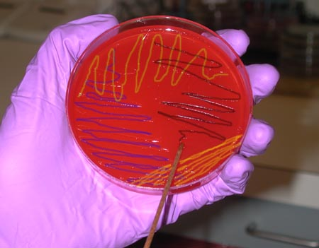

Procedural Notes:
A rapid Strep is usually ordered first (GRPAR). If the rapid Strep is negative, a GRACM is reflexed in the LIS
and a culture (GRACM) is set up and sent to the Hospital Lab.

References:
1. Forbes, Betty, Sahm, Daniel, Weissfeld, Alice, Diagnostic Microbiology, 11th Ed., C. V. Mosby Company 1998,
pages 12, 298-315.
2. Versalovic, Carroll, Funke, Jorgensen, Landry, Warnock, Manual of Clinical Microbiology, 10th Ed.,
ASM Press 2011, pages 236, 239, 242-246, 255, 284

Approved By | Date | Reviewed / Revised By | Date | Revision
 | 08/26/08 | Jackie Koranda | 08/26/08 | New
Dr. Vege | 9/21/09 | Jackie Koranda | 9/1/2009 | Annual review; no changes
Dr. Vege | 9/13/10 | Jackie Koranda | 9/10/10 | Updated References
Dr. Vege | 9/19/11 | Jackie Koranda | 9/14/11 | Added #4 under Media & Storage; updated Media & Storage table
 |  | Jackie Koranda | 11/30/12 | Updated Scope & References;  included Media Storage in Specimen Plating and expanded #1 & #5

Similar Procedures (Specify title of procedure and other OMC location(s) used if applicable)

Attachments:

