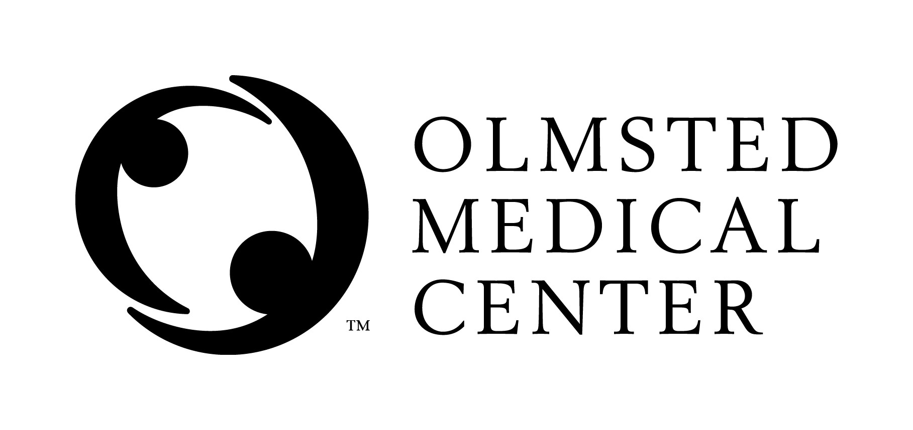
Clinical Laboratory
SECTION: Equipment
DOCUMENT TYPE: Policy
TITLE: Preventative Maintenance Program
APPROVED BY: Laboratory Supervisor | DOCUMENT #: 13.0007.1
WRITTEN BY: Charlotte Yuza, MLT(ASCP) | EFFECTIVE: 8/1/12
SCOPE: FastCare and Skyway Laboratories | COMPLEXITY: NA

Purpose:
To describe the preventative maintenance program for FastCare and Skyway Laboratories.

Policy:
- Safety / Electrical checks are performed on all equipment prior to being put into service and at least annually thereafter by the OMC Maintenance staff.
- Preventative maintenance and cleaning is performed per manufacturer’s recommendations.
- Cleaning is performed using manufacturer’s recommended cleaners.

Procedure:
Definitions:
General Cleaning is defined as the cleaning of the outside of the instrument or item of splashes, spills, dust, etc.
Internal Cleaning is defined as a manufacturer specified cleaning procedure; refer to individual maintenance procedures for details.

Maintenance Schedules
Instrument | Cleaning Schedule | Cleaning Performed by: | Preventative Maintenance Schedule | Preventative Maintenance Performed by: | Scheduled Replacement (Life span)
Clinitek Status | Daily- general cleaning  Weekly- clean table | Lab staff | NA | NA | 6 - 10 years
Incubator LabLine | Daily- general cleaning | Lab staff | NA | Lab staff | 6 - 10 years
Thermometers (digital only) | Daily- general cleaning | Lab staff | Annually- replace batteries | Lab staff | 6 - 8 years
Refrigerator | Daily- general cleaning  Semiannually- internal cleaning | Lab staff | Only as needed- vacuum coils | Maintenance Dept | 6 - 10 years
Label Printer | Monthly- internal clean platen | Lab staff | NA | NA | 8 - 10 years
Laser Printer | Semiannually- internal clean with canned air | Lab staff | NA | NA | 8 - 10 years
Counter tops | Daily- general cleaning | Lab staff | NA | NA | 20+ years
Specimen Coolers | Daily- general cleaning Semiannually- clean all surfaces | Lab staff | NA | NA | 8 - 10 years
Humidifiers | Daily- general cleaning  Monthly (while in use) - internal cleaning change filters. | Lab staff | NA | NA | 3 – 5 years

COLA Standards:

COLA MA 20 Manufacturer’s Maintenance Instructions
COLA MA 21 Preventative Maintenance Performed

Approved By | Date | Reviewed/ Revised By | Date | Revision
C Yuza | 7/31/12 | C Yuza | 7/31/12 | New locations

Similar Procedures (Specify title of procedure and other OMC locations used if applicable)
..\..\URINALYSIS & MICROSCOPY\MAINTENANCE\Maintenance- Clinitek Status.doc
..\PROCEDURES\Humidifier Usage and Preventative Maintenance.doc

Attachments:

