Clinical Laboratory
SECTION: Equipment
DOCUMENT TYPE: Procedure
TITLE: TempTrak Continuous Temperature Monitoring
APPROVED BY: Laboratory Director | DOCUMENT #: 13.0326.4
WRITTEN BY: Judy Vaughan MT(ASCP) | EFFECTIVE: 11/5/12
SCOPE: Hospital, Northwest, and Southeast Clinic  Laboratories | COMPLEXITY: NA

Purpose:
To describe the procedure for continuous temperature monitoring using the TempTrak System.

Policy:
- Designated refrigerators and freezers with critical and/or high volume/cost reagents are continuously monitored electronically using NIST-certified TempTrak thermistor probes.
- Deviation from assigned temperature ranges is reconciled and corrective action documented.
- Temperature ranges are determined using manufacturer’s recommendations.
- Temperatures are audited at least once daily using the Sensor Snapshot Audit function.
- All temperature and corrective action records are retained for 2 years.

Definitions:
- Probe: Thermistor probe (semiconductor temperature measuring device) in liquid glycol mounted in refrigerator/freezer and attached to transmitter.
- Sensor /Transmitter: Box mounted on outside of refrigerator/freezer which sends temperature readings to TempTrak website.

Supplies:
TempTrak Transmitters & NIST-certified Probes:

NAME | DESCRIPTION
Hospital Lab 1 | Microbiology Refrigerator
Hospital Lab 2 | Chemistry Refrigerator
Hospital Lab 5 | Gem Freezer
Hospital Lab 6 | Access Refrigerator
Hosp Lab Stockroom | OCH Stockroom
Hosp Lab Ultra Low Freezer | Ultra Low Freezer
Clinic Lab 1 | Hematology/UA Refrigerator
Clinic Lab 2 | Chemistry Freezer
New Gem Lab | Vitros Refrigerator
Clinic Lab 4 | Central Supply Refrigerator #1
Clinic Lab 5 | Central Supply Refrigerator #2
NW Clinic Lab Freezer | Specimen send out Freezer
NW Clinic Lab Refrigerator | QC and Specimen send out Refrigerator

TempTrak Monitoring Procedure:
- Designated Hospital, SE, and NW Clinic Laboratory refrigerators and freezers are monitored continuously using NIST-certified TempTrak thermometers and transmitters.
- Temperatures for each unit are recorded electronically every 5 minutes and averaged over a 15-minute time span. This data is transmitted to the TempTrak website.
- Acceptable temperature ranges are defined for each refrigerator and freezer using manufacturer’s recommendations and programmed into the TempTrak system.
- Two consecutive temperatures outside of the acceptable range will initiate the “Alert Escalation Path” to notify lab staff of a problem.

Alert Escalation Path:
ALERT | HOSPITAL LABORATORY  (Hospital & SE Clinic Problems) | SE CLINIC LABORATORY  (SE Clinic Problems only) | NW LABORATORY  (NW problems only)
FIRST ALERT:
Pop-up Box Alert | Vitros & Blood Bank Computer Terminals  Hospital Lab Supervisor  Lab Director | Hematology, Chemistry & UA Computer Terminals  SE Clinic Lab Supervisor | Specimen Processing Computer terminal  Branch Clinic Lab Supervisor  Lab Director
Email Alert | Lab Director | SE Clinic Lab Supervisor | Branch Clinic Lab Supervisor  Lab Director
SECOND ALERT: (If 1st alert unanswered in 30 minutes)
Pop-up Box Alert | Vitros & Blood Bank Computer Terminals  Hospital Lab Supervisor  Lab Director | Hematology, Chemistry, & UA Computer Terminals  SE Clinic Lab Supervisor | Specimen Processing Computer terminal  Branch Clinic Lab Supervisor  Lab Director
Email Alert | Lab Director | SE Clinic Lab Supervisor | Branch Clinic Lab Supervisor  Lab Director

Types of Alerts:
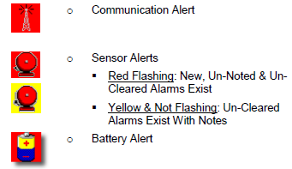

- Communication Alert: generated whenever a sensor does not send information as scheduled.
- Can be intermittent.
- May be due to dead battery.
- Notify Maintenance if alert continues.
- Monitor temperature with another thermometer until problem corrected. Document temperatures.
- Sensor/Temperature Alert: generated when a sensor transmits a temperature that is outside of the assigned temperature range for that refrigerator or freezer.
- Red Flashing: new, unnoted and un-cleared alarm.
- Yellow and Not Flashing: un-cleared alarm with notes.
- Check unit and document corrective action.
- Move inventory to another refrigerator/freezer and notify Maintenance if unable to reconcile.
- Battery Alert: generated when a battery is low on voltage or has been fully drained.
- System will generally continue to work for approximately 2 weeks before the battery fails.
- Notify Maintenance to replace battery (3V Lithium). System must be “pinged” following battery replacement.
- Monitor temperature with another thermometer if battery fails. Document temperatures until battery replaced.

Pop-Up Alert (computer terminal):
- Will be flashing with audible alert (if sound available on computer terminal).
- Displays name of unit, current temperature and acceptable range.
- Select “Close” to close pop-up alert or “Open Alert Window” to log onto TempTrak system.
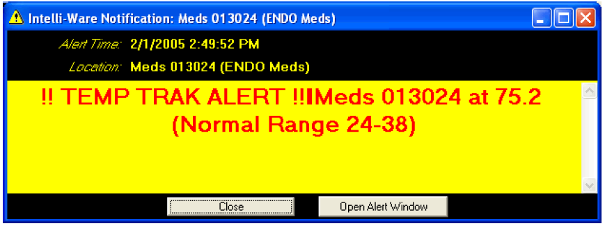
Laboratory Procedure:
Daily Audit of Temperatures:
- At least daily, Log onto the TempTrak system and check that all temperatures are within assigned ranges (green) and that all alarms have been reconciled and cleared. Check graph for each unit noting any out of range temperatures over the past 24 or 48 hours.
- At the Hospital, this is assigned to the night shift tech
- Click on the red check mark in the upper right-hand corner of the temperature display.
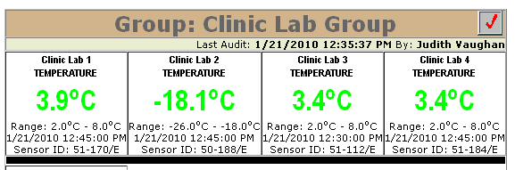
- A TempTrak System Snapshot Audit screen will appear. Document that “All temperatures within acceptable ranges for past 24 /48 hours.” Make sure the Select All box is checked.
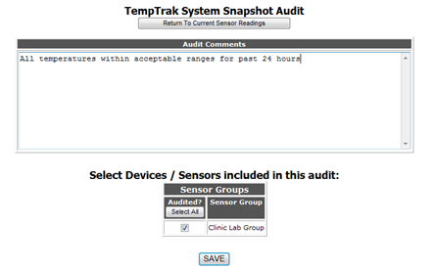
- Click on SAVE.
- The TempTrak system will automatically date/time stamp the entry with your name.
- This documents that all temperatures were checked and within acceptable ranges.

Responding to Sensor/Temperature Alerts:
Hospital Refrigerator/Freezer Alert:
Hospital Lab staff will:
- Check unit for problems (i.e. door left open, etc)
- See “Temperature and Humidity Monitoring” Procedure for troubleshooting guidelines.
- Clear alarm on TempTrak website and document corrective action.
- Move supplies/reagents to a different unit if unable to reconcile problem.

SE or NW Clinic Refrigerator/Freezer Alert:
Hospital Lab staff will:
- Only contact the appropriate Clinic Lab Supervisor, Laboratory Director, or designee after hours and on weekends.
- Southeast Lab hours: 7-1730 Monday-Friday
- Northwest Lab hours: 6:30- 19:00 Monday - Friday

Clinic Lab staff or designee will:
- Investigate problem, clear alarm, and document corrective action.
- See “Temperature and Humidity Monitoring” Procedure for troubleshooting guidelines.
- Move supplies/reagents to a different unit if unable to reconcile problem.

Log On/Off TempTrak Website:

- Double click on TempTrak icon on desktop or go to TempTrak website(http://temptrak/intelli-ware/):
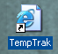
- Log on using your OMC ID and assigned password.
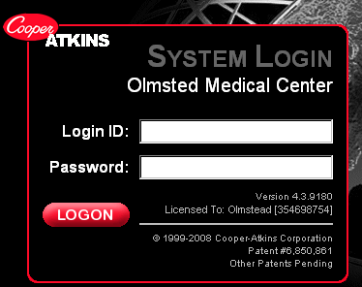
- A screen will display unit ID and location, current temperature readings of freezers and refrigerators, and acceptable ranges.
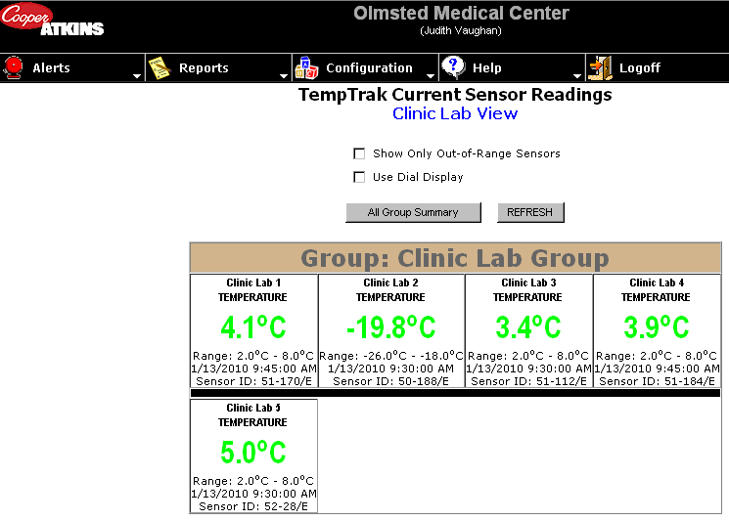
- Green indicated the temperature is within range.
- Red indicated the temperature is too warm.
- Blue indicates the temperature is too cold.

- Log off of the TempTrak Website by selecting the Logoff button located on the upper right of the screen:

Clearing a Temperature Alert & Documenting Corrective Action:
- Click on the alert to be cleared.
- Active alerts will be indicated on the screen in the upper right-hand corner.

- Uncleared alert will be outlined with a red box.
- Acknowledged alerts, that have not been cleared, will be outlined with a yellow box.
- Acknowledging an alert only stops the Escalation Path. This means that no new pop-up or email alerts will appear even if the temperature continues to be out of range.

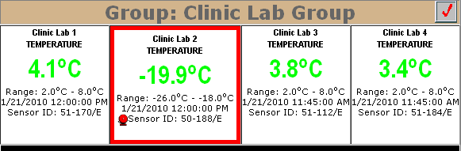

- Clicking on the active (flashing) alert icon will display the following Sensor Alerts screen:
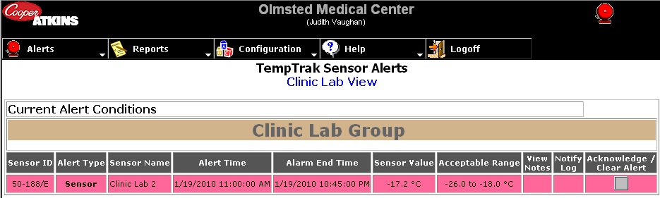

- Click on “Acknowledge/Clear Alert” to document corrective action. The following screen will appear:
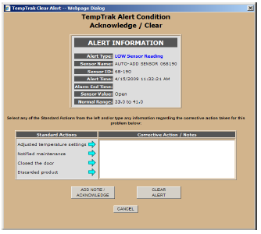
- Log the corrective actions by either clicking on a Standard Action or placing your cursor inside of the Corrective Action/Notes box and typing the action.
- Multiple corrective actions may be selected.
- Document any adverse effects to the contents and follow-up corrective action.
- Document length of time temperature was out of range.
- Any adverse effects to reagents, controls, or calibrators stored in the unit.
- Corrective action and follow-up.
- If additional notes/acknowledgements are needed for this alert, click Add Note/Acknowledgement.
- Note: this will not clear the alert; only update the Temperature Alert with new notes.
- To clear the alert, click Clear Alert.
- The following screen will display showing documented corrective action and the time the alarm was cleared.
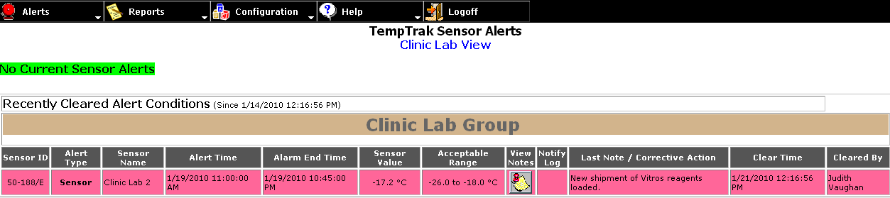

Viewing Alarm Conditions / Notations:
- Log onto the TempTrak website to view recent alarms and documented corrective action.
- Go to ALERTS>TEMPTRAK>SENSOR READINGS
- The Sensor Alerts screen displays current and recently cleared temperature alerts:
- Current alerts that have not yet been responded to.
- Cleared alerts that have been cleared and corrective action logged.
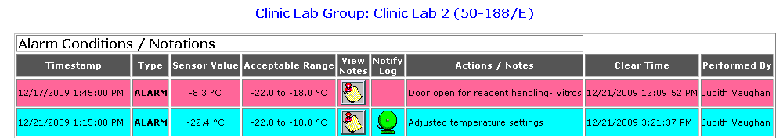
- View Notes Button: Displays any notes associated with the Temperature Alert.
- Red background indicates temperature was too warm.
- Blue background indicates the temperature was too cold.

Logging into Citrix to Open TempTrak from a non-OMC Computer (Supervisors only):
- Click on IE (Internet Explorer or any web browser) and type in this URL in the address field: http://omcra.olmmed.org
- Enter your OMC User Name and Password (same as you use for logging in at OMC or to check your
e-mail)
- The first time you login to Citrix it may ask you to install software and there will be a yellow bar across the top of your screen to install (or it may not appear at all). Click on install if it appears.
- Click on the TempTrak icon. To login to TempTrak for the first time, enter your OMC User Name and enter the default Password “temp” in lower case. It will prompt you to change your password.

Reports and Supervisory Review:
Periodic Alarm Review:
- Supervisor or designee will monitor alarms for appropriate and complete documentation and follow-up.

Daily Summary Report:
- Go to REPORTS>TEMPTRAK>DAILY SUMMARY REPORT.
- Select Sensor, Ending Date, and Reporting Period.

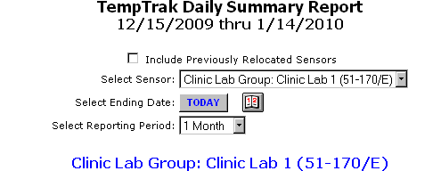
- Print.
- Report lists the average, minimum and maximum temperatures for each day categorized by AM, PM and Entire Day.

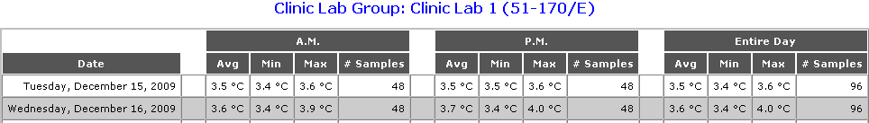

- Reviewed monthly by Lab Supervisor or designee.

Alerts/Notes by Sensor Report:
- Go to REPORTS>TEMPTRAK>ALERTS/NOTES BY SENSOR.
- Select Sensor, Ending Date and Reporting Period.
- Print.
- Report lists all alerts and corrective action for designated sensor for a specific time period.

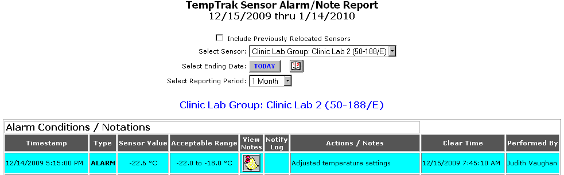

- Reviewed monthly by Lab Supervisor or designee.

Sensor Audit Report:
- Go to REPORTS>TEMPTRAK>SENSOR AUDIT REPORTS.
- Select User, Sensor Group, or Sensor.
- All daily audit comments will display for selected unit.
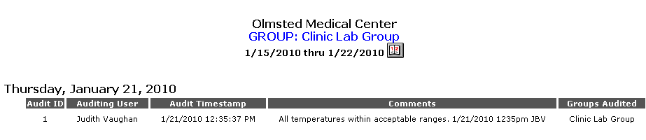
- Reviewed weekly or monthly by Lab Supervisor or designee.
- Print as required.

Procedure Notes:
- This procedure follows manufacturer’s instructions without alteration.
- Corrective action notes cannot be edited after alert is cleared and/or additional notes are added.
- Right click on a screen to bring up the Print option.
- Right click on a dot on a temperature chart to display the date, time, and temperature.

References:
TempTrak Operator’s Manual 4/2009

CAP/COLA Standards:
CHM.24500 NIST-certified thermometer available
CHM.24600 Check before initial use
CHM.24700 Temperature checks
CHM.24900 Corrective action

Approved By | Date | Reviewed/Revised By | Date | Revision
J De Clercq | 1/26/2010 | J Vaughan | 1/25/2010 | Implementation
J De Clercq | 4/29/2010 | J Vaughan | 4/28/2010 | Added instructions for logging into system from non-OMC computer. Updated “Clearing a Temperature Alert…” Updated Clearing Alert #5
J De Clercq | 7/29/10 | J Vaughan &  A Petersen | 7/28/2010 | Updated Temptrak Monitoring Procedure #4; Deleted Hospital Lab #3 & 4 and renamed #5; Added note to Daily Audit #1, added Periodic Alarm Review
Dr Durga Vege | 4/11/2011 | J Vaughan | 4/1/2011 | Updated SE Clinic refrigerators
Dr Durga Vege | 4/11/2012 | J Vaughan | 4/2/2012 | Updated Supply List
 |  | J Vaughan, C Yuza |  | Updated scope and Daily Audit of Temperatures #1 & #3, Monitoring Procedure #1, Alert escalation path, Responding to Sensor / Temp alerts for Clinics

Similar Procedures (Specify title of procedure and other OMC locations used if applicable)
..\POLICIES\TEMPERATURE & HUMIDITY MONITORING.doc

Attachments:

