Clinical Laboratory
SECTION: LIS
DOCUMENT TYPE: Procedure
TITLE: Advance Beneficiary Notice (ABN)
APPROVED BY: Laboratory Director | DOCUMENT #: 3.1010.5
WRITTEN BY: Judy Vaughan, MT(ASCP) | EFFECTIVE: 9/19/2012
SCOPE: All Laboratories | COMPLEXITY: NA

Purpose:
To describe the procedure for obtaining and processing ABN forms.

Policy:
Medicare patients, with ordered Lab tests whose cost may not be covered by Medicare due to medical necessity, frequency, or experimental or research, must be presented with the option to sign an ABN form prior to the performance of services.

Supplies:

Medicare-approved ABN form CMS-R-131
OMC Medicare ABN form 1101904

Procedure Notes:
- Patient must register to update insurance information prior to laboratory services.
- An ABN must be signed on the date of service and prior to the performance of services.
- An ABN is required when a provider requests a Lab test that may not be covered by Medicare for one of the following reasons:
  - Medical necessity (Medicare does not pay for the test for the specified condition or diagnosis)
    - Contact provider when entering order to check for other applicable diagnosis code(s).
  - Experimental or research (Medicare does not pay for experimental or research tests)
- ABN’s are used when there is a specific and identifiable reason to believe that Medicare will not pay for the Lab test. The ABN informs the patient that Medicare may not cover or reimburse the full amount for that test. This allows the patient to make an informed decision whether to accept the lab test, understanding that they may be taking on full financial responsibility for the cost.
- ABNs are required on all MISC or MISCG for clinic patients.
- ABN’s are not required in emergency situations or for Hospital patients.
- ABN’s are not required for pathology specimens.

Procedure:
Generating ABN forms in LIS (GUI):
- Enter order information.
- Select button on Order Entry task bar or press Control D.

- Diagnosis codes from Order Entry screen auto-populate Control D order diagnoses boxes.
  - If more then four codes are present, add additional codes in the top of the Medical Necessity Checking box.
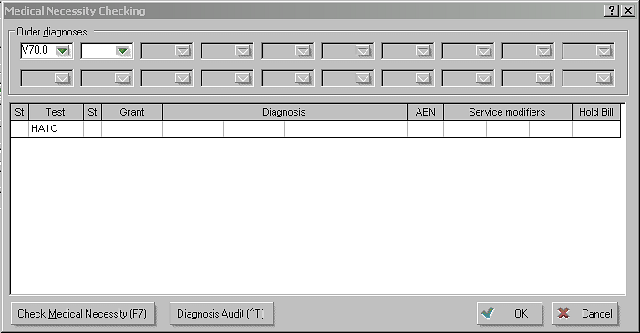

- Check Medical Necessity by selecting F7 or the “Check Medical Necessity” button.
- Medical Necessity is checked for all Clinic patients. This attaches the appropriate diagnosis code to each test and allows the tests to bill correctly.
- LIS checks ordered lab tests against diagnosis codes for medical necessity.
- LIS checks for experimental or research tests.
- ABN only needs to be printed for financial classes: G_ and S_.
- Enter provider-designated diagnosis code in the second column of the Diagnosis field if it is different than what auto-populated.
- If an ABN is not required, an “N” will populate the ABN column.
- No further action is required.
- Save order.

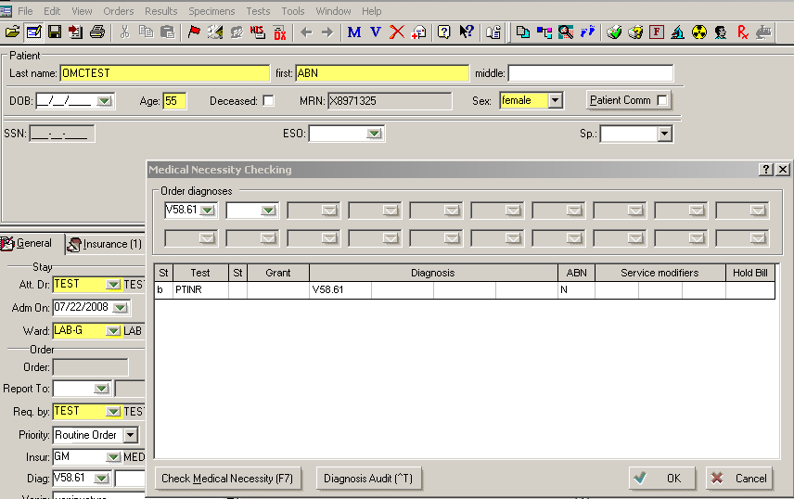

- If an ABN is required due to a medical necessity violation, an order entry box will pop up indicating a Medical Necessity.

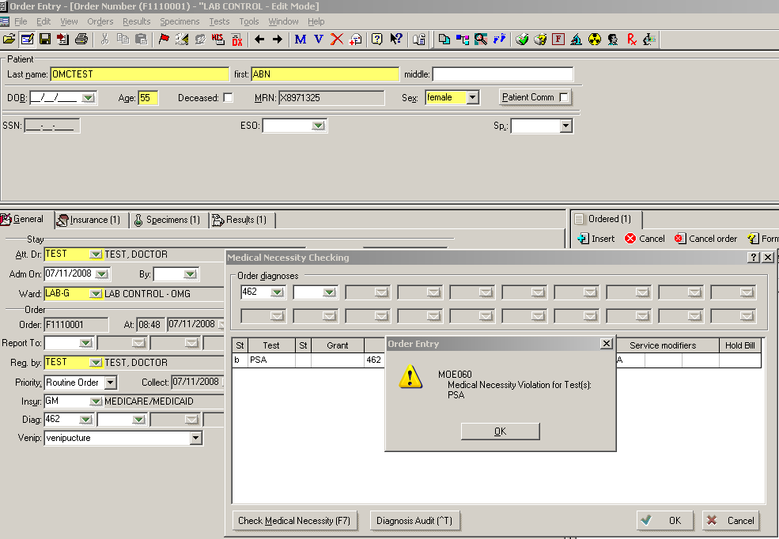

- Select OK.
- “P” will be visible in the ABN column indicating an ABN needs to be printed .The “GA” modifier will appear in the Service Modifiers column.
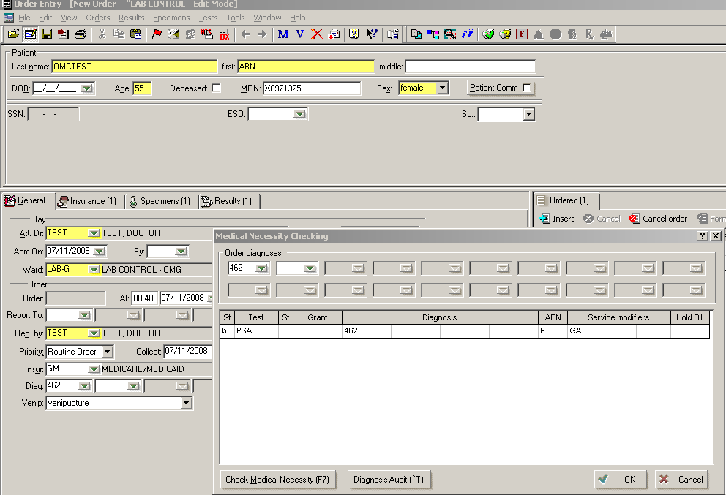

- Select OK.

- Save the order.
  - A “Select printer to print ABN form” box will appear if:
    - If an ABN is required due to experimental testing. (There is no pop-up message associated with experimental testing.)
    - If an ABN is required due to a medical violation.
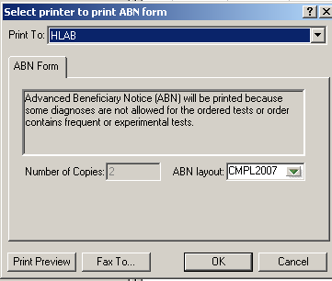
  - Select correct printer
  - Number of copies will default to “2”
  - Select OK
- Pop-up box will appear notifying user that “ABN form successfully printed.”
- A check mark will appear in the ABN box on the General tab screen.
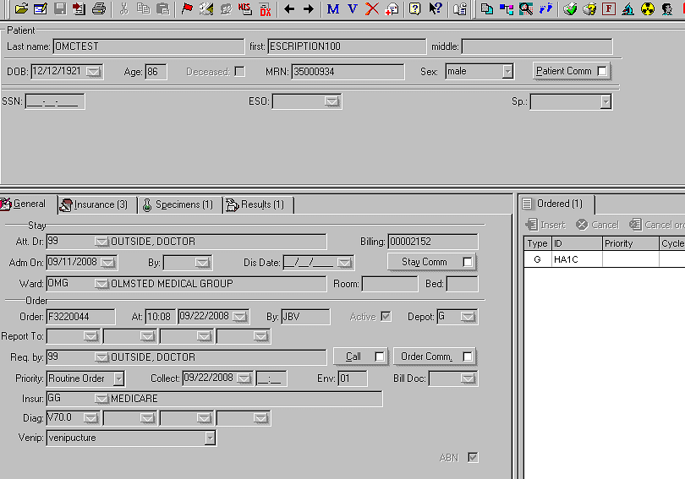

- “P” will change to an “A” in the ABN column of the Control D box for a medical necessity violation or an “E” for an experimental violation.
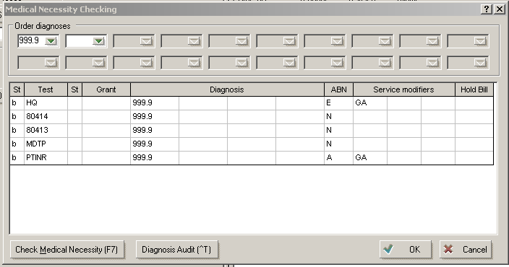
Completing the ABN Form:
- LIS prints the Medicare-approved ABN form displaying the patient’s full name and ID# (MRN).
  - Place a LIS label on the back of the ABN with patient name and order number.
  - Laboratory tests and estimated costs are listed in the appropriate column(s) indicating the probable reason for denial (Medical necessity, frequency, or experimental/research). This cost does not include possible reflexed tests, venipuncture or processing fees.
- Explain the purpose of the form to the patient, and ask the patient to check Option 1, 2 or 3 (See “Patient Options” below) and date and sign the ABN forms (all pages and all copies).
  - If the patient refuses to sign the ABN, a witness (OMC employee) must sign and date all forms, noting that the ABN was given to the patient but the patient refused to sign.
  - Give one ABN to patient.
  - If the patient selects Option 2, notify Kristy Sutton via email with patient name, ID#, test and date of service.
3. If the patient does not want charges submitted to Medicare or secondary insurance, cancel and reorder test using FC 11 (self-pay).

Modifiers:
ABN codes and corresponding Service Modifiers:
ABN CODE | ABN CODE DEFINITION | CORRESPONDING SERVICE MODIFIERS  (Auto-populates field)
P | ABN form printed on site | GA
A | ABN on file | GA
R | Patient refused to sign ABN form | GZ
W | Waiting for an ABN from physician | GZ
Y | Signed ABN on file | GA
X | No ABN form on file | GZ
N | ABN form not required | None required
F | Frequency ABN printed | GA
E | Experimental ABN printed | GA
S | Test with Statutorily Excluded diagnosis | None required
- Once an ABN has been printed, an “A” or “E” will appear in the ABN code column with a GA modifier.
- If the patient refused to sign the ABN, enter “R” in the ABN column and a “GZ” modifier will auto-populate the Service Modifier field indicating that the test is not reasonable or necessary and is expected to be denied and that no ABN is on file.
- If Lab personnel failed to have patient sign ABN, enter “X” in the ABN column and a “GZ” modifier will auto-populate the Service Modifier field indicating there is no signed ABN on file. Enter non-chartable order comment that ABN was missed. (?Missed ABN.)

Patient Options:
- Option 1:
- Patient wants laboratory tests.
- Patient understands that Medicare may not pay for the Lab tests and that he will be billed for the tests if Medicare denies payment.
- If Medicare does not pay, the patient or other insurance will be responsible for the payment, but patient can appeal Medicare’s decision.
- Option 2: (Email Kristy Sutton if Option 2 is selected)
- Patient wants laboratory tests but does not want Medicare billed.
- Patient is responsible for payment.
- Patient cannot appeal if Medicare is not billed.
- Option 3:
- Patient does not want laboratory tests.
- Cancel test(s) from order.
- Notify provider.
- Document information in Call Box [“?(Name of person) notified of test refusal”]
- Patient wants lab tests but refuses to sign the ABN form:
- Witness (OMC employee) signs and dates ABN form noting that the ABN was given to the patient but the patient refuses to sign.
- Enter “R” in the ABN column and a “GZ” modifier will auto-populate

Patient Unable to Understand/Sign ABN (Disability, Diminished Mental Capacity, etc):
- If the patient is unable to understand and/or sign the ABN, the patient’s representative may sign for them.
- Patient’s representative is defined as the person who has the power to make healthcare and financial decisions for the patient:
  - Legal guardian
  - Person with designated “Durable Medical Power of Attorney”
- If no power of attorney is present enter “X” in the ABN column and a “GZ” modifier will auto-populate the Service Modifier field indicating there is no signed ABN on file. Enter non-chartable order comment that no power of attorney was present for signature. (?No power of attorney.)

Add On Testing:
- Processing of Add-on testing for Medicare patients requires a completed ABN form before testing.
  - If an ABN cannot be obtained, do not perform testing. Refer to Add-on procedure.
2. Check financial class of all patients before agreeing to perform add-on testing.

Standing Orders:
ABNs for standing orders are valid for one year for specified tests. Enter non-chartable order canned
comment: “SO: Signed ABN on file. Enter GA modifier in child orders” Date/Time stamp.
- Child Orders: Change ABN code to Y. GA modifier will auto-populate Service Modifier field.

Pap Smears (SurePath):
Clinicians will be responsible for asking patients to sign ABN forms prior to performing PAP procedures.
- Allowable PAP frequency: every 2 years.
- Enter Y in ABN column if ABN received. GA modifier will auto-populate.

Pre-Op Testing (V72.83):
- Do not print ABN.
- Enter “X” in ABN column. GZ modifier will auto-populate.

Specimens Dropped-Off (i.e. Occult Blood)
Obtain ABN at drop off time (date of service).
- Must access the order in the LIS
- Check medical necessity as described while the patient is still present to generate the ABN for signature

MISC or MISCG Tests:
- Use OMC 3-part Medicare (Form#1101904) or Standard ABN (Form #1102004)
- Complete the following:
- Patient name, DOB and MRN
- Test name and date of service
- Reason Insurance May Not Pay: Experimental or Research
- Estimated cost= Mayo list price: contact supervisor or LIS staff for Mayo List Price.
- Have patient select option 1, 2, or 3 and date and sign ABN.
- Give patient yellow copy

RAST Testing:
- RAST testing performed at Mayo will generate an ABN when appropriate test code is ordered in LIS.
- RAST testing performed at Common Wealth (CML):
  - Will generate an ABN when appropriate panel code is ordered in LIS with correct total fee.
- Will generate an ABN when “RAST” is ordered, but fee will not be correct. Contact LIS for total fee.

Reprinting ABN:
- Select printer icon
- Select “Print ABN form”
- Select printer
- Prompt OK

Processing/Storage of ABN Forms:
- Mayo/Reference Lab Tests:
  - Send copy of signed ABN to Mayo/Reference Lab with Third Party forms.
- SE and Branch Clinic Labs:
  - Send ABN to Medical Records to be scanned into IC Chart.
- Hospital:
  - All ABNs from all sites are sent to SE Clinic HIM
- ABN’s are retained for 7 years.

References:
http://www.medicare.gov/

Approved By | Date | Reviewed/Revised By | Date | Revision
Jenn De Clercq | 7/10/2009 | J Vaughan | 7/6/2009 | New procedure
Jenn De Clercq | 7/29/10 | Becky Schran | 7/30/2010 | Annual Review; Remove frequency Info; Update Generating ABNS #5, #11; Update Modifiers #3; Update patient Options #3, #4; Update Pre-Op #2; Add Reprinting ABNs #3-4; Add Processing/Storage ABN #3
Jenn De Clercq | 9/23/10 | C Yuza | 9/23/10 | Revised Procedure Note #7 and Pap Smear bulletin 1 for Pap ABN storage. Added to Modifier #3 to enter Order comment in the event an ABN was missed
Jenn De Clercq | 9/22/11 | J Vaughan, S Christenson | 9/19/2011 | Add Procedure Note #5; Deleted “Completing ABN Form” #4; Add Add-on Testing #1a; Updated “RAST Testing”; Updated “Processing/Storage of ABN Forms”
Jenn De Clercq | 9/20/12 | J Vaughan, B Schran | 9/19/2012 | Updated Supplies, Completing ABN Form #1, PAP Smears, MISC or MISCG Tests, RAST Tests, Processing/Storage #3 and Attachments. Deleted Procedure Note #8, Added Pt Unable to sign #3, Specimens dropped off #1-2

Similar Procedures (Specify title of procedure and other OMC locations used if applicable)

Attachments:

ABN form CMS-R-131
OMC Medicare ABN form 1101904

