Clinical Laboratory
SECTION: Laboratory Information System
DOCUMENT TYPE: Procedure
TITLE: Order Entry - FastCare and Skyway Clinics
APPROVED BY: Administrative Director/LIS Support | DOCUMENT #: 3.1056.5
WRITTEN BY: Jennifer De Clercq, CLS, Charlotte Yuza | EFFECTIVE: 9/17/12
SCOPE: FastCares, Skyway Clinics; Hospital Lab

Purpose:
To describe the process for order/result entry for FastCare and Skyway testing.

Policy:
- Convenience care clinics include two FastCare Clinic locations and an OMC Skyway Clinic. These convenience care clinics are limited, rapid service clinics and will provide specific waived level testing on site. Provision of Laboratory services is under the technical direction of the OMC Laboratory Administrative Director or designee.
- Order, result entry, and manual verification of data entry in the LIS will be performed by the convenience care clinical support staff and will allow test results to appear in IC Chart.
- Staff with documented training and competency may perform this task.
- Laboratory records are retained for 2 years.

Procedure Notes:
 | Convenience care  (FastCare or Skyway walk-ins) | UMR Students
Task | Actions required
Registration in Plus | Full registration | None- do not register
Test Orders recorded | Clinicians: Enter orders into the Electronic Health Record (EHR) via exam template | Clinicians: Document on UMR Exam Template.
Specimen Collection | Clinicians or support staff will collect | Clinicians or support staff will collect
Tests performed | Clinicians or support staff will perform testing according to manufacturer’s instructions | Clinicians or support staff will perform testing according to manufacturer’s instructions
Results documented | Clinicians or support staff will document on Patient Manual Test Worksheet | Clinicians or support staff will document on Patient Manual Test Worksheet
- Test codes used for this procedure are orderable for only wards FCN, FCS, SKY, and UMRC

Procedure: Order Entry
- Log into LIS, select Order Entry
- Search for patient using PTID (Patient Identification Number) and last name.
 | Convenience care  (FastCare or Skyway walk-ins) | UMR Students
Search for patient in LIS | Last Name and MRN | Last Name and MRN starting with U
Verify the correct patient | Full name and date of birth must match | Full name and date of birth must match
If the patient is not found,  “Create new patient?” | Answer “No”  Wait for demographics to transfer from PLUS. | Answer “Yes”  Enter Last Name, First Name, DOB, Sex  Age- will auto calculate  MRN- Remove the ‘U’ leave MRN blank

- Select “New” and “New Stay”.
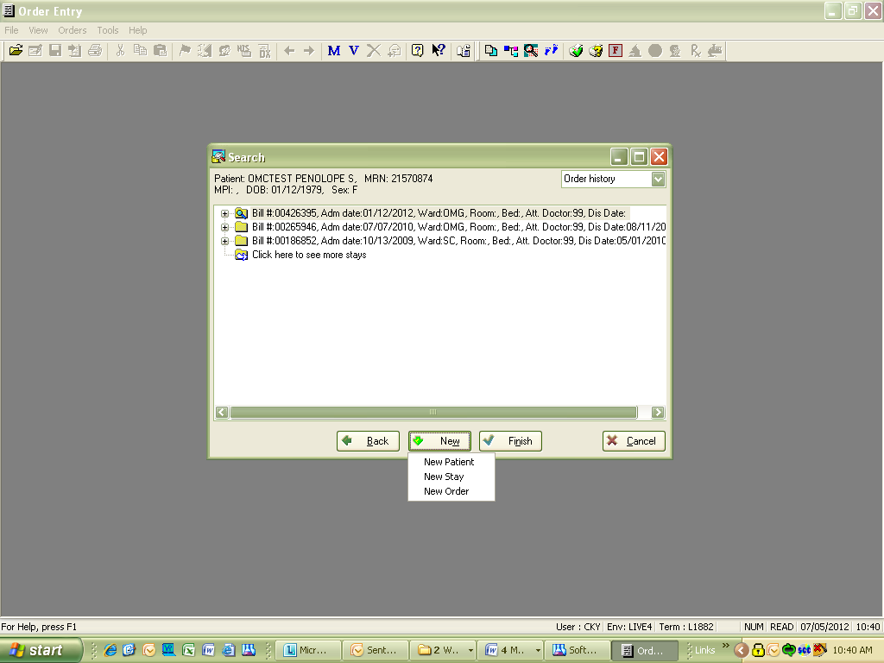

- Enter the following information:
Field | Convenience care |  | UMR Students
Att Dr. | As listed on template |  | As listed on template
Ward | FCN  FCS  SKY | FastCare North  FastCare South  Skyway Clinic | UMRC
Report to | As listed on template |  | As listed on template
Req by | As listed on template |  | As listed on template
Insurance | As listed in Plus |  | UM
Diag | As listed on template |  | As listed on template

- Test codes: [Orderable only under Wards: FCN, FCS, SKY, and UMRC]
Tests | Convenience care | UMR Students
Influenza A and B | FCRI | FCRI
Rapid Strep; GRACM will reflex with negative Rapid Strep | FCSTA | FCSTA
UA Dip | FCUAD | FCUAD
Mono screen | FCMS | FCMS
Urine Pregnancy | FCPG | FCPG
Pap specimen | Not orderable for these services / patients | GYN  Note: need to complete and send cytology requisition and send with specimen
Nisseria G. / Chlamydia T. | Not orderable for these services / patients | LCN

- Collect and receive; use date and time provider documents on form.
- Perform medical necessity check. An Advanced Beneficiary Notice (ABN) may print for patients who are eligible.
- Print labels, select standard label.
- Save order.

Procedure: Enter /Verify Results
- On Main Menu, select RESULTING WORKLIST:
- Enter the following information
Field | Selections |  | Notes
Template | FCN  FCS  SKY | FastCare North  FastCare South  Skyway Clinic
Status | Pending and Non-verified |  | Default setting
From order # | Defaults to today minus one day |  | Can change to look back further
Remaining fields | Leave on default settings do not change
- Select OK button.
- Review each item on the template
  - Select the correct patient: review patient’s full name, DOB, and sex
  - Review the ordered tests; verify all of the tests ordered are on the template.
    - Each waived kit test contains internal controls as well as a patient result field.
    - Internal control result fields begin with IC, contains either P (positive internal control), or N (negative internal control), and one additional letter to identify the test code.
 | Positive Internal Control | Negative Internal Control
Rapid Strep A | ICSAP | ICSAN
  - Enter patient result and internal control results from Patient Manual Test Worksheet.
    - Negative Rapid Strep A resulting requires additional steps:
      - Enter Negative patient result.
      - Reflex testing box appears, select ‘ok’ to add the culture
      - Select to go to the Order Entry Screen.
      - Select the Micro tab
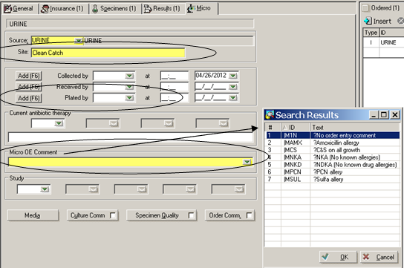
      - Select the collection site
      - Plate the specimen
      - Enter appropriate Micro OE Comment
      - Exit Order Entry screen.
      - NOTE: If “Throat Culture Plate Sent” is marked as “No” for a negative rapid strep, cancel the reflexed culture (GRACM) and enter comment “No culture plate sent”.
  - Save results select.
  - Perform Time out steps:
    - Exit to the Main Menu.
    - Access resulting worklist screen.
    - Select correct patient.
    - Confirm correct results were entered or correct any erroneous results.
    - Verify and release results. Select
    - Document initials in appropriate “Results entered by” column on the Patient Manual Test Worksheet.
    - Place worksheet / printout in box to be reviewed (red-checked) by another person or at a later time.
  - Red Checker- review verified results for resulting errors.
    - Correct errors and notify ordering Clinicians as per Result Correction Procedure states.
    - Document initials in appropriate “Manual results reviewed and verified by” column on the Patient Manual Test Worksheet.

COLA Standards:
PST 1 Written procedure for correcting results
PST 4 Record retention of original and corrected reports
QA 17.1 LIS: Precision, accuracy of data entry
QA 20.1 LIS: Procedure to identify and correct incidents of non-compliance of stated procedures, and policies
QA 20.2 LIS: Procedures to identify and correct of any unexpected event, which has caused, or has the potential to cause, death or serious injury to patients or laboratory staff

Approved By | Date | Reviewed/Revised By | Date | Revision
Jennifer De Clercq | 07/16/2007 | Jennifer De Clercq | 07/16/2007 | New
Jennifer De Clercq | 7/2008 | Jennifer De Clercq | 7/2008 | Annual Review
Jennifer De Clercq | 11/2008 | Judy Vaughan | 11/2008 | Added FCS location, FCPG test code, and depots.
Jennifer De Clercq | 3/2009 | J Vaughan | 3/2009 | Added Note: canceling GRACM, updated to Southeast Clinic,
Jennifer De Clercq | 3/4/09 | J Vaughan | 3/4/2010 | Updated format
Becky Schran | 3/9/11 | J Vaughan | 3/9/11 | Annual Review
Becky Schran | 3/16/12 | J Vaughan | 3/19/12 | Annual Review
Jennifer De Clercq | 7/9/12 | C Yuza | 7/5/12 | Revised entire procedure to reflect new process. Removed data entry by SE Clinic staff and replaced with FastCare staff data entry. Added COLA Standards.
Jennifer De Clercq | 9/12/12 | C Yuza | 9/11/12 | Revised Order Entry section to include Skyway and UMR student ordering information.

Similar Procedures (Specify title of procedure and other OMC locations used if applicable)

Attachments:

