- PURPOSE:
To describe the procedure to be used to receive specimens in ULTRA

- PROCEDURE:
All specimens must be received into ULTRA by scanning each specimen label prior to being distributed to each department for testing.

2 – Nurse Collect is for receipt of all specimens collected by the RN.
K – Receive by Specimen is for receipt of individual specimens collected by the lab.

- To Receive Nurse Collected Specimen(s) labeled with ULTRA barcode
  - Select 2 - Nurse Collect from the main menu
  - At Barcode:, scan barcode
  - At Collected: enter nurse collected date and time
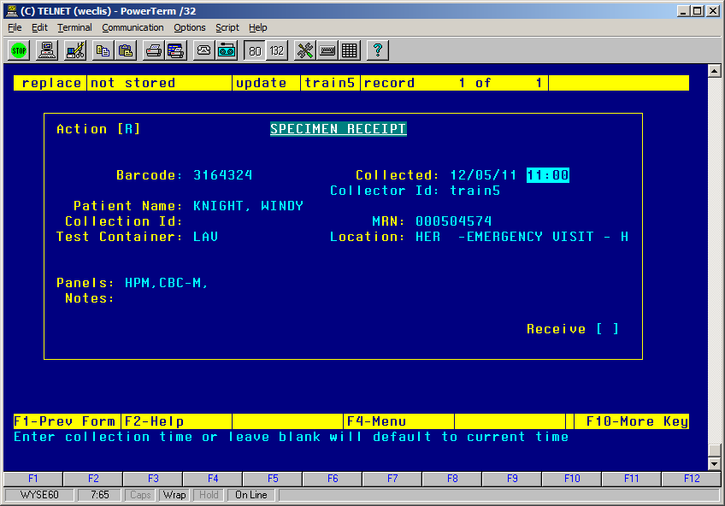

  - Collector Id: defaults to the user logged in, change to NURSE. *Note: must be changed to NURSE in order to accurately count workload units
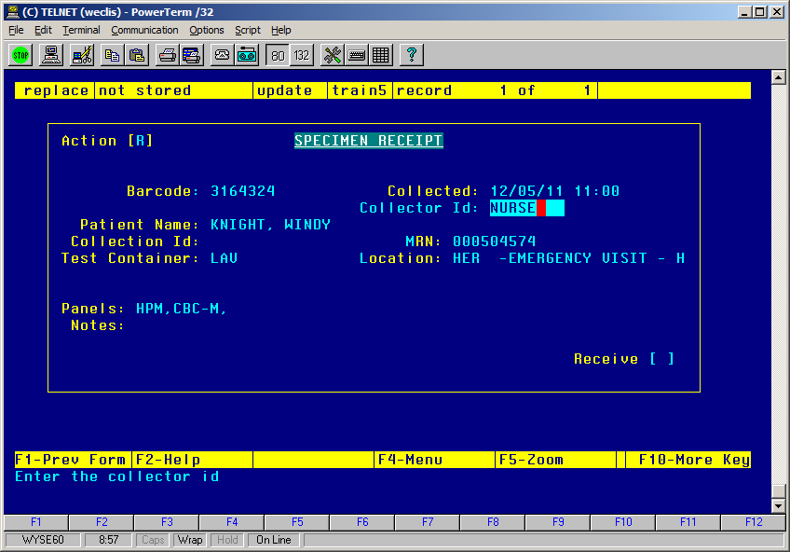
  - Receive [Y] to receive the specimen
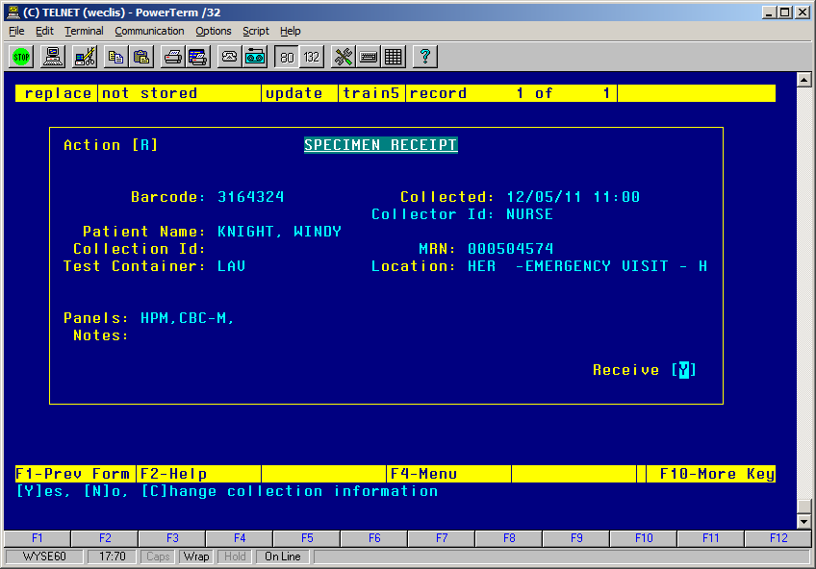
  - If there is a problem with the information provided by the nurses, please enter appropriate label reject panels for your department (i.e. for SPD, its LLR) and then enter decode [10] CIA (Collection information absent) or decode [11] CII (Collection information illegible).
  - Continue scanning barcodes or F1 to return to the main menu
  - Request Details specimen collected time is now updated and the actual collection time will now print on the reports

- K – Receive by Specimen (ALL Lab collected specimens)
  - Select K – Receive by specimen from the main menu
  - [L] List
  - Scan barcoded specimen(s) or enter in the specimen number(s)
  - F6 to action box when list is complete
  - [R] to Receive
  - If prompted, enter to accept the FYI message “This specimen is not on a collection batch.”
  - Enter person who collected the specimen
  - Enter in the Actual Collection Date and Time collected
  - The Collection Method form displays
    - If the collection method is correct, Enter to close the form
    - If the collection method is not correct:
      - Arrow up, [X] to delete, [Y] OK to delete. Enter.
      - Enter the appropriate collection method i.e. VEN, PED, CPU. Enter. Do not add a tracking note. Enter to close form.
    - If an Referred Out request displays i.e. Anti Thrombin III:
      - Do not delete the Referred Out panel
      - [A] to add a collection method panel
      - Enter the appropriate collection method i.e. VEN, PED, CPU. Enter. Do not add a tracking note. Enter to close form.
Please note: The Collection Method form will display for each specimen being received but only one collection method will be added per request.
  - F1 to exit

- To add a Collection workload panel without receiving the request
  - Select 1 – Request Entry from the main menu
  - [N] Enter Request number
  - [R] Request Details
  - [P] Panels
  - [A] add the collection workload panel required i.e. MVP and TRP
  - Add all necessary tracking notes.
  - Once the specimens have been collected, receive as indicated. If the specimens cannot be obtained, follow the appropriate rejection procedure found in Maintenance.

- References: NA

