- Purpose: To describe the step involved in creating an item and importing it into the Medworxx Content Manage System.

- Step-by Step Instructions:
  - Create and save your item.
  - Access the Manage content list using the following procedure “IHL-MDX-II Logging on to access administrative functions of the Medworxx CMS”.
  - Click “Manage Content”, then “Add New Content”, and choose the content type (Policy & Procedures or Document).
  - A content item screen will appear made up of four tabs: Content, Category, Security and Workflow. Each “tab” screen is explained later in this procedure.
  - There are three buttons which appear at the bottom of the tabs:
    - The “Save” button saves the content item but keeps the screen open.
    - The “Save & Exit” button saves the content item and closes the screen.
    - The “Cancel” button cancels any changes made to the content item since it was opened for editing and closes the screen.
- Content Tab contains:
Document Control Number | This number is automatically assigned by the Medworxx system and will change every time content is checked back into the system.
Title | This title must be the same as the item’s title.
Descriptions | A brief description can be included in this field that will appear on the document details page.
Saved As | The file should be saved with the same filename as the Title
Types | Policy and Procedure: Select this type if the item is a policy, procedure or process by clicking and selecting the appropriate checkbox.  Documents: Select this type if the item is an external document, flowchart, form, meeting minutes, memo, miscellaneous or a template. Choose the document type by clicking and select the appropriate one.
Distribution Groups (Policy and Procedure only) | Click and choose the groups to whom the content applies to by selecting the appropriate checkboxes. Please note that for abridged documents, select “abridged documents” as well as the location to which it pertains.
Regulatory References (Policy and Procedure only) | Click and choose the regulatory reference(s) which apply to the content by selecting the appropriate checkboxes.
Collaborators (Policy and Procedure only) | This section can be used to indicate who may have contributed to the content. Click and choose the applicable collaborators.
Approvers (Policy and Procedure only) | Click and choose the name of the person who approved the document.
Author | Click and choose the name of the person who wrote the content.
Last Review Date | Date the content was last reviewed. For new content, this date will be the same as the Effective Date. Click and select the appropriate date.
Next Review Date | Date the content is due for its next review. The default for all laboratory content is 1 year from the Last Review Date. If required, click and select the appropriate date.
Effective Date | Date the content is effective for use. Click and select the appropriate date
Keywords | Other words or phrases that do not appear in the title or description that users may use to search for the content. Please note for abridged documents, “abridged document” must be indicated.
Cross References (Policy and Procedure only) | This field can be used to link other policies, procedures or processes that relate to this content. However, the content you wish to link must already exist in the Medworxx system. Click to search for content. The search can be performed using a key word or selecting the first letter in the title. Once the content is located, click and select Uni (unidirectional) next to the content.
Attachments | This field should be used to attach any form, logs, etc., to the content. However, the form, logs, etc., must already exist in the Medworxx system. Click to search for content. The search can be refined by choosing a content type and/or key word in the title and/or by selecting the first letter in the title. Once the content has been located, click the checkbox.
Archived | This checkbox is used to indicate the content is archived and must be selected when content has been archived. Archived content must also be unpublished from the system. When the content has been archived, add “- Archived” to the end of the title.
Read Confirmation | This check box is used to track that the content has been read, understood and will be complied with by the end user. This check box must be selected for all new content and revised content that will affect laboratory processes.

- Category Tab contains:
  - This tab will determine where the item will reside in the system.
  - Select the site, followed by section and subsections to which the item will belong.
  - If the item belongs to more than one site, select IHL, then select and indicate to which sites, section and subsections the item will belong.

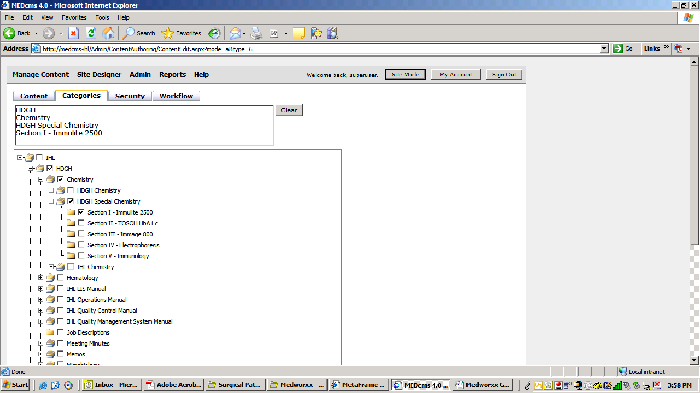

- Security Tab will determine where the item will be visible on the “Web Site Viewing” based on the following selections:

Public | Will be displayed on the anonymous section of the website and available to all hospital users. Use the Public selection for content that non-laboratory users will need to refer to. Web Site Viewers need not to be selected
Internal | Will only be available to laboratory users with a username and password (all laboratory staff). All laboratory policies, procedures and process should be set to Internal; except for those that non-laboratory user will need to refer to. Web Site Viewers need not to be selected
Private | Can only be viewed by groups or persons selected in the “Web Site Viewers” field. The Private selection should not be used by laboratory staff.

- Workflow Tab contains 5 different roles. They are as follow:
Editor | Persons or user groups in this role can view, check out/in, edit, delete, undo checkout, and copy.
Reviewer | Persons or user groups in this role can mark a policy as "reviewed" and can add comments from the review to the policy.
Approver | Persons or user groups in this role can approve or reject a policy and add comments/reasons for the decision.
Manager | Persons or user groups in this role can manage the workflow for this policy, meaning they can add persons or user groups into the 5 role categories on the workflow tab.
Publisher | Persons or user groups in this role can publish a policy for viewing on the web site.

  - In most circumstances, the content writer (owner) will be the Editor, Manager and Publisher.
  - The content owner will default into the Editor and Manager Fields.
  - However, one cannot approve their own policies, processes or procedures, therefore the Approver must be the person responsible for the area for which the content applies (i.e. Clinical Leader or Medical Director).
  - In all circumstances the Quality Management Officer must be selected as one of the Approvers as they oversee the entire Medworxx system.
  - Ensure the selection is set to “Yes” when asked if “All approvers have to approve?”
  - If content needs to be reviewed or approved by another person or group, the person or group can be selected in the Reviewer section.
  - To add more people to the Workflow fields, click and select the role, position or group name that is needed for each function. DO NOT SELECT THE ACUTUAL NAME OF THE PERSON. It is important to track approval authority (i.e. the role the person fulfills) since over time people switch roles in the organization. This also aids in management of the system to ensure policies and procedures are not being sent to people who are no longer employed by the IHL Laboratories.
  - In the Medworxx system, the chair of the various laboratory committees and focus groups has been given the approval/reviewer authority for the group. If the role, position or group name cannot be found or needs to be added, contact the Quality Management Officer for assistance.

- When all steps have been completed, click.

- References: Medworxx CMS Content Manger User Guide

