Purpose: To describe the steps involved in creating and documenting an abridged document.

Procedure:
- On the “content” tab, select “abridged document” and the location of distribution in the “Distribution” section.
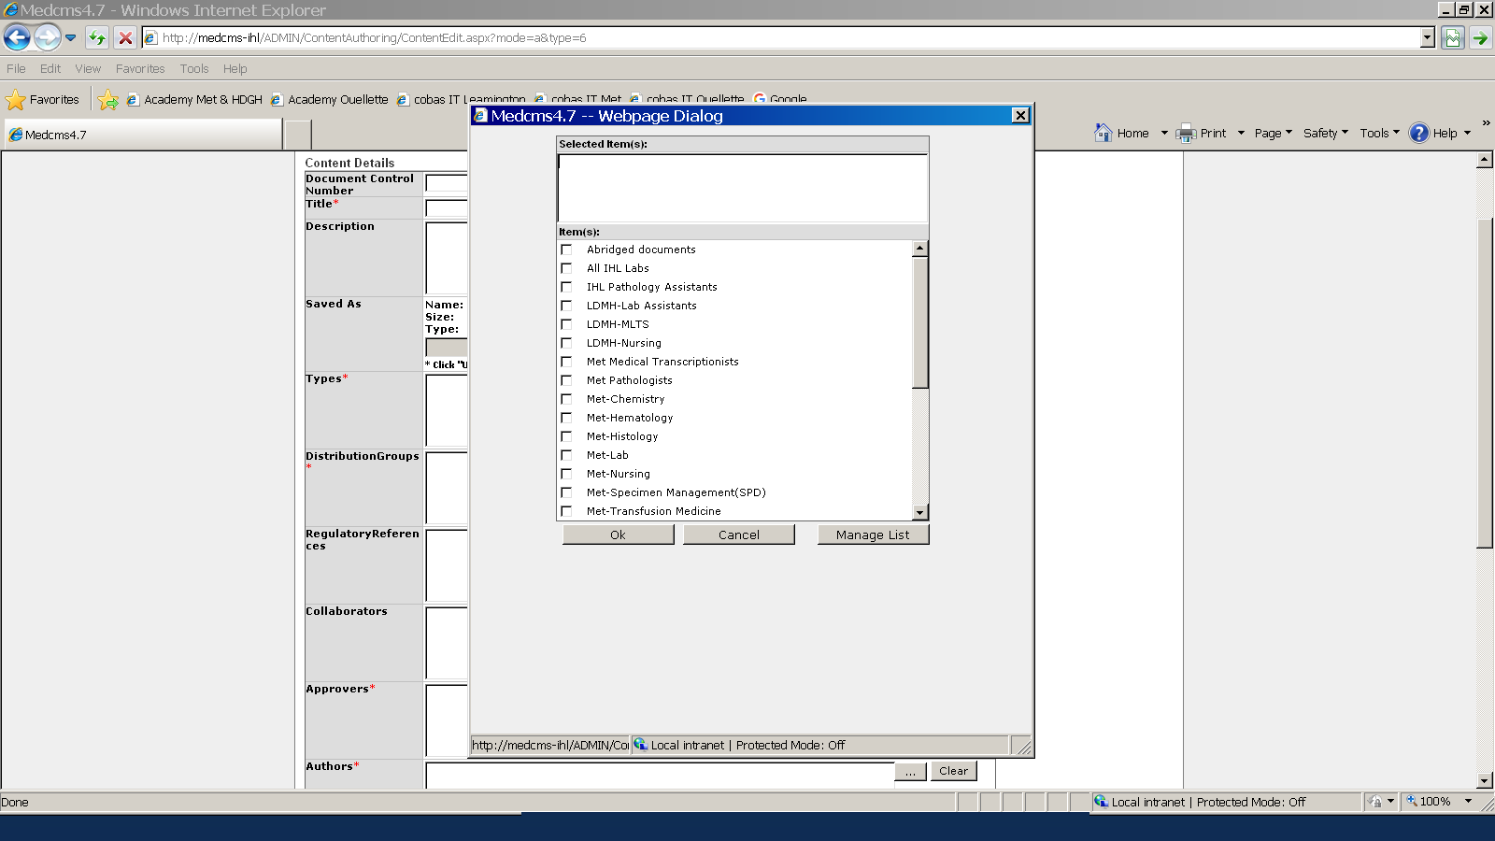

- Indicate in the keyword box when importing a document “abridged document” in order to ensure that all abridged documents’ distribution is traceable.

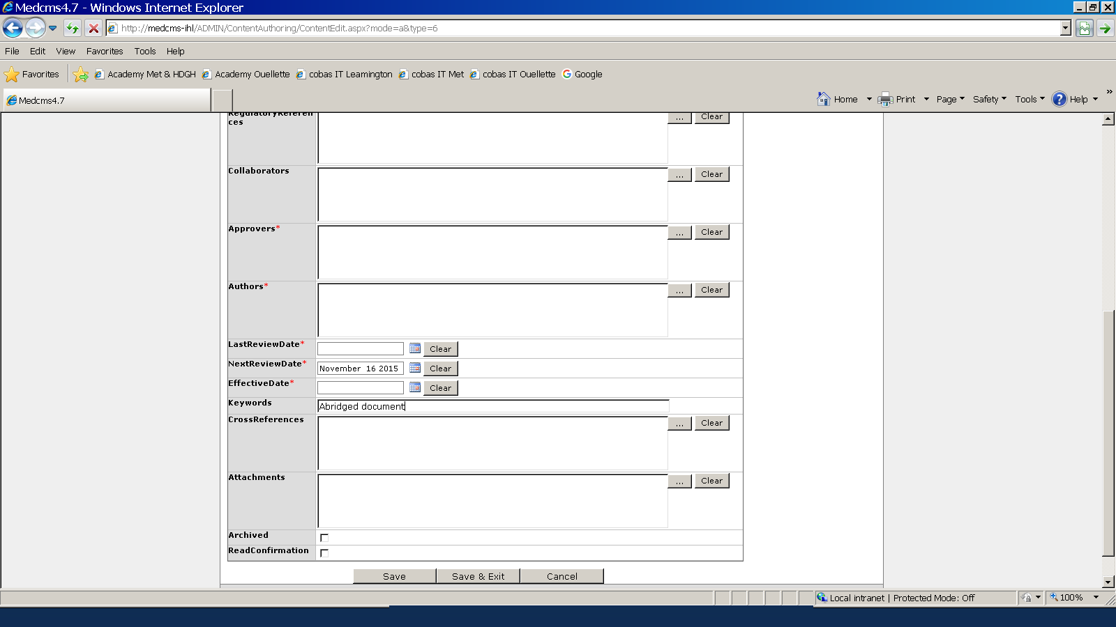

- Only documents that have been approved by the technical coordinators or designate are authorized to be printed and posted in a department.
- Periodically the technical coordinators or designate will do an inventory of posted document and ensure they are properly identified in the Medworxx system.
- To list all authorized abridged document by inputting in “Manage Content” and select “Edit Content”

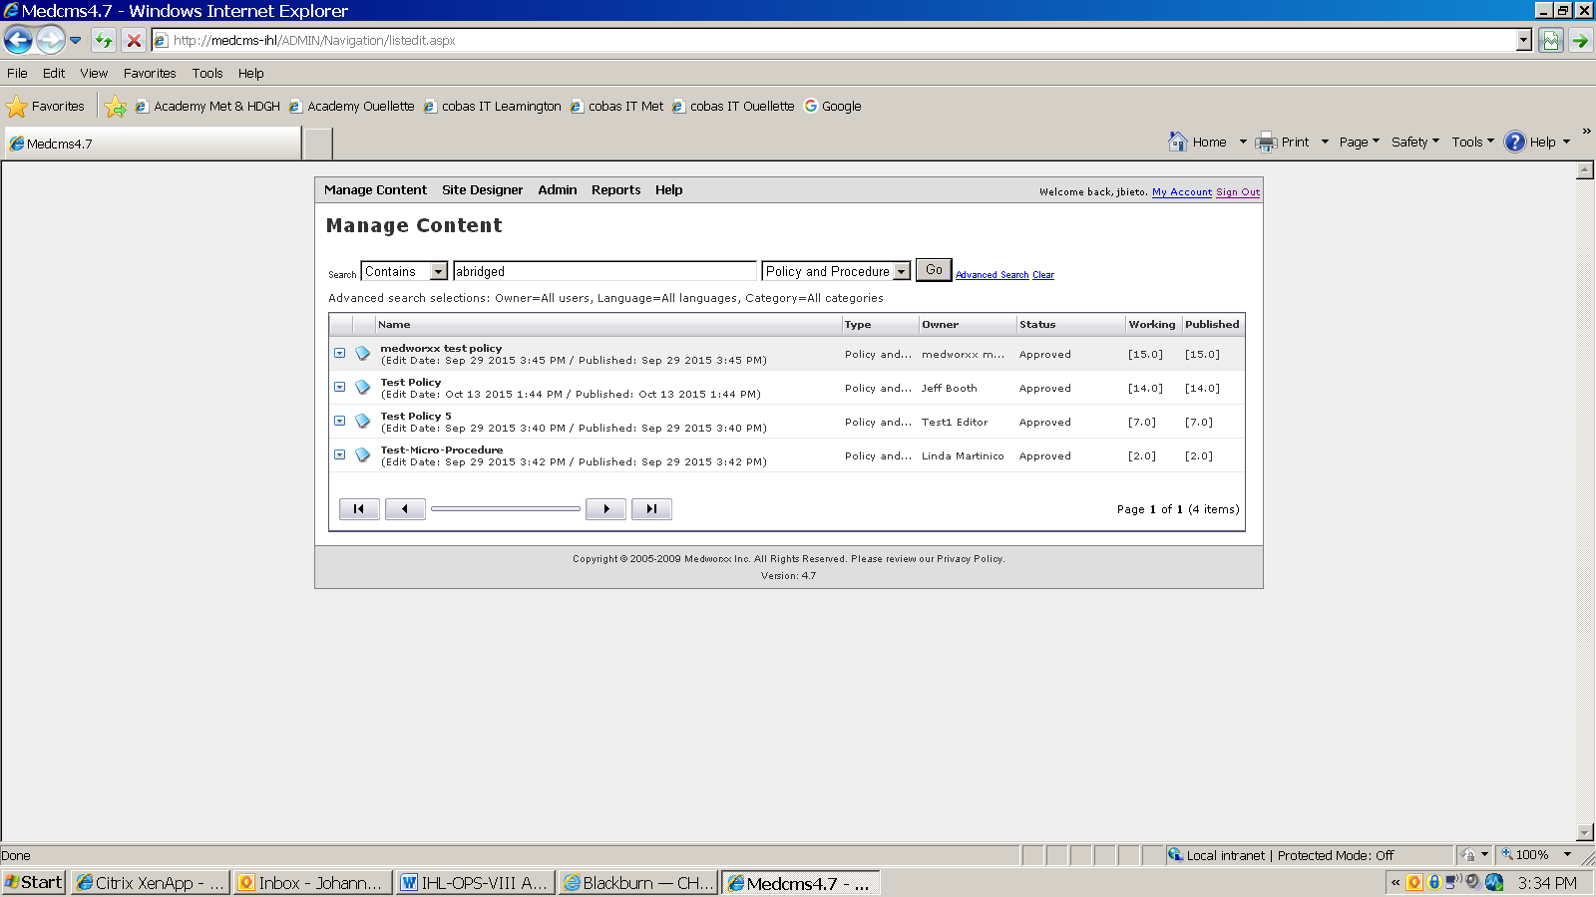

- Type in “abridged” in the box, select type of document and hit “go”.
- A list with all documents containing the key word abridge will appear.

References: N/A

