 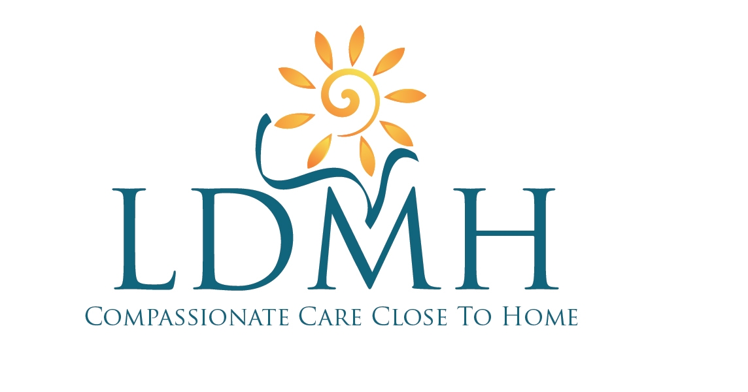 Memorandum

Ext. 33455

DATE: Dec. 2, 2015

TO: WRHOC SPD, Core MLTs, Pathologists

RE: Histology pagers replaced with cell phones

Effective Wednesday, Dec. 9, 2015, the Histology on-call pagers will be replaced by cell phones for after hours and weekend on-call for frozen sections. The O.R. will be directed to call the ‘Histology After-hours’ phone. The Histology After Hours phone, if not answered, will forward the call to the cell phone of the MLT who is responsible for on-call for that particular shift.
The After Hours phone will remain in the Lab in the designated mail slot next to Hematology. This phone will always ring when there is a call but be forwarded to the on call person when not answered.
The OR has been instructed to call SPD at extension 33458 if they do not get a response within 15 minutes. The Histology on call schedule will be posted in SPD so the person on call can then be contacted directly by Lab staff.
These are the individual numbers for the phones:
Histology After-Hours Phone: 519-995-0892
Alina: 519-995-0568
Chris: 519-995-5024
Kate: 519-995-0989
Tracy: 519-995-4813

