1. **PRINCIPLE:**
   1. In serologic testing, the hemolysis or agglutination that constitutes the visible end-point must be described accurately and consistently.
   2. The grading of reactions allows the comparison of reaction strengths and gives an indication of the relative amount of antigen or antibody present. This is beneficial in detecting multiple antibody specificity or antibodies exhibiting dosage.
   3. The grading of agglutination reactions should be standardized among all staff for the purpose of uniformity and reproducibility of test results.
2. **PROCEDURE:**
   1. Immediately after centrifugation and without disturbing the cell button remove the tube from the centrifuge and observe the supernatant fluid for hemolysis by comparing the color of the supernatant with that of the original serum. Record the hemolysis if present.
   2. Holding the tube at an angle, gently tilt and dislodge the cell button. Over shaking may break up large agglutinants or disperse weakly cohesive agglutinates. A visual aid may be used (e.g. illuminated concave mirror or a white background). Do not hold tubes up to the light above the face.
   3. Observe the way that cells are dispersed from the red cell button. NOTE: the characteristics of the agglutination should be noted. Loose, ‘stringy’, mixed field or refractile agglutinates should be recorded as they provide valuable clues in the investigation of aberrant findings.
   4. If the test is ABO or Rh grouping, read macroscopically. If a discrepancy is suspected (i.e. mixed field or rouleaux), read microscopically.
      1. Grade and record immediately as each reaction is read.
      2. A cloudy background with some large aggregates may indicate mixed population (i.e. mixed field).

Microscopic examination may be required.

* + 1. If mixed field is observed, record with “MF” along with the grading results (i.e. 2MF)
  1. If the tube test is an antibody screen, DAT or panel, read the tubes:
     1. Macroscopically at the 37°C
     2. Macroscopically at the AHG phase, then microscopically if the results were negative
     3. To all negative AHG tubes add 1 drop of IgG-coated control cells. Centrifuge, resuspend cells and read macroscopically. Record results.
     4. Antibody screen and panels incubated at room temperature or lower should only be read macroscopically
  2. If the test is an antigen typing (phenotype), follow the manufacturer’s directions for reading and result interpretation.
  3. If the test is MTS™ (Micro Typing System) gel, read macroscopically after centrifugation.
     + 1. Observe both the front and back of each microtube in the gel card.
       2. Refer to the MTS™ Interpretation Guide for diagrams or pictures showing the range of reactions

1. **INTERPRETATION:**

**Tube Reactions:**

* 1. Positive reactions may be characterized by hemolysis and/or agglutinates in the supernatant fluid. The cells seem to come off in chunks.
  2. Negative reactions are characterized by the cells swirling off the red cell button.
  3. Always record the tube readings as you make the observation.

|  |  |
| --- | --- |
| **SYMBOL** | **OBSERVED APPEARANCE IN TUBE** |
| **4** | One large clump or one clump and several small fragments; background clear. |
| **3** | A small number (4-6) of large clumps; background clear. |
| **2** | Many small clumps of about equal size clearly visible; background slightly cloudy. |
| **1** | Many tiny clumps of just visible size, background cloudy. Microscopically, very many small clumps of 20 or so cells and many free cells. |
| **w or 1w or 02** | Definite “grainy” appearance; no obvious clumps. Microscopically tiny clumps of up to 12 cells, very many free cells. |
| **01** | No obvious clumps macroscopically. Microscopically tiny clumps of 3 to 6 cells; many free cells. |
| **neg** or 0** | Cells float freely. No “stickiness” or agglutinates when examined microscopically. |
| **PH** | When placed beside a graded reaction indicates that partial hemolysis was seen with some intact RBC’s seen |
| **H** | Complete hemolysis, no cells remain |
| **MF** | Indicates a mixed field reaction seen microscopically or macroscopically. Large agglutinates are seen surrounded by a “sea of free cells” |
| **R** | Rouleaux, classic appearance of coin stacking |

**neg=negative, no agglutination (Do not use a minus sign “–“ for negative: either write neg or 0)

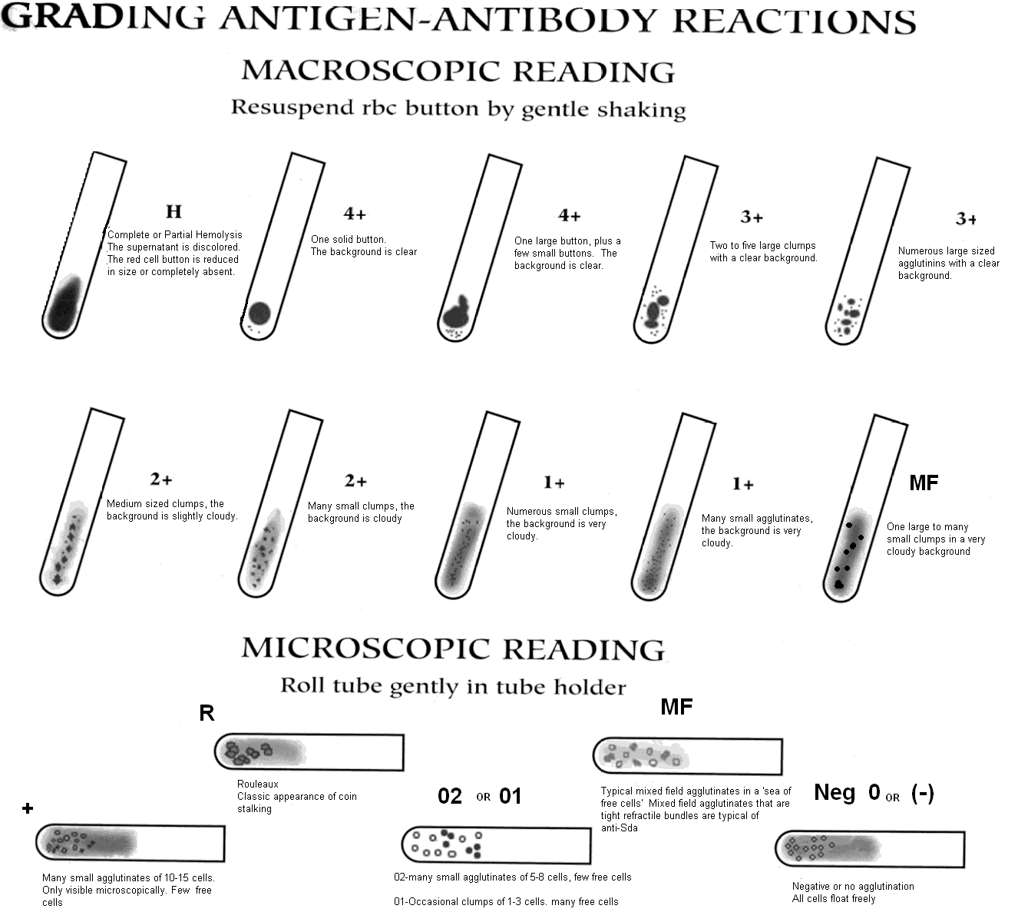

NOTE: the characteristics of the agglutination should be noted. Loose, ‘stringy’, mixed field or refractile agglutinates should be recorded as they provide valuable clues in the investigation of aberrant findings.

1. **REFERENCES:**
   1. AABB Technical Manual, 17th Edition, 2011. Bethesda, Maryland.
   2. Judd’s Methods in Immunohematology, 3rd edition, 2008. AABB, Bethesda Maryland.
   3. Transfusion Ontario Ottawa – Standard Work Instruction Manual (SWIM templates); ORBCON.