MICROBIOLOGY WORKLISTS
- PRINCIPLE
  - Worklists for panels MRV, MRC, VRC, UR, BC and BCS have been created to result no growth specimens quickly.
  - Specimens must be received in ULTRA and MICRO (as applicable) in order to be available to be put on a Worklist.
  - If the specimen is not received appropriately, “No tests waiting” will display when attempting to put that specimen on a worklist.

- WORKLIST NAMES
  - MRV: for MRV, MRC, VRC
  - UR: for Urines
  - BC: for BC, BCS

- PROCEDURE
  - GUI WORKLISTS
    - From the ULTRA main menu, choose W (Worklist Printing and Default Entry).
    - In the Action box, enter S for specimen, then in Code, enter the Worklist Code (UR or MRV), then press Enter.
    - Lab will self populate with HDH.
    - Pass through the Urgent and Collect fields by pressing Enter.
    - The Device will default to hmiol. Enter through this field as it is set up in the background and no list will print in the interest of saving paper.
    - Enter through the “Enter by range” portion, ensuring it is NOT defaulted with a check mark.
    - In the “From” field, scan in the barcodes. After the last barcode, press Enter, and then Enter again. The “OK?” box will default to Y (yes). Note the number of specimens you’ve scanned in.
    - A new Worklists box will appear. In the Action box, enter O for Outstanding.
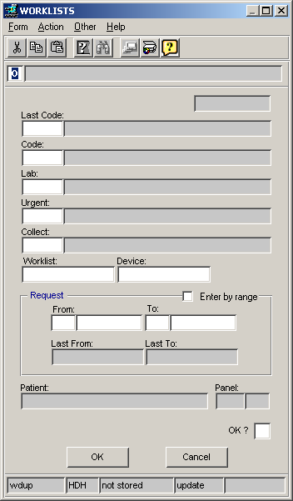
    - This will bring up the OUTSTANDING WORKLISTS box.
    - Under A enter E, then under Code enter the Worklist code.

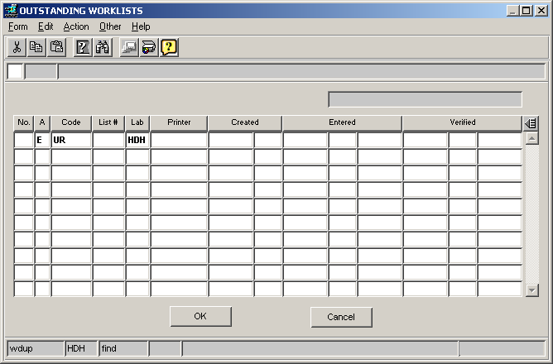

    - Press F3, and your Worklist number will be assigned.

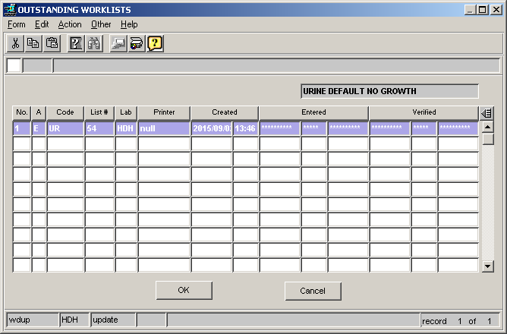

    - Enter D in the action box and the DEFAULT WORKLIST ENTRY box will appear.

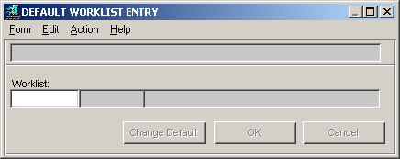

    - Enter the Worklist number and press “Change Default”.
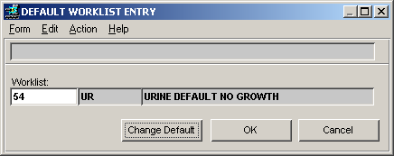

    - The Worklist Result Defaults box will appear. The Workup must be slashed (/). Then enter the appropriate default results (options will appear at the bottom of the box). Press Choose Specimen and the box on the right will populate with the specimens you’ve scanned in. Check to make sure the number of specimens is correct (see 3.1.7).
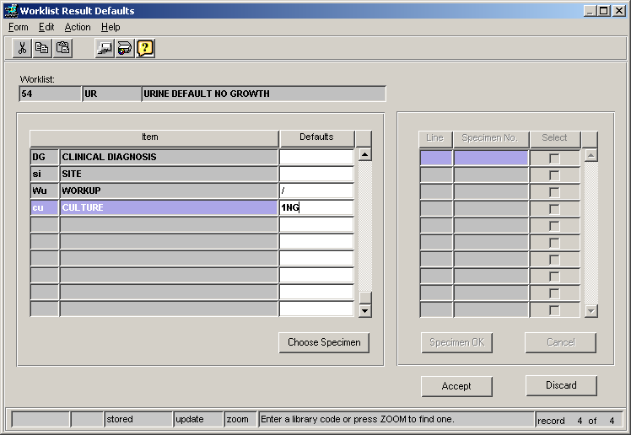

    - Hit Select to choose all specimens, then press Specimen OK, then Accept.

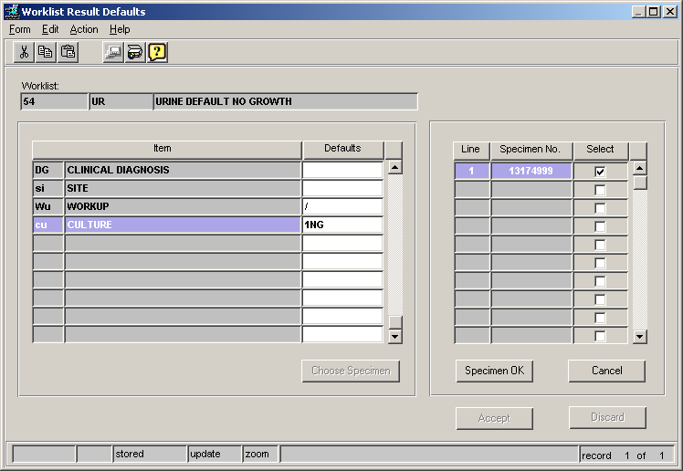
    - The Default Worklist Entry box will appear again. Hit OK.

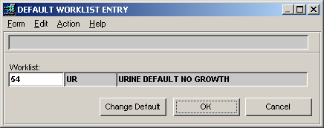

    - A dialog box will appear demonstrating the number of requests processed and results updated. Press OK and select F2 to exit all pages.

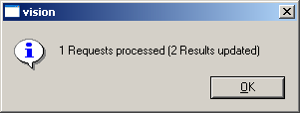

- REFERENCES

N/A

