**PURPOSE:**

To evaluate the results obtained with a panel of red cells to determine accurate identification of an unexpected antibody (ies). This process will determine which antibodies are ruled out and whether additional testing is required to confirm or exclude the presence of an antibody.

**SCOPE AND RELATED PROCEDURES:**

This procedure is used when positive results are obtained with any reagent red cell while performing an antibody investigation.

Refer to :

IHL-TMD-IV Antibody Investigation and Identification

IHL-TMD-IV Antibody Investigation Checklist

**MATERIALS –**

Supplies – antigram with recorded reactions.

**PROCEDURE:**

* 1. The first approach to interpreting panel results is to exclude specificities based on panel cells which **did not** react with the test plasma. For example, if an antigen is *present* on a panel cell and the test plasma *did not* *react* with that panel cell, then the presence of that antibody can at least be tentatively excluded.

Exclusions of common clinically significant antibodies are routinely made using **two** homozygous cells. The homozygous cell is the double-dose or strongest expression of the corresponding antigen. Exclusions performed on a single-dose antigen or heterozygous cell may result in excluding a weak antibody which may be present.

There are some exceptions - refer to Appendix A: Exclusion Criteria

* 1. Perform exclusions for all non-reactive cells of the antibody screen and panel. When an antibody is ruled out using a homozygous cell place an (X) through the antigen on the antigram sheet. If an antibody is non-reactive on a heterozygous cell, place a (/) through the antigen indicating the number of heterozygous exclusions (example { /3 }).

Refer to figure 1 and 2.

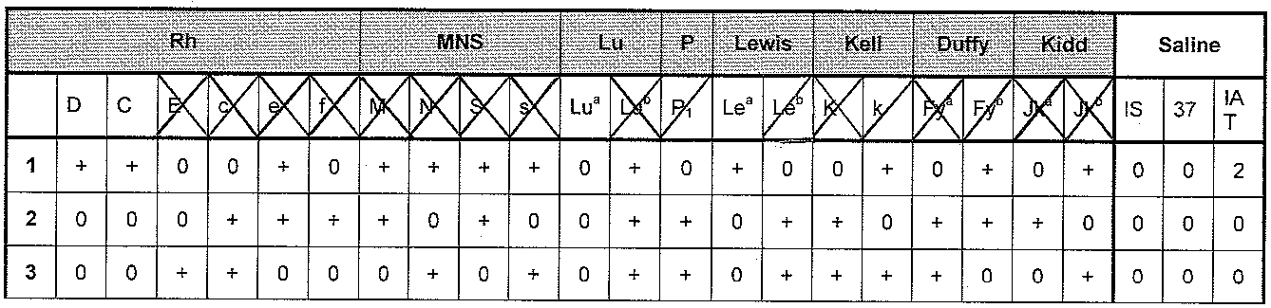

Figure 1 Antigens crossed out on the top of the antigen profile.



Figure 2 Antigens crossed out on each individual panel cell.

* 1. Next, the cells found to be reactive with the test plasma are compared to the pattern of each of the antibodies not ruled out in the exclusion process. If there is a direct match, that is likely the specificity of the unknown antibody. However, further exclusions may be required to eliminate other specificities not yet ruled out. Multiple antibodies may present a pattern that directly matches one single antibody. Strength or grade of the reactions seen may be an indication that this is the case.
  2. Circle or highlight remaining specificities that could not be excluded. Choose selected cells negative for the probable antibody/antibodies and positive (homozygous) for the specificities not excluded. Repeat the exclusions process above.
  3. When there are multiple antibody specificities present ensure there are sufficient reactions present to determine independent specificity and whether the antibody is either reactive or non-reactive (considered ‘on-file’).

Example: anti-C and anti- K present, set up C pos K neg and C neg K pos panel cells

* 1. Expired panel cells may be used for exclusions when other in-date panel cells are not available, refer to *IHL-TMD-VI Reagents and Antisera.*
  2. In order to determine that the results are not due to chance it is recommended when identifying a new antibody to have a minimum of three (3) antigen positive cells reacting (panel or screening cells) for the identified antibody(ies) and three (3) negative or non-reacting cells (panel or screening cells).
  3. Evaluate results and reporting, refer to:
     1. IHL-TMD-IV Antibody Investigation and Identification and
     2. IHL-TMD-IV Antibody Investigation Checklist

**REFERENCES:**

* 1. AABB Technical Manual, 17th edition, 2011.
  2. Judd’s Methods in Immunohematology, 3rd edition, 2008.

**Appendix A: Exclusion Criteria**

**1) Exclusion of clinically significant antibodies to the following:**

**D*, C**, E**, c, e, K***, k, Kpb, Jsb, S, s, Fya, Fyb, Jka, Jkb, Lub, Lea (hemolytic)**

**\* ** \*\*\*** see exception criteria below in (2)

Refer to Chart A – Clinically Significant Antibody List, IHL-TMD-IV Antigen Phenotyping

|  |  |
| --- | --- |
| **If the pattern suggests:** | **Then exclusion is based on a minimum of:** |
| a single antibody specificity | ONE or TWO non-reactive cells with homozygous antigen expression |
| multiple antibodies, autoantibodies, or there are ambiguous or unexplained reactions | Two non-reactive cells with homozygous antigen expression |

**2) Exception exclusion criteria:**

|  |  |
| --- | --- |
| IF | **Then** |
| **\***the pattern and history suggests the presence of a **passive anti-D**  **(i.e., anti-D obtained from injection of Rh Immune Globulin)** | A minimum of **one** non-reactive cell with heterozygous antigen expression of C or E must be obtained. |
| **\*\* exclusion of anti-C or anti-E in the presence of anti-D is required** | A minimum of **two** non-reactive cells with heterozygous dose antigen expression of C and E must be obtained |
| **\*\*\* exclusion of anti-K is required** | either one non-reactive cell with homozygous K antigen expression or  exclude with two non-reactive cells with heterozygous K antigen expression must be obtained |

**3)** Exclusion of the following with a minimum of one non-reactive cell is acceptable for antibodies to: **f, P1, Lea, Leb, Xga**

**4)** *Routine* exclusion is usually not required for antibodies to low incidence antigens such as:

**Kpa, Jsa, Wra, Cob, V, Cw, Lua**

These antibodies occur infrequently and would usually be detected when crossmatched red cells have the corresponding antigen.

NOTE: Further investigation of this group is required when there are unexplained reactions or if a crossmatch expected to be compatible, appears incompatible.