**Case 1**

**A 35 year old male presents to his family physician with flu-like symptoms after returning from a camping trip in upstate New York.  The following is observed in a blood film. (Wright-Giemsa, 400x)**

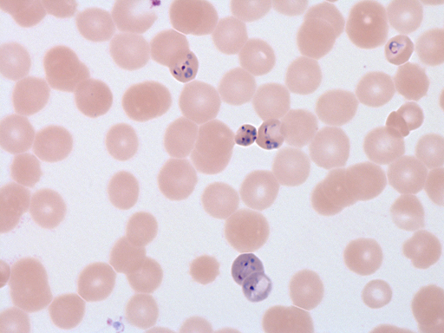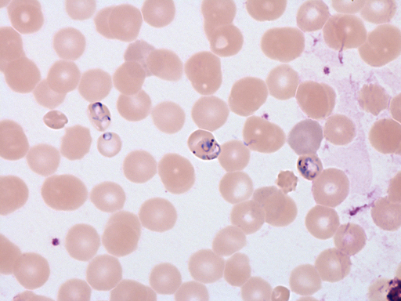

|  |  |
| --- | --- |
|  |  |

**Please select the best diagnosis:**

**a)  *Plasmodium falciparum*.**

**b)  *Toxiplasma gondii*.**

**c)  *Babesia* species.**

**d)  *Toxocara canis*.**

**Case 2**

**An 8 year old male is brought to the emergency department complaining of muscle aches, chills and headache.  His family arrived in Canada one week prior from a refugee camp in Tanzania.  The following is observed on blood films (Wright-Giemsa and Giemsa, 200x and 400x).**

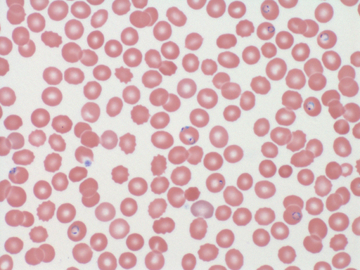

|  |  |
| --- | --- |
|  |  |
|  |  |

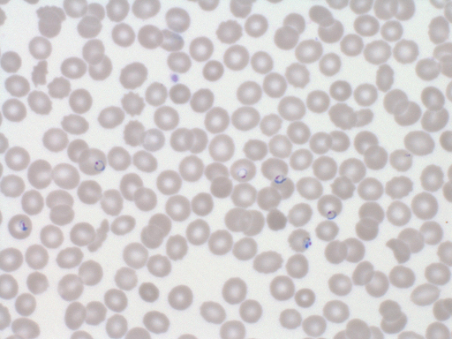

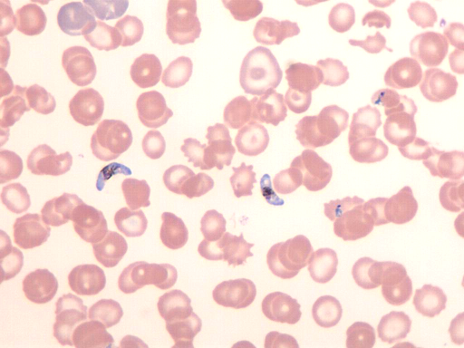

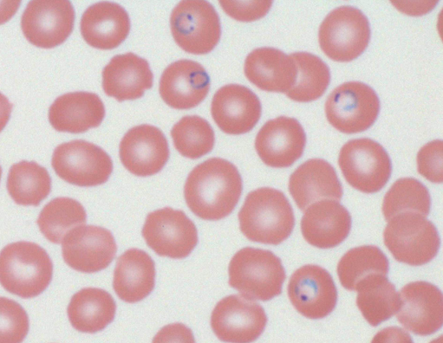

**Please select the best diagnosis:**

**a)  *Plasmodium falciparum*.**

**b)  *Plasmodium malariae*.**

**c)  *Plasmodium vivax*.**

**d)  *Plasmodium ovale*.**

**Case 3**

**A 28 year old female presents with fever and myalgias shortly after returning from humanitarian work in West Africa. The following is observed in a blood film (Wright-Giemsa, 400x).**

|  |  |
| --- | --- |
|  |  |
|  |  |

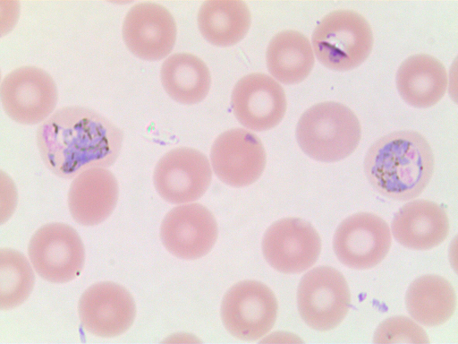

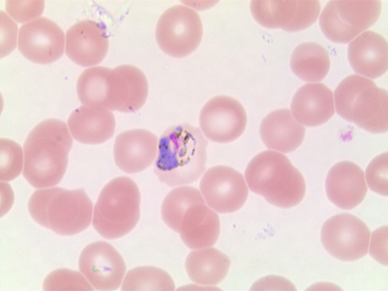

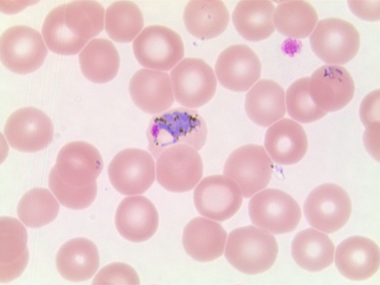

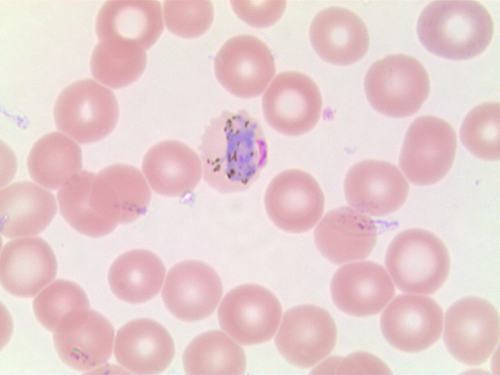

**Please select the best diagnosis:**

**a)  *Plasmodium falciparum*.**

**b)  *Plasmodium malariae*.**

**c)  *Plasmodium vivax*.**

**d)  *Plasmodium ovale*.**

**Case 4**

**A 45 year old female presents with fever, chills and abdominal fullness after returning from a trip to India. The following is observed in a blood film. (Wright-Giemsa, 400x)**

|  |  |
| --- | --- |
|  |  |
|  |  |









**Please select the best diagnosis:**

**a)  *Plasmodium falciparum*.**

**b)  *Plasmodium malariae*.**

**c)  *Plasmodium vivax*.**

**d)  *Plasmodium ovale*.**

**Case 5**

**A 65 year old male, originally from Panama, is undergoing chemotherapy for lung cancer.  He feels acutely unwell and is febrile.  The following is observed in a blood film. (Giemsa, 400x)**

|  |  |
| --- | --- |
| **P:\case 5-1.png** |  |

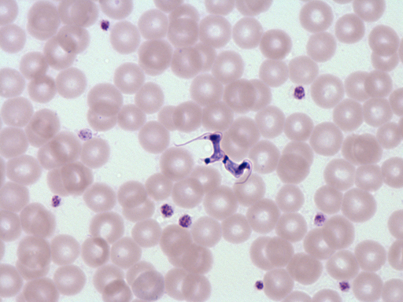

**Please select the best diagnosis:**

**a) *Plasmodium falciparum*.**

**b) *Toxiplasma gondii*.**

**c) *Trypanosoma cruzi*.**

**d) *Trypanosoma brucei*.**

**Case 6**

**A 25 year old male presents with fever, eosinophilia and ankle swelling after returning from India.  The following is observed on a Giemsa stained smear. (100x)**

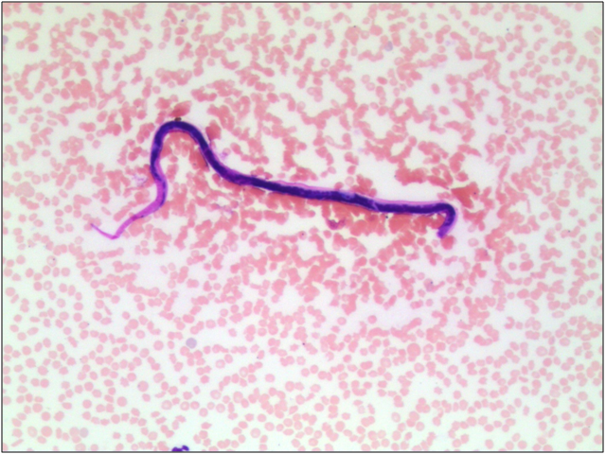

|  |
| --- |
|  |

**Please select the best diagnosis:**

**a)Microfilaria – *Brugia* sp.**

**b) *Ascaris lumbricoides*.**

**c) *Trichinella spiralis*.**

**d) *Enterobius vermicularis*.**