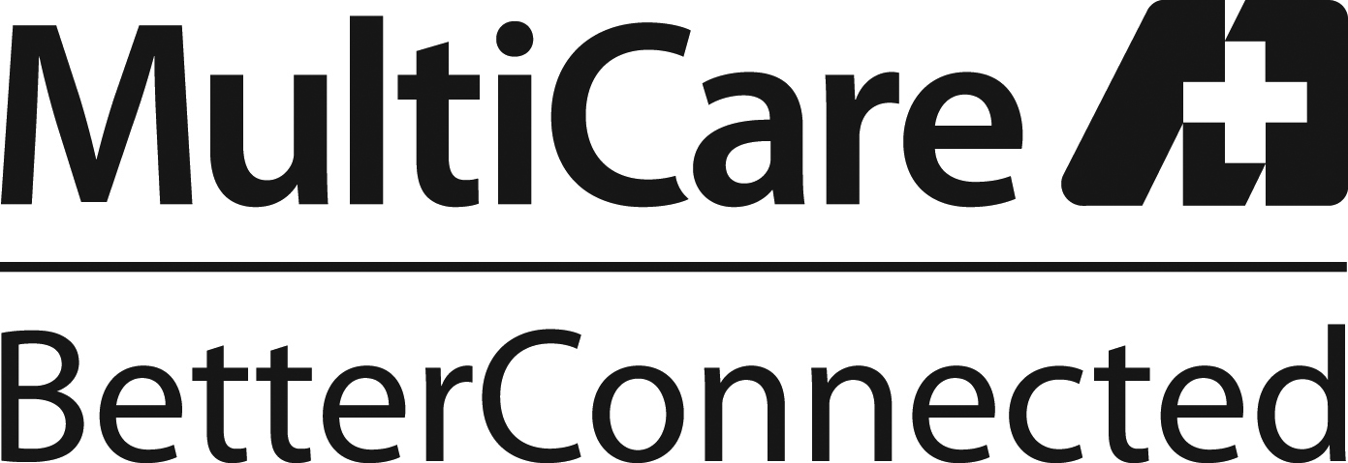 |  | 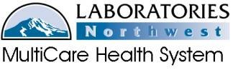  Category of the Policy  (i.e. Patient Care or Infection Control)
Title: Educational Resources
Scope: All employees of LABORATORIES Northwest.
Policy Statement:
LABORATORIES Northwest strives to provide continuing education opportunities so staff may complete any requirements for certification or continued employment.
Procedure: The following information describes the tools available to MultiCare employees.
- INSTITUTE FOR LEARNING DEVELOPMENT (ILD): A department within
MultiCare Health System that develops educational exercises for all disciplines.
Courses taken through the ILD are automatically entered into your LMS transcript.
The ILD also maintains the Learning Management System (LMS) which is used to
monitor individual transcripts for MHS sponsored activities.
A. Access the LMS through the MultiCare MHSNet
1. Select Education from the top bar:
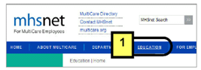
2. Select “Institute for Learning and Development – ILD”
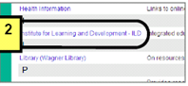
3. Click LMS-Learning Management System” from the green bar on the left side
of the page
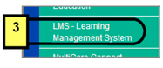
4. Click on the purple button – “I am working on a shared computer”
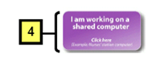

5. You will now be at your Citrix login
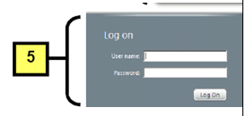
6. Click on the LMS icon:
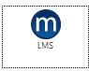
B. Once you have entered into LMS you can manage your education activities by viewing what you have recently completed or accessing the Training Catalog and selecting activities to complete.
II. Self Reported Training: Records for continuing education activities that are
not sponsored through the Learning Management System may be tracked using
the Employee Education Record available in the Red Manual.

- ASCP: Paper exercises are available for laboratory staff and are valued for CE credit per exercise. The list is updated annually and posted in the Red Manual. ASCP has sanctioned continuing education credits three years after publication.
- Exercises are available in the copy room at Tacoma General or may be requested through the Laboratory Regulatory Compliance Consultant. Return the completed exercise for evaluation.
- After successfully completed (80%) the continuing education credit will be entered into your personal transcript.
- MTS: On-line education modules (medtraining.org) that contain competencies and training. Employees initially access this website during new employee education. Modules may be either assigned or available to interested staff.
- To access: Using internet access from the MultiCare homepage or your internet browser at home, go to: www.medtraining.org.
- Competency Assessments are 0.5 CE units
- Training Exercises vary in units

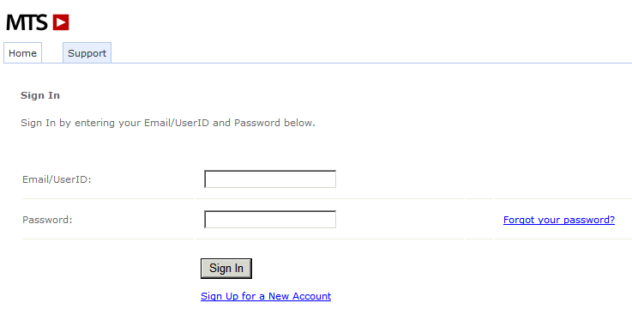
1. Email/User ID is your MultiCare email.
2. Password is usually first initial, last name.
Example for Peter Pan:
Email: peter.pan@MultiCare.org
Password: ppan.
C.E’s may be recorded in the Employee Education Record or MTS maintains a transcript of courses you have taken.

IV. TELECONFERENCES: May be offered throughout the year as available. If offered by MultiCare, the CE will be entered into LMS for your records.
Summary of Edits: Updated LMS functionality and method of self reported training.
Point of Contact: Laboratory Regulatory Compliance Consultant
Original Date:  Revision Dates: | 4/2005  12/2007;3/2012;3/2014

