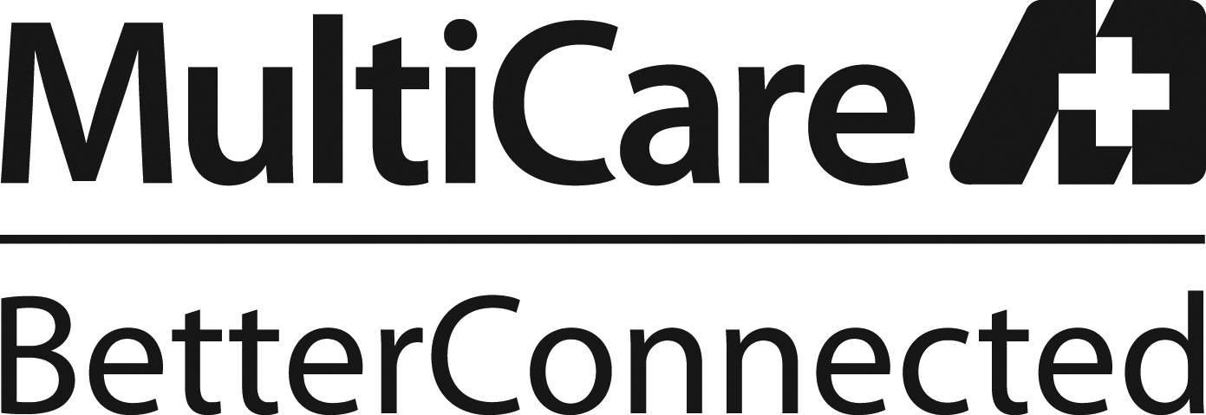 |  | 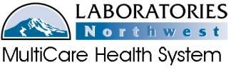  Category of the Policy  (i.e. Patient Care or Infection Control)
Title: REPORTING of EVENTS
Scope: Event reporting is the responsibility of all employees of LABORATIES Northwest.
Policy Statement: LABORATORIES Northwest complies with the reporting requirements established by the Joint Commission and the Food and Drug Administration (FDA) for Sentinel Events, Adverse Occurrences and Medical Devices.
Special Instructions: All information is to be entered in a professional, objective manner based on facts of the investigation. Use of abbreviations or slang is unacceptable.
Definitions:
ADVERSE OCCURENCE: A “minor” unanticipated adverse or potentially adverse occurrence that has caused, or if repeated, could potentially cause harm to a patient. In the event the occurrence was a system wide issue, an electronic quality improvement memo (MeQIM) is completed for review. Additional adverse occurrences that are a result of interlaboratory processes must be documented using the internal Laboratory MeQim, (also referred to as QERN). This is forwarded to the department manager for review.
SENTINEL EVENT: A sentinel event is an unanticipated occurrence that results in death or serious harm. A hospital MeQim must be completed immediately following the incident. An event is defined as a “Sentinel Event” by the MHS Quality Management department. All Sentinel Events requires the initiation of a Root Cause Analysis and a report to the FDA is submitted if a sentinel event is confirmed.
MEDICAL DEVICE REPORT (MDR): A report that is required by the (FDA) when an instrument, reagent, or other device is suspected of causing or contributing to a patient death or serious injury. This report must be completed and filed within 10 days of the incident.
VENDOR NOTIFICATION: Notification from vendors regarding the integrity of reagents, supplies, software or other defects is managed by the individual; department and documentation is retained for future reference.
ADDITIONAL REPORTING of EVENTS:
Transfusion Services is required to complete a “Problem Report Form” and the manager will identify if the event is FDA reportable. If a concern is not addressed by laboratory management, or the MultiCare Quality Management department, employees must understand they may communicate directly with AABB regarding transfusion service issues.
If a concern is not addressed by laboratory management, or the Multicare Quality Management department, employees must understand they may communicate directly with the College of American Pathologists (CAP). It is the policy of LABORATORIES Northwest to prohibit any harassment or punitive action against an employee who has voiced any concern regarding safety or quality.
Related Policies:
Laboratories NW Internal Quality Event Reporting
MHS “MeQIM Process Guidelines (For Unusual Occurrences and Critical Events)”
MHS “Critical Event Management and Disclosure”
“Safe Medical Devices Act of 1990 Reporting (Pub L101-629) and Amendments”
“Unusual Occurrence, Reporting, Management and Disclosure.”
Related Forms:
Summary of Edits: 3/16/12 Retire “Reporting Device-Related Adverse Patient Events” (6/05)
1/2013 Expanded Medical Director review; additional MHS related policy
3/2014 Expanded Medical Director review
4/2014 Included AABB as an additional reporting agency.
References:
Joint Commission Reference Manual, 2008. Sentinel Events, pgs SE-1 through SE-8
21 CFR part 803 and 807
College of American Pathologists: GEN.20330
College of American Pathologists: GEN.20340
College of American Pathologists: GEN.20371
Standards for Blood Banks and Transfusion Services, 29th Edition: AABB 1.5
Point of Contact: Laboratory Regulatory Consultant
Approval By:  LABORATORIES Northwest Medical Directors  G. David Austin M.D.  Eric Arntson M.D.  George Hodges M.D.  Larry O’Bryant M.D. | Date of Approval:  3/16/2012  1/23/2013  1/18/2013  3/5/2014
Original Date:  Revision Dates:  Reviewed with no Changes Dates: | 12/2009  3/2012;1/2013;3/2014; 4/2014  12/2010

