**Introduction to the Cincinnati Laboratory Test Directory**

For a laboratory to operate and be able to bill for the testing that is done, it must be accredited by some agency that is acceptable to the federal government. Our laboratory is accredited by the College of American Pathologists (CAP), which means that we are subject to the requirements of the CAP.

We have certain policies and procedures that must be followed to ensure that our product – lab test results - are accurate and timely.

Policies and procedures are constantly changing with the introduction of new testing and improvements that are made to improve quality and reduce errors. The CAP requires that we make sure all the policies and procedures being followed are up to date and reviewed every other year. This is what CAP tells us about controlling all of our documents we use in the Lab:

Document Control

*The laboratory has a document control system to manage policies, procedures, and forms that are subject to CAP accreditation.*

*NOTE: This includes documents relating directly to laboratory testing, as well as others, such as quality management, safety, specimen collection, personnel, and laboratory information systems. The document control system must ensure that only current policies, procedures (including derivative documents such as card files and summary charts), and forms are in use and that records for approval, review, and discontinuance are available.*

When CAP did inspections of the Mercy Labs, they recommended not having multiple copies of any of the documents above. One electronic copy is the easiest to keep track of and make sure it is reviewed every other year. The easiest way to accomplish this was to have all policies and procedures on-line and have the whole region be able to access these through the HUB.

Lab managers and leads throughout the region have been working on this huge project to get policies and procedures that are region – wide and getting these put on the HUB, so that there is ONE approved copy for all to use.

The first part of the project to be completed is a regional specimen collection manual. The specimen collection manual was created, using software purchased from our reference lab, ARUP, and after many hours of work is now on the HUB to be used by all Labs in our region.

This is the first part of the project to be completed, since the biggest percentage of errors in laboratory testing are made in the pre-analytical phase. This means before the actual testing is performed. It includes ordering the right test on the right patient and that we get the right specimen that is handled the right way. This is a problem prone area since we offer hundreds of tests, all with their own collection requirements. Having only one copy of the specimen collection manual will make sure the most up to date and accurate information is available when questions arise about what type of specimen is needed, stability of specimens for certain tests that may be requested later, normal values for the testing and how often the test is performed (turnaround time).

Following are the directions for using the on-line specimen collection manual and then a quiz to be completed by using the on-line manual to make sure you are comfortable with using this new tool.

There will be more modules to follow as sections of the project are completed and policies and procedures in all sections of the lab are available electronically.

**Instructions for using the Cincinnati Laboratory Test Directory**

1. Hub
2. Services and Specialties
3. Laboratory
4. Regions

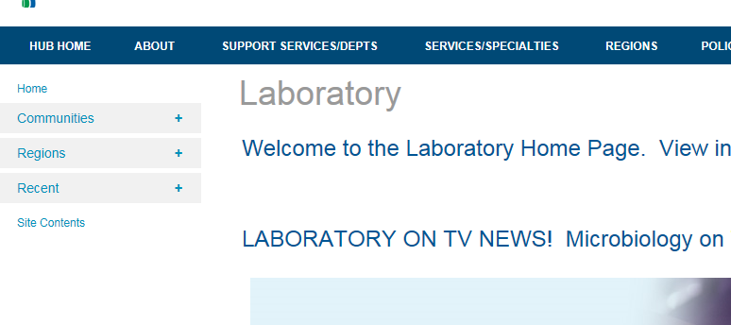

This one!

NOT this one!

1. Mercy Health Cincinnati Laboratory Services

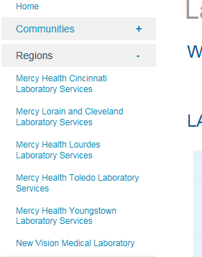

1. Cincinnati Laboratory Test Directory (clicking here will take you to the link <https://www.testmenu.com/SWOH>)

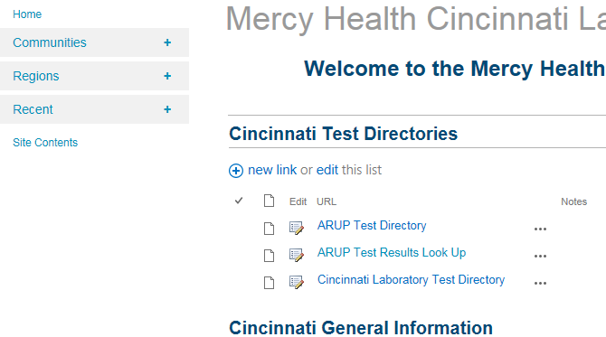

1. Search for the test by typing some or all of the name into the search box (typing less is usually better)

**Very important**: **Press Enter or Click on Search after typing in the name or part of the name.**

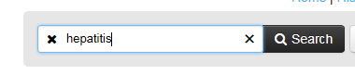

1. If multiple tests come up, choose the one that matches with the physicians order.
2. Test Numbers appear as follows Epic Test Code/Soft Test Code

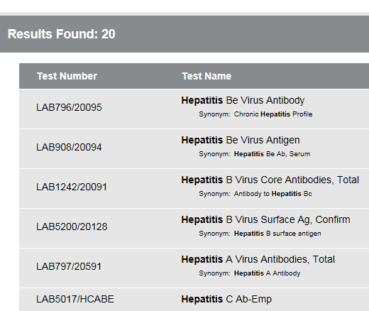

1. Remember that Soft Test Codes that are made up of mostly **letters are the tests we perform in Cincinnati at Mercy Labs**. Soft Test Codes that are all **numbers are performed at ARUP**. In the example above, all of the tests shown are performed at ARUP (we know this because the Soft Test Codes are all number).

Please review the following example also.

EXAMPLE: This search is for the letters “glu” 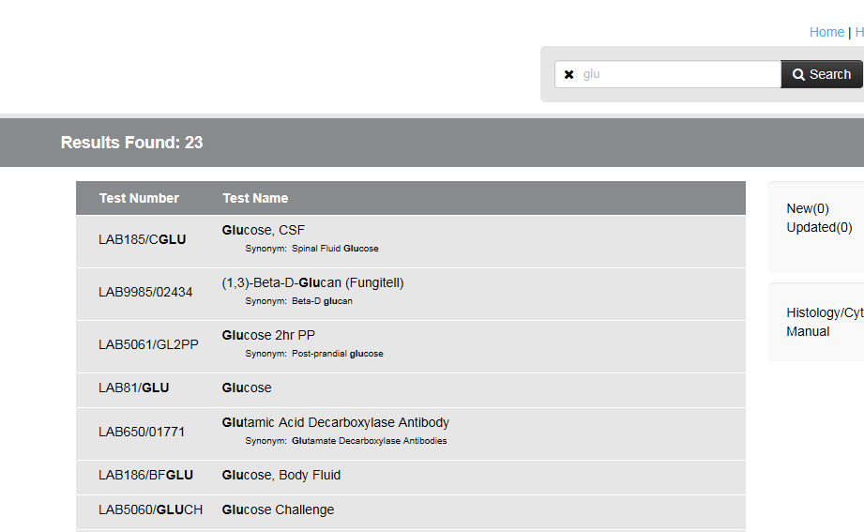

Tests circled in Red are performed at ARUP. Tests circled in Blue are performed in Cincinnati.

1. From the list , double click on the test you would like to view. Information on collection, stability, tube type, storage conditions are displayed. Reference ranges are available under the Result Interpretation tab.
2. If the test you are searching for does not appear, the test should be ordered as an MISS1, 2, or 3 if the test name contains the word REFLEX or ALLERGEN. If the test name does not contain either word, order a Whopper Test Code (97163,98559, 98556, or 98568). To order either Whopper or MISS, find the Test Name , ARUP Test Code, and collection information by going to the **ARUP Test Directory**:

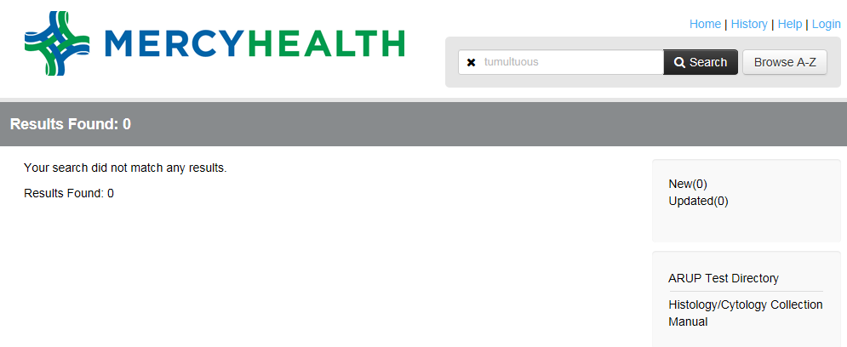

1. If you want to view a test you have recently searched for, click on History.

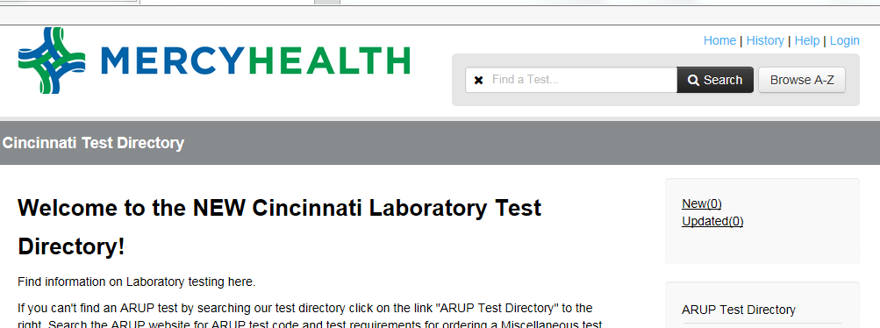

A list of tests you have recently searched for will appear. Using the History button can save you a few clicks when searching: