**Finding and Using the Cincinnati Test Directory**

1. **Click on this icon  at the bottom left of your screen**
2. **Click on either Internet Explorer or Google Chrome and you will be taken to the BSMH Central home screen**
3. **On the BSMH Central home screen, click on either Quick Links or Quick Link Finder:**

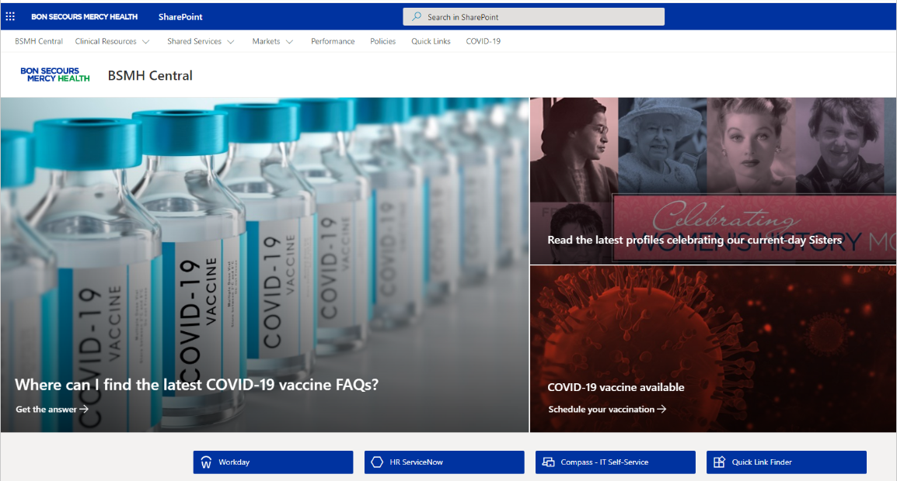

1. **On this screen find All Quick Links followed by a long list:**

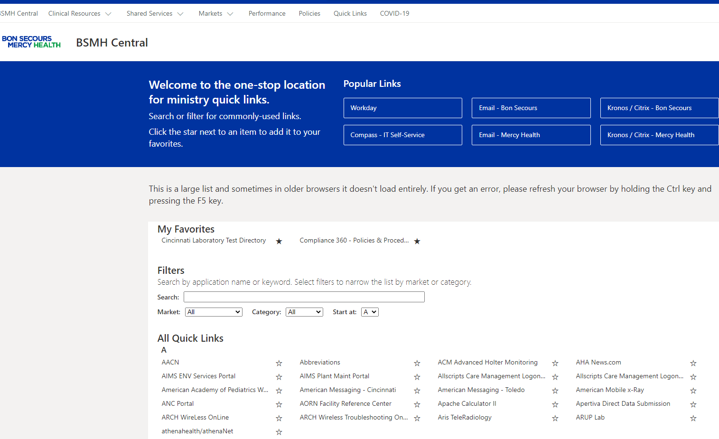

1. **Look for Cincinnati Laboratory Test Directory in the long list:**

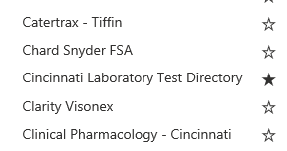

1. **Click on Cincinnati Laboratory Test Directory and you will be taken to it:**

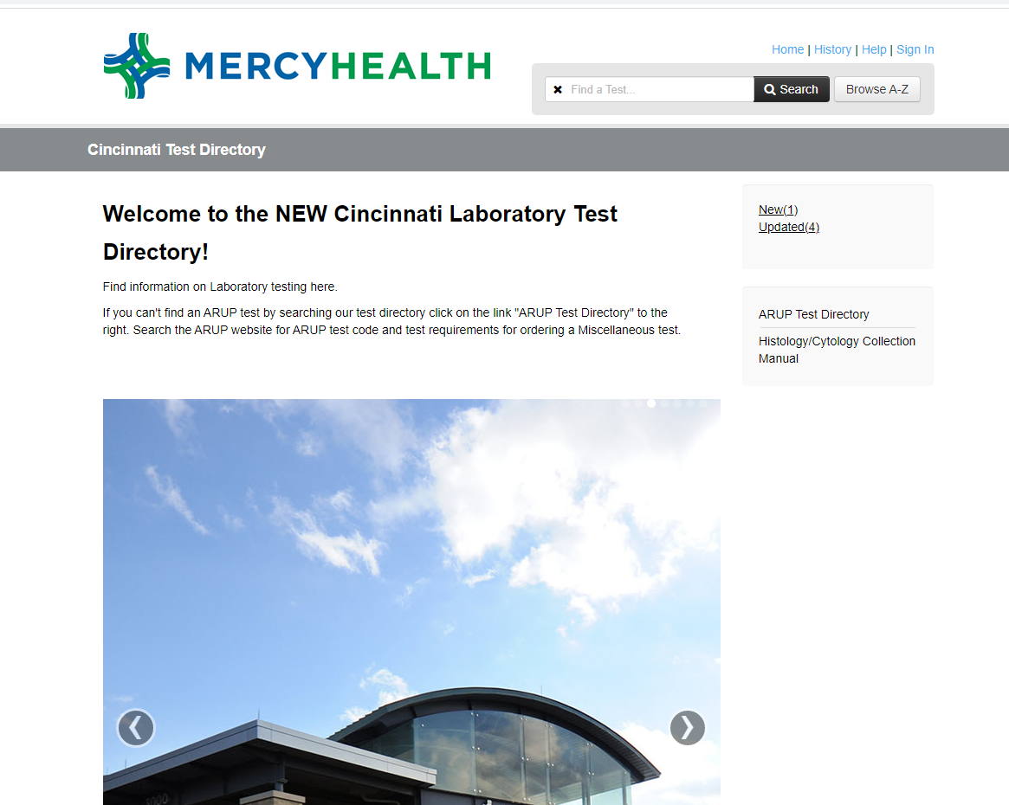

1. **Search for a test by typing some or all of the test name into the search box. Typing less is usually better. Important: after typing in all or part of the name, click on Search or press Enter.**

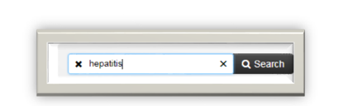

1. **If multiple tests appear, choose the one that matches the physician’s order.**
2. **The codes indicated by blue arrows are the Epic Test Code (on the left) and the Soft Test Code (on the right).**

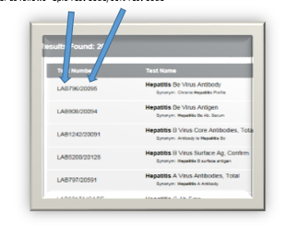

**10) *Soft Test Codes for tests performed at* *ARUP are made up of mostly numbers*. Exception: Some Soft Test Codes for ARUP tests contain a single letter followed by numbers. For example: A0075, which is Amphetamines, URN, Quant. A0075 is performed at ARUP.**

***Soft Test Codes for tests performed at Mercy Labs in Cincinnati (aka inhouse tests) are made up of mostly numbers*. Exceptions: 1) some inhouse tests begin with the single number 7 followed by letter, for example 7CGE is Crypto/Giardia/E. histolytica O and P screen. 2) inhouse 24 hour urine tests have the number 24 in them, for example UNA24. 3) several inhouse Thyroid Tests contain a single number, for example T3 and T4.)**

1. **This screen shows a search for the letters “glu”**

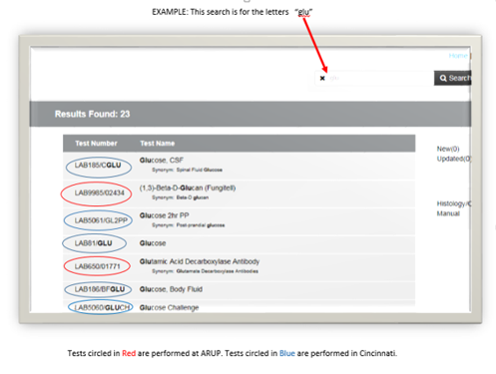

1. **If the test you are searching for does not appear, the test should be ordered in Soft using either the Soft Test Codes MISS1, 2, or 3**

**OR one the Soft Test Codes known as Whopper Codes (97163, 98559, 98556, or 98568)**

**To decide whether to use one of the MISS codes or the Whopper Codes when ordering in Soft:**

**Go to the ARUP Test Directory.**

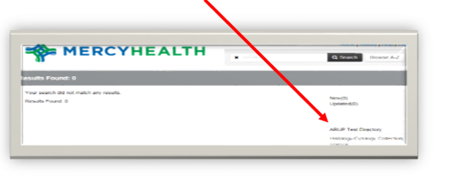

**If the test name** **in the ARUP Catalog contains any of these words:**

**Reflex, Allergen, Cascading, or Culture - order MISS 1,2, or 3 in Soft.**

**If the test name in the ARUP Catalog doesn’t contain any of these words:**

**Reflex, Allergen, Cascading, or Culture - order one of the Whopper Codes in Soft.**

1. **If you want to view a test that you have recently searched for, Click on History.**

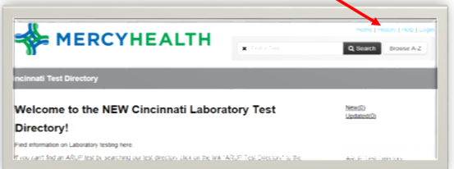

1. **A list of tests you have recently searched for appears. Using the History button can save you a few clicks when searching.**

