To understand why this is a useful tool for ALL staff, you first must have a general understanding of the workflow from point of pickup at the client office until drop off in the lab and into the Order Entry processes in the lab.

Specimens are picked up by Courier at the client site. Using a handheld device, much like a large cell phone, couriers scan the barcode on the requisitions or lab slips submitted if a bar code is present. Once they scan this into the handheld, the courier is prompted to enter the numbers and types of specimens recorded as “picked up” at the client location, ie, 2 SST, 1 BLUE etc.

This information then gets recorded into the handheld and SoftExpress and is searchable at any time after the courier is finished at the client site.

Now the courier returns to the lab and performs a scan of “dropped” specimens at the lab. Again, the courier will scan the barcode of the requisition and be prompted to confirm that what was picked up for that requisition number at that client is indeed what was transported back to the lab. This is called “ Chain of Custody” for the specimens.

Then the specimens are bucketed up by Processing and our processes take over from there placing Har’s, Orders etc.

What should be noted is if at any time a Processor is working with that requisition and specimens and they are short a tube, have too many specimens, is looking for a specimen etc, as long as they have a requisition number they can use the steps listed below to verify what indeed was picked up at the client site and what was dropped in the lab for that requisition number.

Prior to any canceling of tests, or write ups for RSM Req specimen mismatch, ALL processors should check this report to verify what specimens were transported by the couriers to the lab.

If Processors are still unsure of how to run this report, the screen shots below will show the user step by step how to do this and this online tutorial will always be present for the user to refer back to in the event that department leadership is unavailable to assist the staff member.

This quick guide will walk the user through the report in SoftExpress that can be helpful when the specimens “dropped” in the lab are in question.

It must be noted that the user must have a ***requisition number***, ie barcode number, associated c/p number to be able to pull this report and its documentation in SoftExpress.

Steps to Access this information in SoftExpress are:

* + 1. Log into SoftExpress from the desktop and click on the “Reports” tab

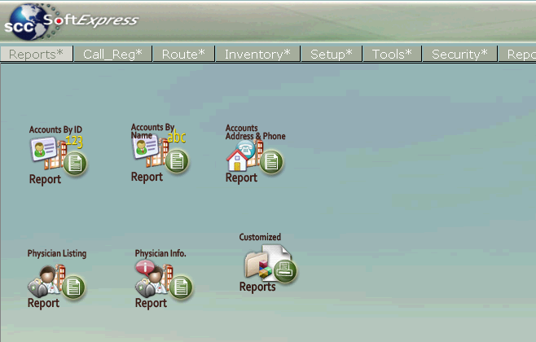

* + 1. Click on the icon “Customized” reports
    2. Click on the “Tubes for Requisitions” report

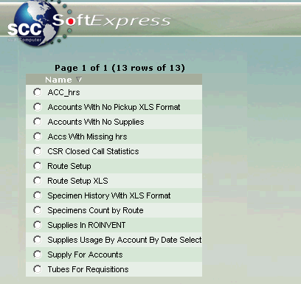

* + 1. Click on “View”

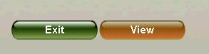

* + 1. Scan or key in the requisition number.

**\*\* Remember, if you do not have the requisition in front of you or it has not yet been imaged, you can open Order Entry in SoftLab and information in the Aux Post field can be copied and pasted into the requisition number field in SoftExpress. ( From OE procedures, the aux field is the scan of the req barcode)**

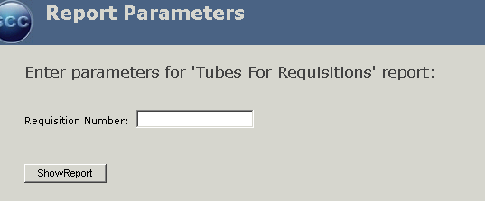

You will place your cursor in here and either scan or key in your barcode ID. Scanning is preferred.

* + 1. Press “Show Report”
    2. A report will appear to the user to view that indicates the chain of custody from the point of pickup to the point of drop in the lab for the requisition number you queried. It also lists the numbers and types of specimens that were transported and the time and courier that transported the specimens.

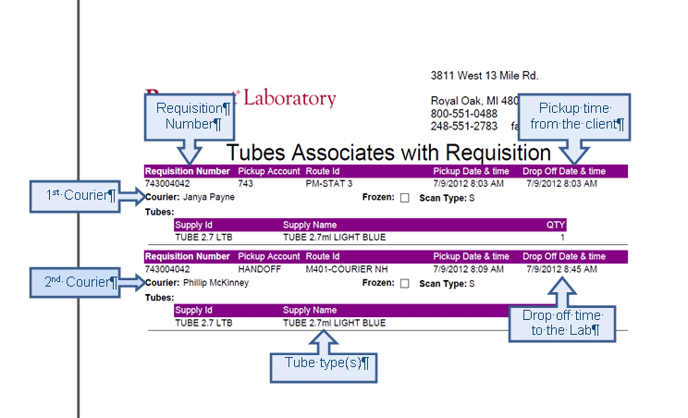

* If there are any questions as to the type of specimens that should have been received in the lab, this report will clarify this information.
* **Outreach Processors should NOT cancel or write up problems UNTIL they check this report to verify that specimens did or did not make it to the lab.**

**THIS ENDS THE INSTRUCTIONAL PART OF THIS INSERVICE. YOU WILL NOW BE ASKED A FEW QUESTIONS TO TEST YOUR COMPETENCY ON THIS SUBJECT.**