

**LABORATORY ABN INSERVICE**

**FEBRUARY 2013**

**NON FACE TO FACE LAB ORDERS**

**An ABN (Advanced Beneficiary Notice) is a standardized notice that a health care provider/supplier or his/her designee must give to a Medicare beneficiary, before providing certain Medicare Part B or Part A items or services. The ABN must be issued when the health care provider believes that Medicare may not pay for an item or service that Medicare usually covers because it is not considered medically reasonable or necessary for the patient in that particular instance.**

**In a non face to face test ordering process , as in the BRL or AP lab locations, we do perform a Medical Necessity check for every lab order generated from SoftLab. This is done at the end of the order , after asking the system to save the order by pressing F7 when the diagnosis window appears prior to printing labels for the order.**



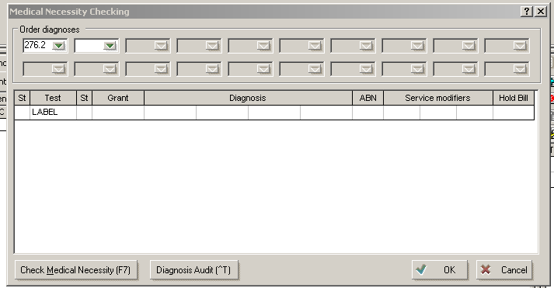

**The window above is what the medical necessity window looks like when we are saving the Lab order. This window appears for every lab order created and all staff members are to press F7 or the Check Medical Necessity box for every order placed.**

**By pressing F7, you are asking the system to compare the patients insurance, the diagnosis codes given for the tests indicated and the tests to determine if the diagnosis codes provided are medically necessary to cover the testing indicated.**

**ABN prompts for the user will ONLY occur when the patient has a Medicare insurance product.**

**When prompted with an ABN prompt, the user will see a window like this one below:**



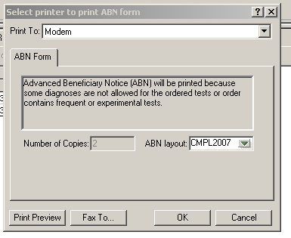

Failing to note this window, will send a message to the SoftAR (billing) module that you DID print an ABN for this patient when we would not ever do this in a non face to face setting.

Because we do not see the patient in a face to face setting, we cannot request the ABN to print or have the patient sign. When this window appears, the users MUST click on cancel.

After clicking on “Cancel” in the ABN print window above, the user is asked if they want to save the changes that they made to the lab order.

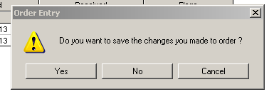



The user should select “No”. This will keep them within the Lab order that now needs to be modified because of the ABN print prompt window noted above.

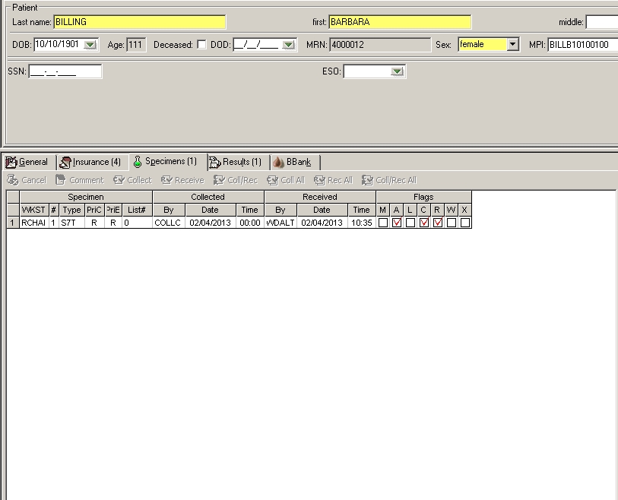

SoftLab keeps the user in this window after they answer “No” to saving the changes to the order. Then the user need only press “CNTRL-D” and the diagnosis windown reappears. We will be making changes in this window to properly address the ABN flag.



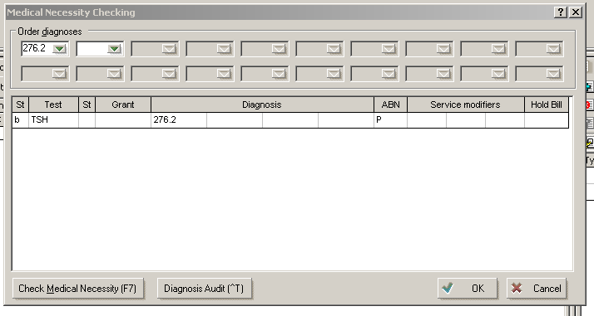

Note the “P” in the ABN column. This P, is a flag that if NOT changed, will send a notation to SoftAR that YOU printed the ABN, when you wont be for the non face to face orders

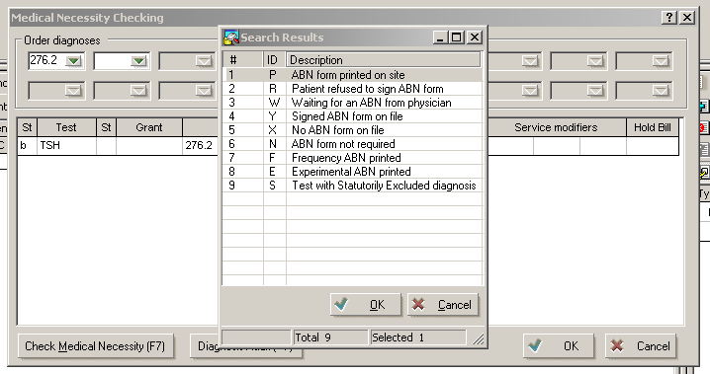

Here are what the flag abbreviations mean for the ABN flags. See how P means ABN printed on site???



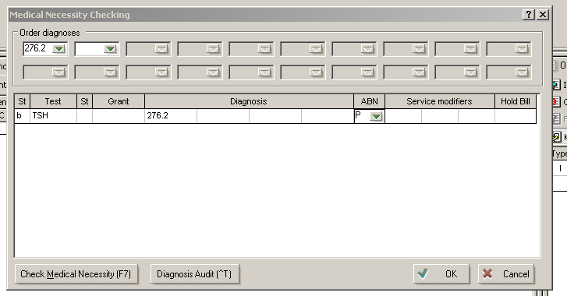

Users will now click in the box containing the “P” and backspace to erase it from the field.

Users will then click on the drop down options in the ABN field and select “X”

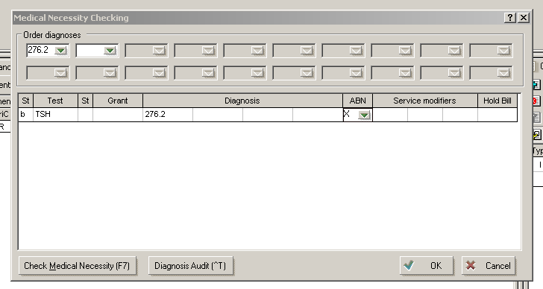

Once the “X” has been entered into the ABN field, it will look like this.

Now the users can press “OK” and proceed to get their labels for their orders placed in SoftLab.



It is important to note, in some departments where Order Entry is done, you may have more than one test ABN field to change. Meaning, if you order 15 tests on an order , and you receive the ABN print prompt you need to look at each line of the order as more than one test may trigger a “P” in the ABN field.

The ABN prompt will continue to appear as long as there is a field with a “P” in it. You will have to view each test line of the medical necessity box to ensure that you have changed all that need to have “X’s” in them before the system will let you proceed and NOT flag you for the ABN print prompt.

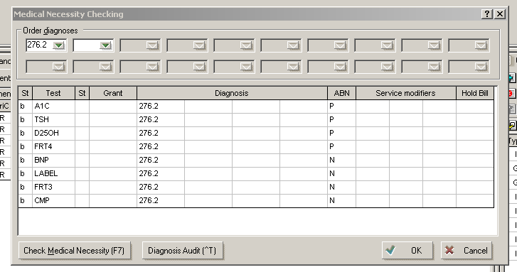

Note all the “P’s” here. Each line has to be addressed and changed or you will continue to receive the ABN print prompt



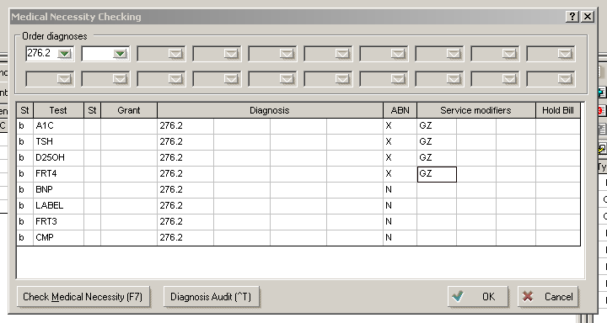

When all the P’s are changed to “X’s” the window now looks like this. The system drops in the appropriate service modifiers, GZ in this case, for the tests.

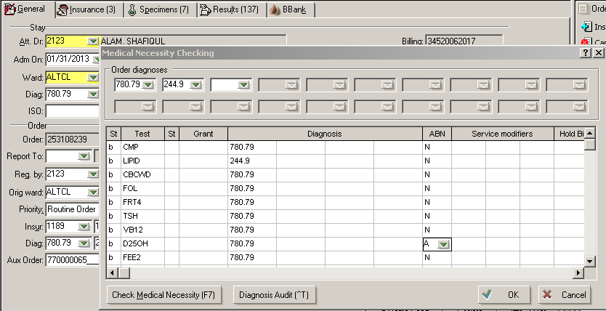

This “A” flag must also be changed to an “X” in order to properly document that we will NOT be printing the ABN in the non face to face setting. j

There may be another ABN flag that will also prompt the users to print the ABN. The “A” flag noted here acts the same way as the “P”