- Purpose
The purpose of this procedure is to define a clear process which coagulation staff can use to result routine coagulation tests in the LIS.

- Procedure
  - Log on to SOFT Live and select the instrument menu icon.

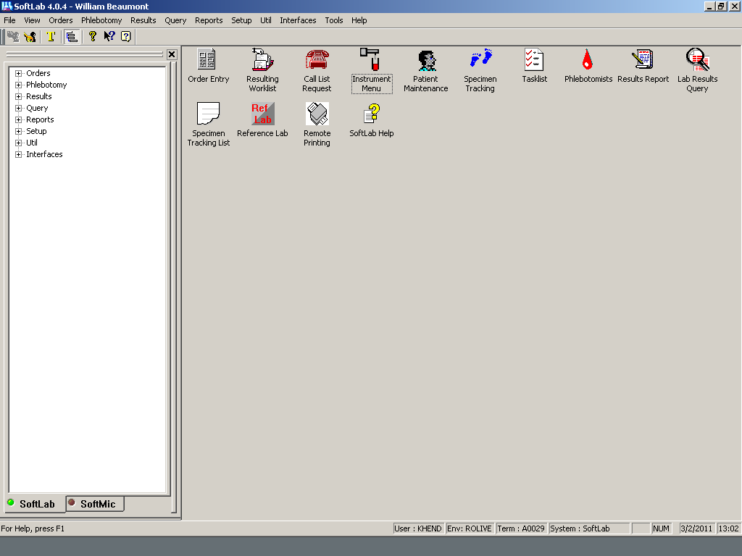

- Select the instruments bay by clicking on RO ACL TOP instrument bay. This will open up results for the current day. The right hand side of the screen list the date of results. If another day is needed, click once on the instrument bay and click on the date needed.

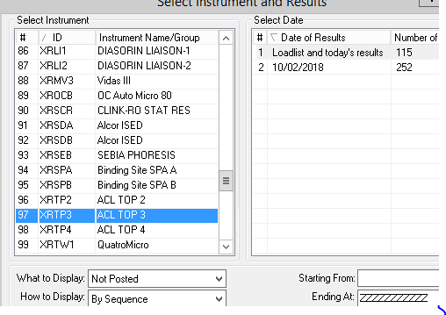

- Click on Filter tab on the bottom left hand side of the screen. Filter can be set to view “Not Posted” or “ALL”. The not posted filter will show results that have not posted. The ALL filter will show all the results.

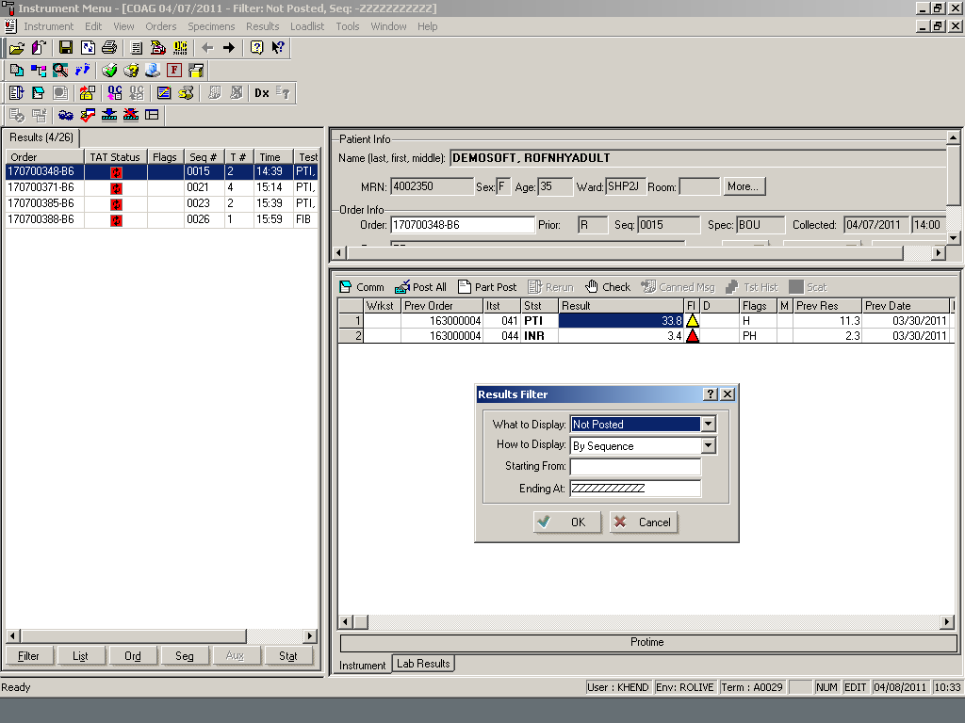

- See table below for Instrument Menu results tab fields descriptions. Refer to the picture for reference left hand side of the screen.

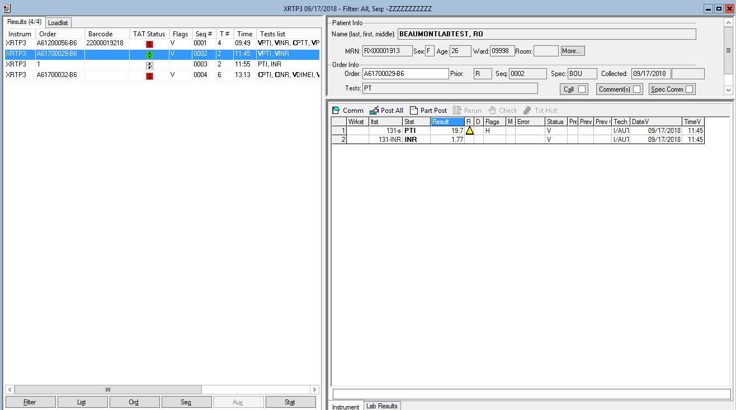

Instrument Menu Results Tab Fields Descriptions
Order | The column displays the order number or Quality control identifier.
TAT Status | This column displays the turnaround for testing. Specimen receiving to resulting.
Flags | This column displays the current status/flags that are set for a particular order (for example, “Q” = Quality Control Record or “S” signifying a Stat order).
Seq # | This column displays the sequence numbers.
T # | The T # column displays the total number of tests.
Time | This column displays the time the order was run on a particular analyzer.
Test list | The column displays the tests.

- A stat order number is in red and the flag has been marked “Verified Stat”.

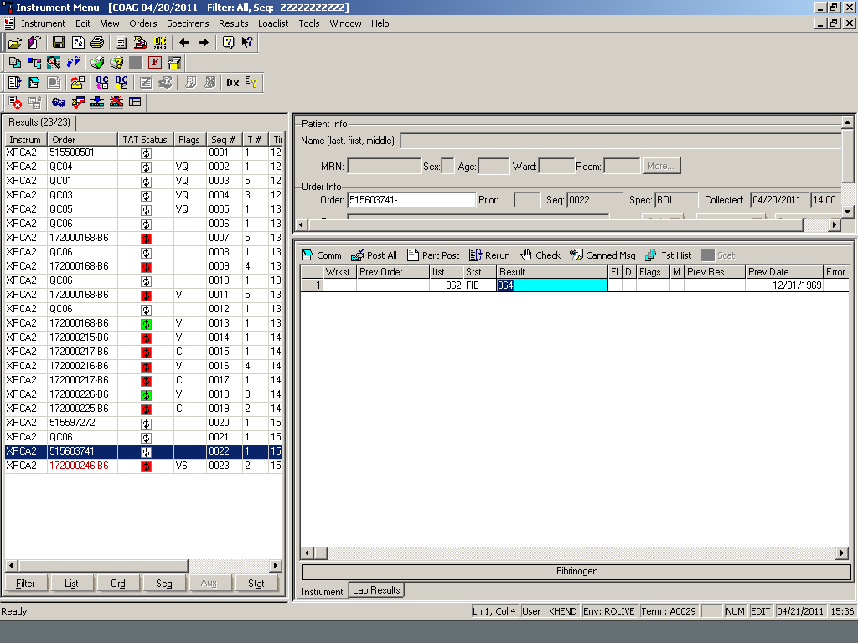

- See table below for Instrument Menu Window Lab Results Tab Field Descriptions under the Instrument Tab. Refer to the picture for reference right hand side of the screen.

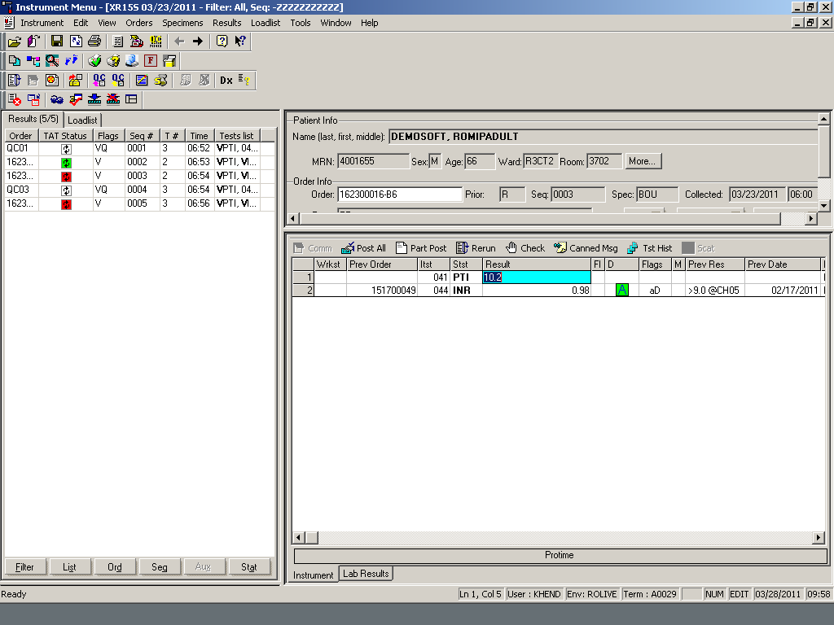
Instrument Menu Window Lab Results Tab Field Descriptions
Wrkst | Workstation
Prev Order | Previous order number
Itst | Instrument test number
Stst | Test code
Result | Test result
Fl | Displays symbolic representation of the flag associated with the result.
D | Delta checking indicator.
Flags | This column displays the specific flag associated with the test result.  PL — panic low  PH — panic high
M | A check mark in this column indicates that there is a comment attached to the test.
Prev Result | This column displays the previous result value for the test. The system will look back through the current stay for a previous value of that test and display it in this column.

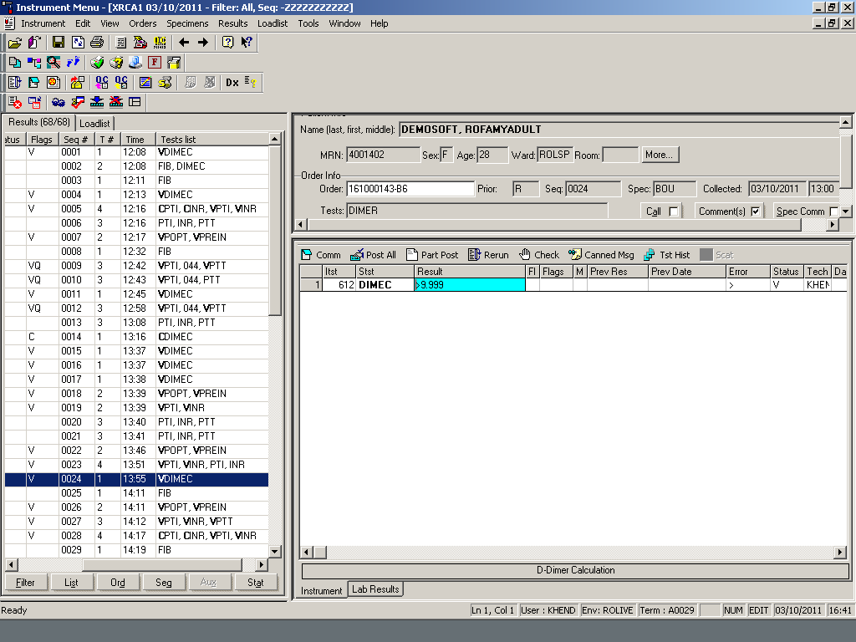

Instrument Menu Window Lab Results Tab Field Descriptions cont.
Prev Date | Displays the date of the previous result value.
Error | Error codes  > above linearity  < below linearity  CR: Data error  CW: Coagulation warning
Status | L Labeled, indicates the specimen has been labeled.  C: Collected, indicates the specimen has been collected (if both the L and C flags are present the specimen has been received).  D: Downloaded, indicates the ordered test has been downloaded to an instrument.  P: Posted, indicates the result has been posted from an instrument  V: Verified, indicates the result has been verified.  E: Edited, indicates the current result displayed has been edited  !: Called, indicates the result has been called and no longer qualifies to the call list.
Tech | The ID of the resulting tech will default into this column upon result entry. This column cannot be edited.
Date V | Date verified
Time V | Time verified

- See table below for Lab Results Menu Window Lab Results Tab Field Descriptions under the Instrument Tab right hand side of the screen. Refer to the picture for reference.

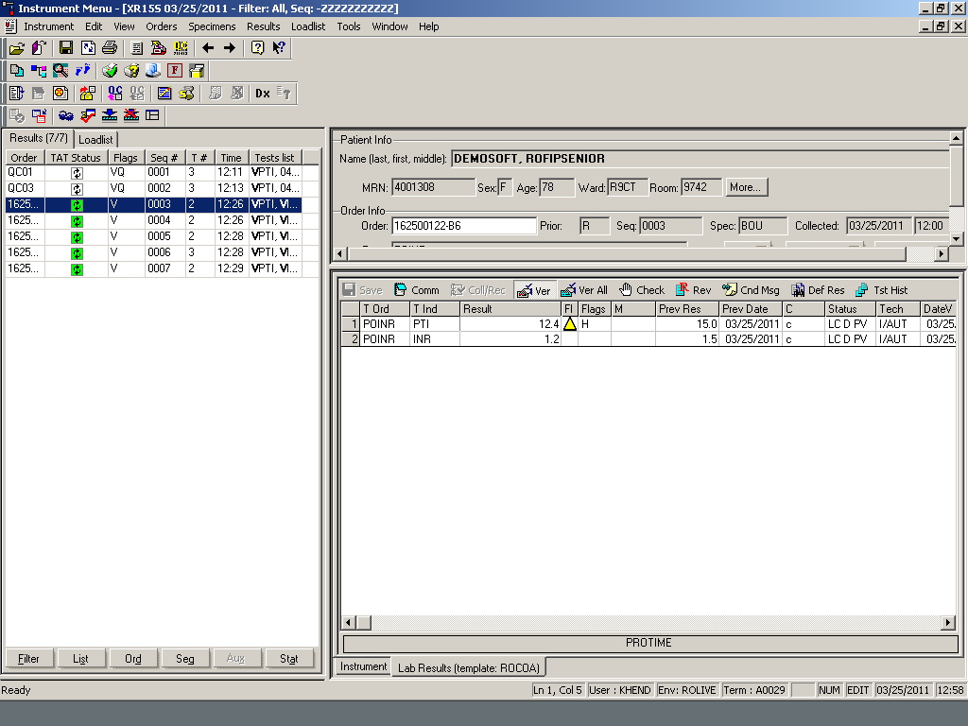

Lab Results Menu Window Lab Results Tab Field Descriptions
T Ord | Test ordered
T ind | This column displays the ID for the individual test. If there is a group test in the T Ord cell, the individual test(s) will be listed in this cell. The system will default information into this cell.
Result | Test result
Fl | Displays symbolic representation of the flag associated with the result.
Flags | The Flags field displays a written description of the flag associated with result. The flags are as follows:  L low normal  H high normal  AB abnormal  ABL abnormal low  AGH abnormal high  P panic  PL panic low  PH panic high  %D% delta failed  aD absolute delta failed  No flag indicates that the test result was normal.
M | A check mark in this column indicates that there is a comment attached to the test. The system will default information in this column.
Prev Result | This column displays the previous result value for the test. The system will look back through the current stay for a previous value of that test and display it in this column.
Prev Date | Displays the date of the previous result value.
C | This field indicates that the result is based on a calculation.
Status | L Labeled, indicates the specimen has been labeled.  C: Collected, indicates the specimen has been collected (if both the L and C flags are present the specimen has been received).  D: Downloaded, indicates the ordered test has been downloaded to an instrument.  P: Posted, indicates the result has been posted from an instrument  V: Verified, indicates the result has been verified.  R: Reported, indicates the result has qualified to a single sheet report and the report has been printed. The result has been flagged as reported in the report option.  E: Edited, indicates the current result displayed has been edited  ! Called, indicates the result has been called and no longer qualifies to the call list.  +: Indicates review is required
Tech | The ID of the resulting tech will default into this column upon result entry. This column cannot be edited. The I/AUT indicates the result was autoverified.
Date V | Date verified
Time V | Time verified

- Select an order to result by highlighting the order number. On the right hand side with the patient info are the results from the instrument. Clicking on a test will highlight the test and display the test name at the bottom. Once you have checked the specimen and decide to accept the results, select “Post All”. This will send the results from the Instrument tab to the Lab Results tab.

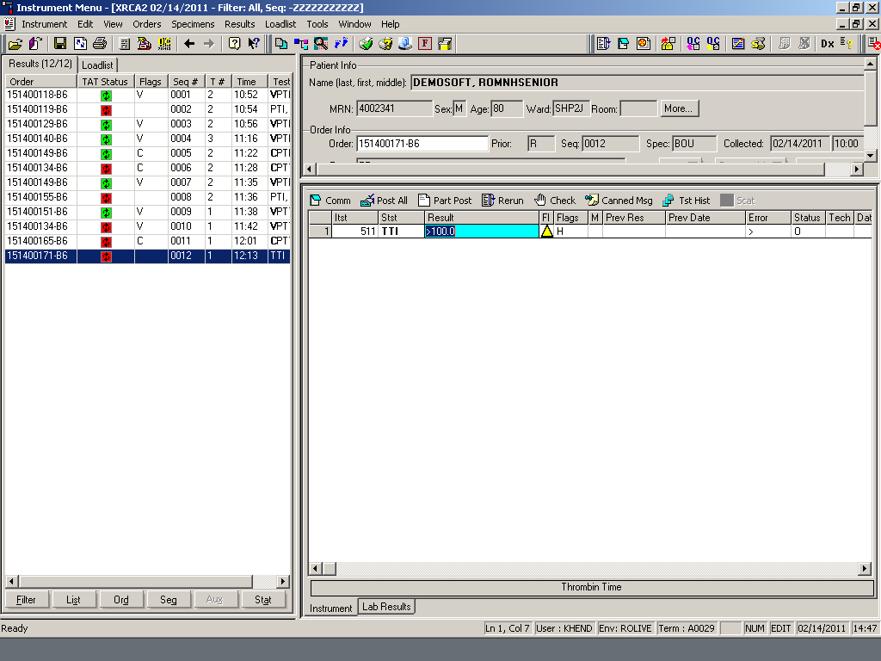

- The test has posted and verified. Notice the “V” located under the Status bar, flag bar and next to the test. Your name will also be listed under the Tech bar.

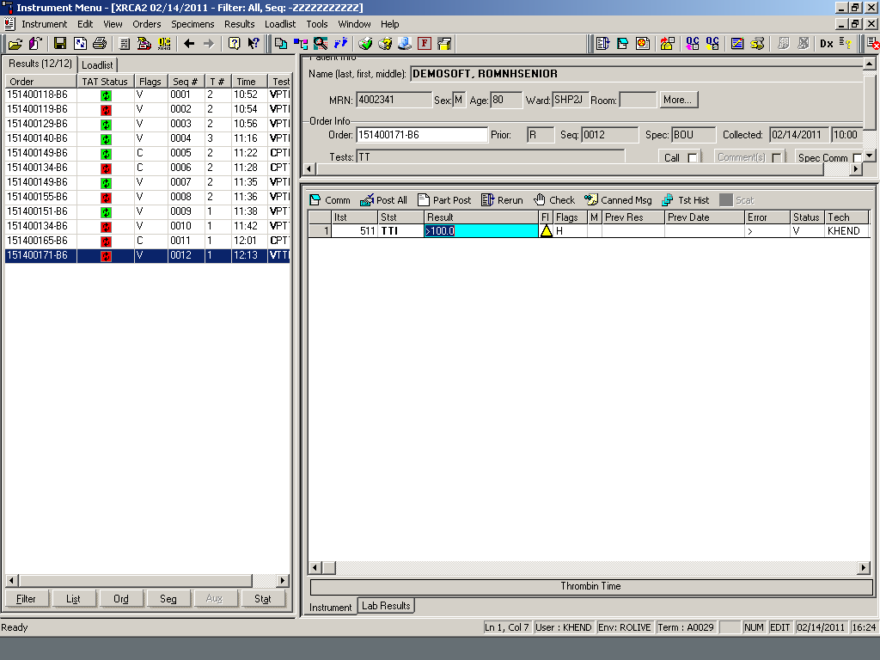
- This is an example of a Prothrombin Time (PT) and an Activated Partial Thromplastin Time (APTT) that autoverified (posted and verified). Notice the “V” (verified) under the Status bar, flag bar and next to the test (VPT). Under the Tech column is I/AUT which means the tests were autoverified.

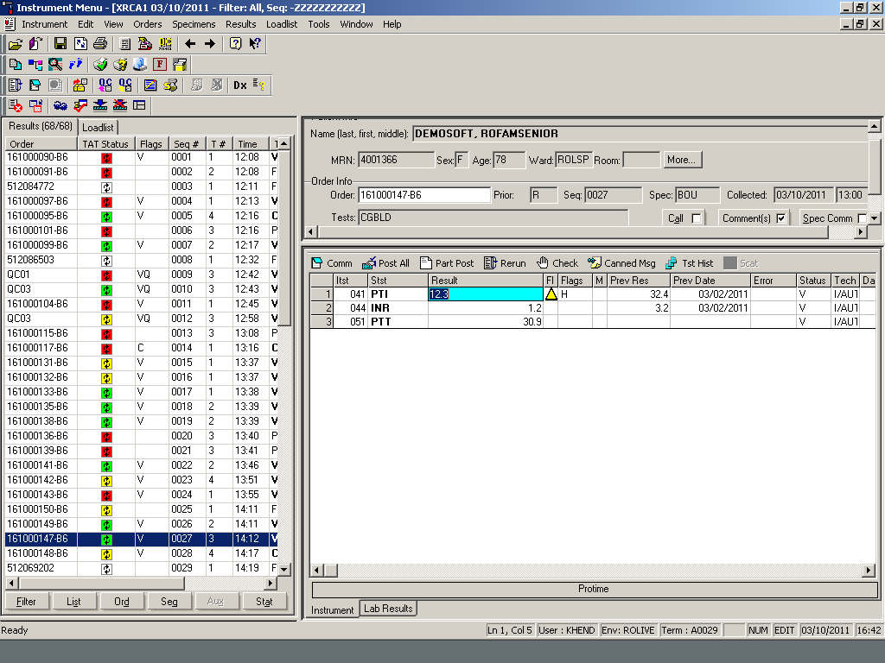

- This is an example of a PT and PTT which did not autoverify due to an INR Delta Check. Notice the aD next to the INR under the Flags column. Also, see the previous results column and previous date.

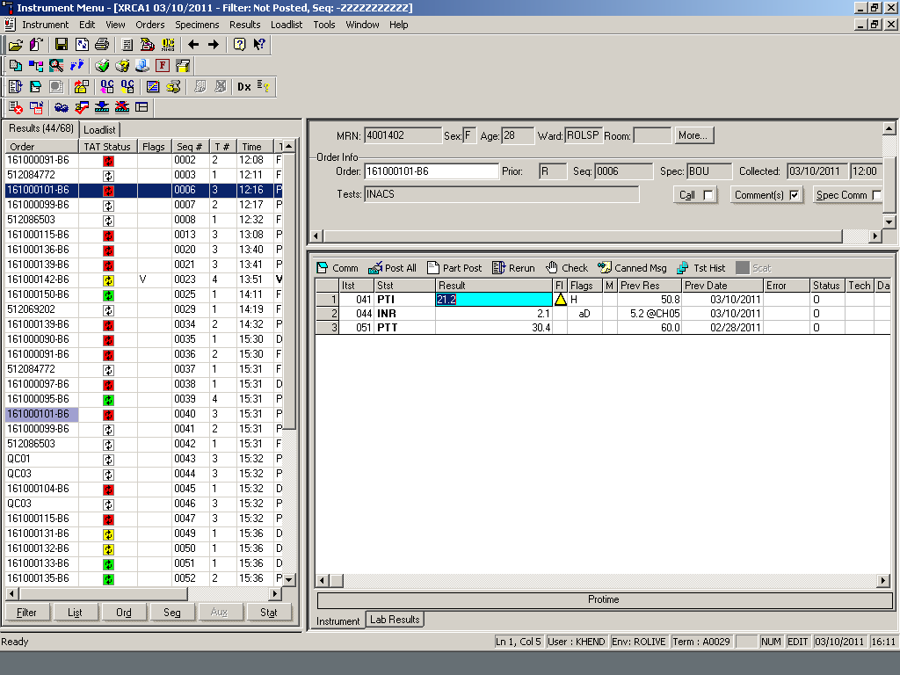

- This is an example of a PT that has been reflexed to the extended mode on the instrument.
  - First the tech must decide which result to accept the original mode or the extended mode. If you post all at this point the first result will post and verify.
  - If you want to post and verify the extended mode test, the original mode test must first be cancelled. Highlight the first test to be cancelled then right click and pick cancel or highlight test and press F4. If you accidently pick the wrong test to cancel, highlight test again and pick cancel.

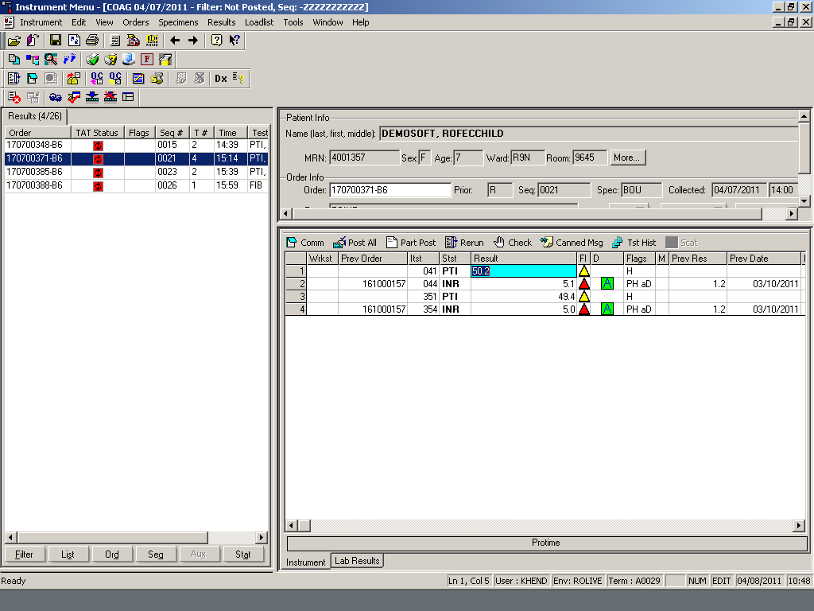

  - This is an example of the right click cancel.

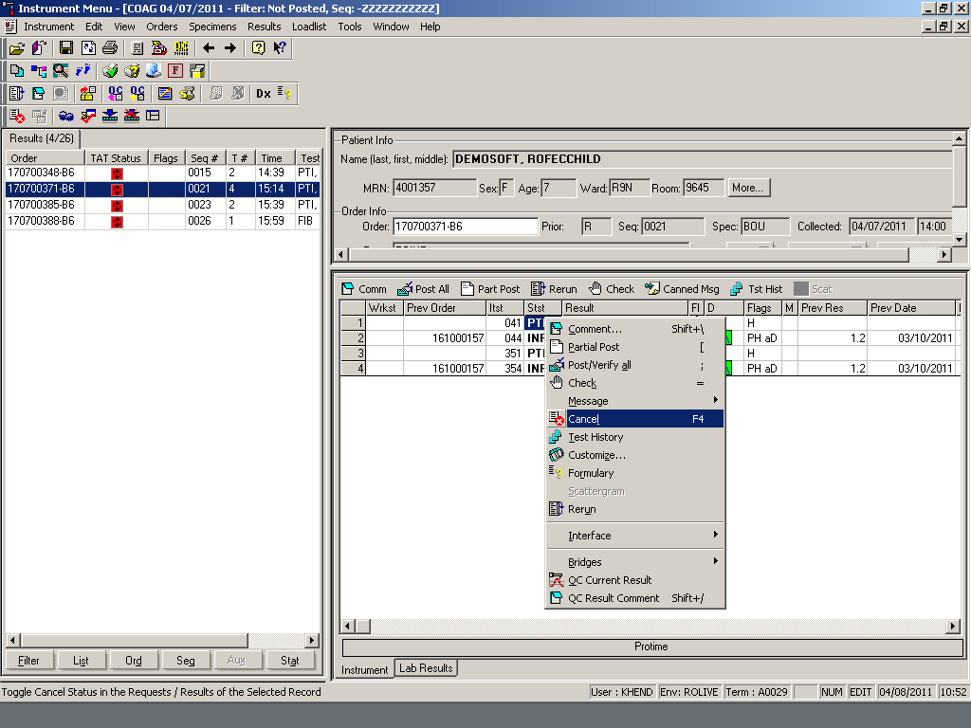

  - A “C” will appear in the Status column.

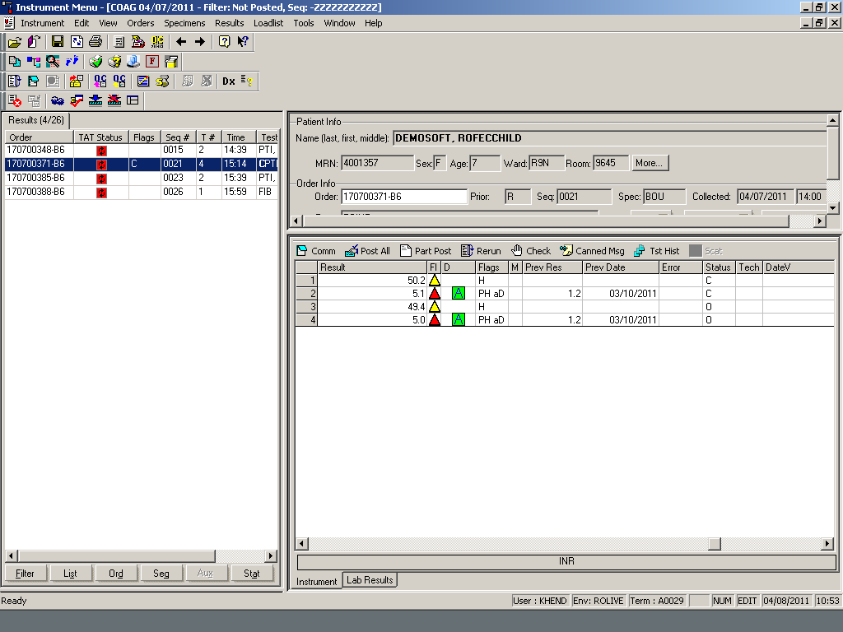

- Select post all. The result that has not been cancelled will post and verify. See example below.

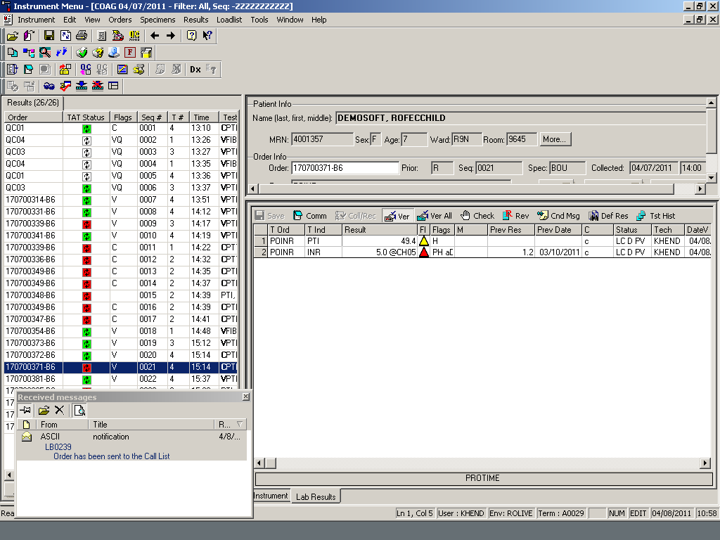

- This is an example of an analysis error. The error automatically cancelled the test. See the status line.
1) To rerun the specimen check for a clot and re-spin the sample.
2) Place specimen uncapped in a yellow rack on instrument for a rerun. The technologist can schedule the test from offline rack if there was multiple tests ordered and only one of them needs a repeat by unselecting these tests
3) If the second run fail, rerun sample on the alternate method.

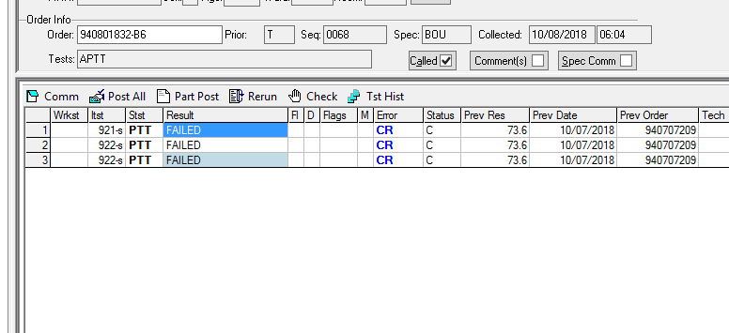

- This is an example of a critical INR. Once the result is posted and verified, the order will be sent to the call list.

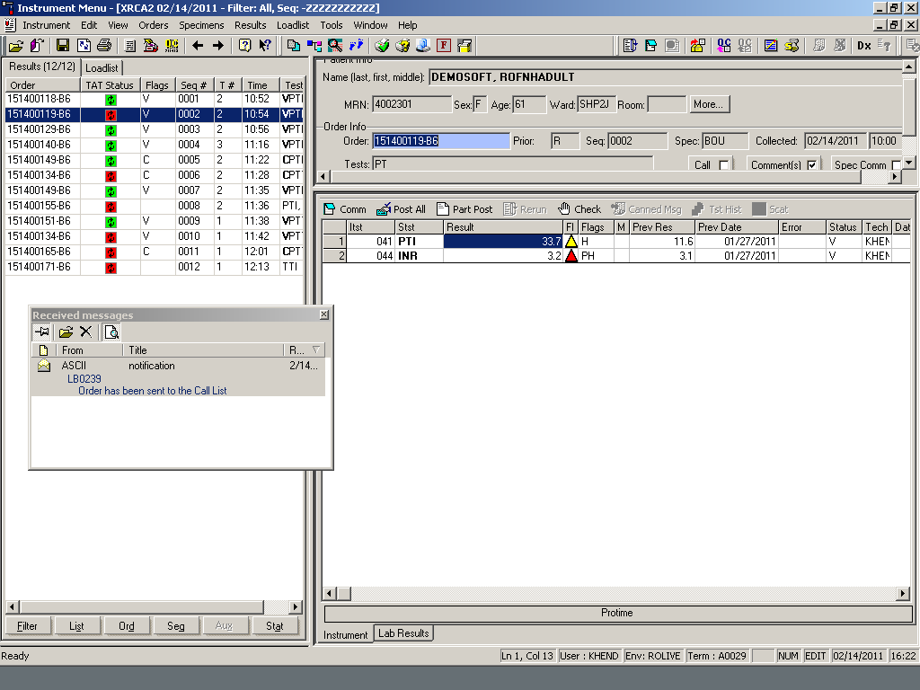

- This is an example of an inhibitor anticoagulant screen that needs to be worked up. The mixing results will be entered under the resulting worklist. See Coagulation Manual tests procedure.
- For outpatient and outreach patients, add on Thrombin time test to the existing order under order entry. Put specimen back on the instrument to run the thrombin time test.
- For inpatients, order a thrombin time test in EPIC.

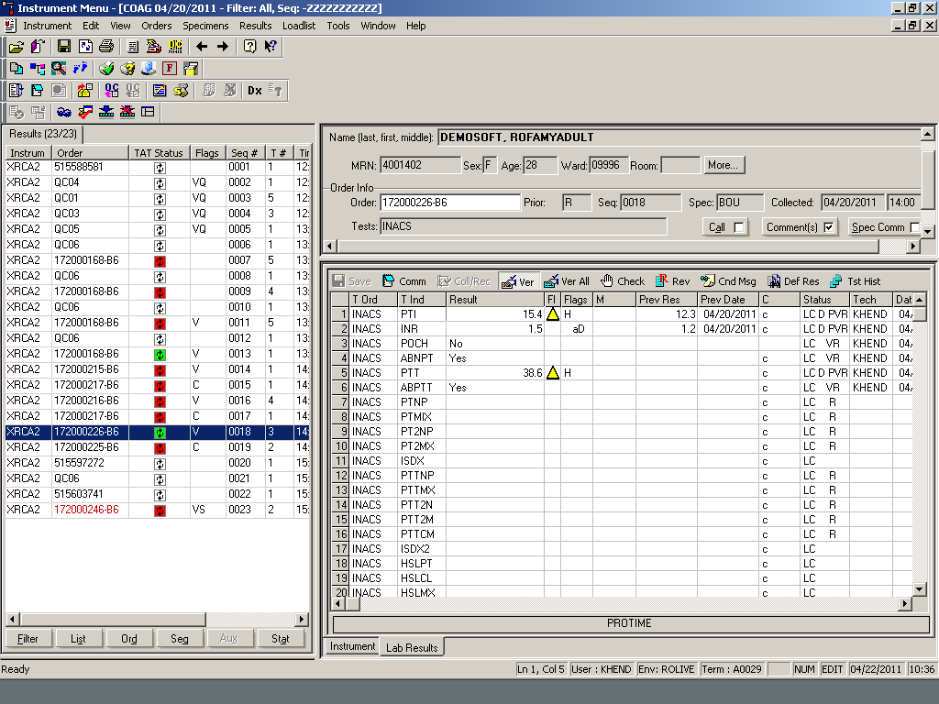

- This is an example of a coagulation consult.

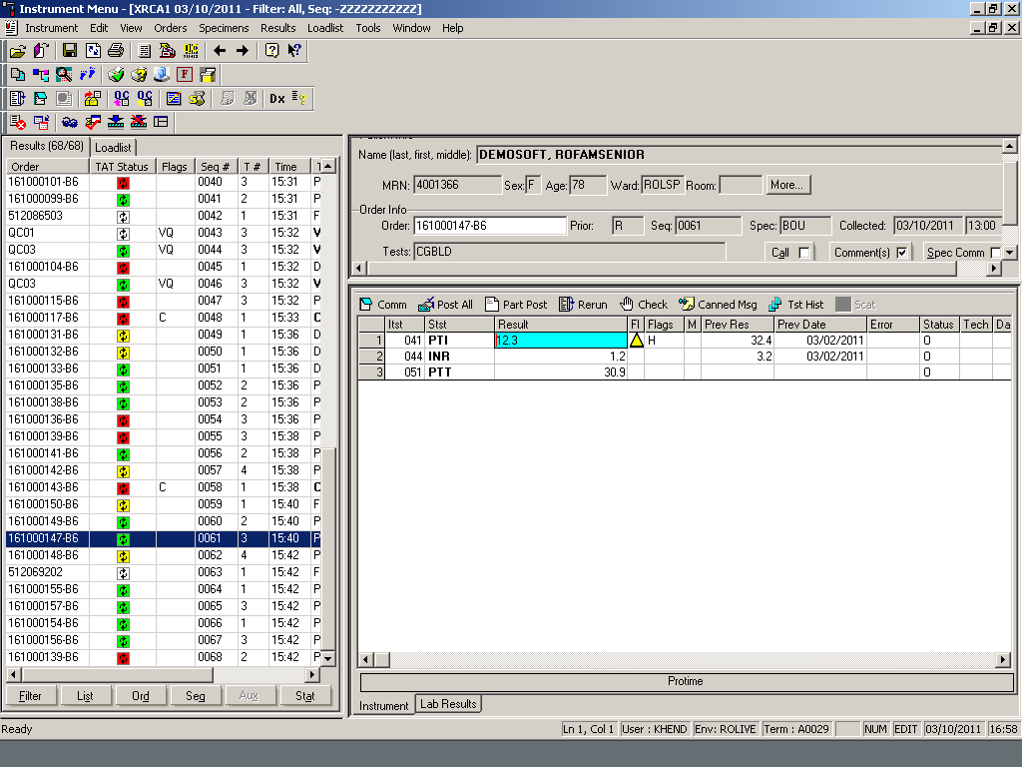

- The PT and APTT within the coagulation consult autoverified.

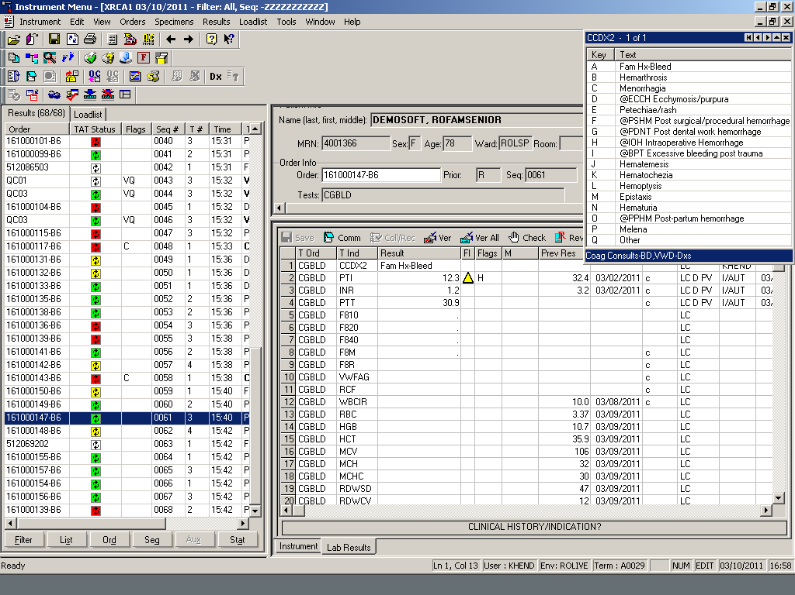

- This is an example of a sample has fibrinogen results less than 150. ACL TOP will rerun all samples with fibrinogen results <150 to be read under a low fibrinogen curve. The technologist has to check the sample for a clot and accept the second run if there is no error associated with that run.

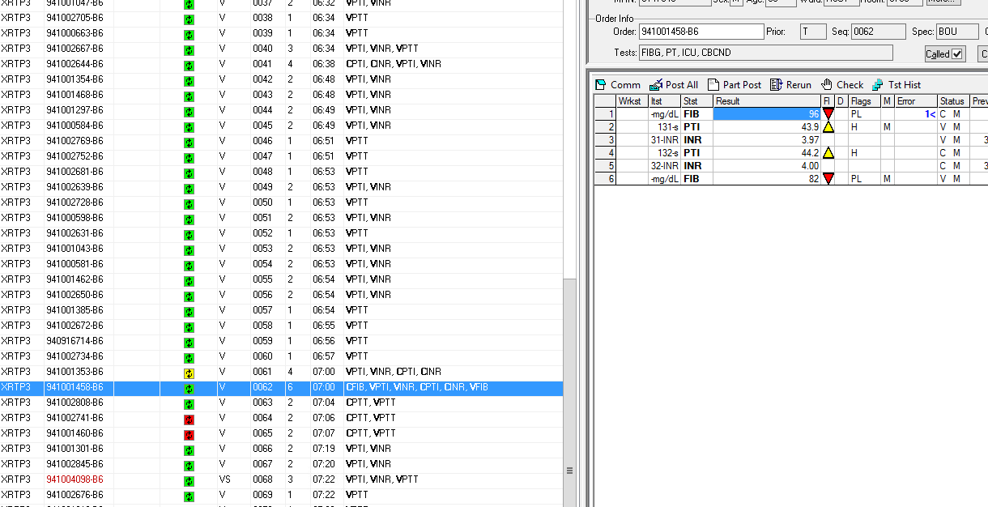

- If a test needs to be corrected after it has been posted and verified follow these steps.
1. Click on the result field under the Lab Result Tab.

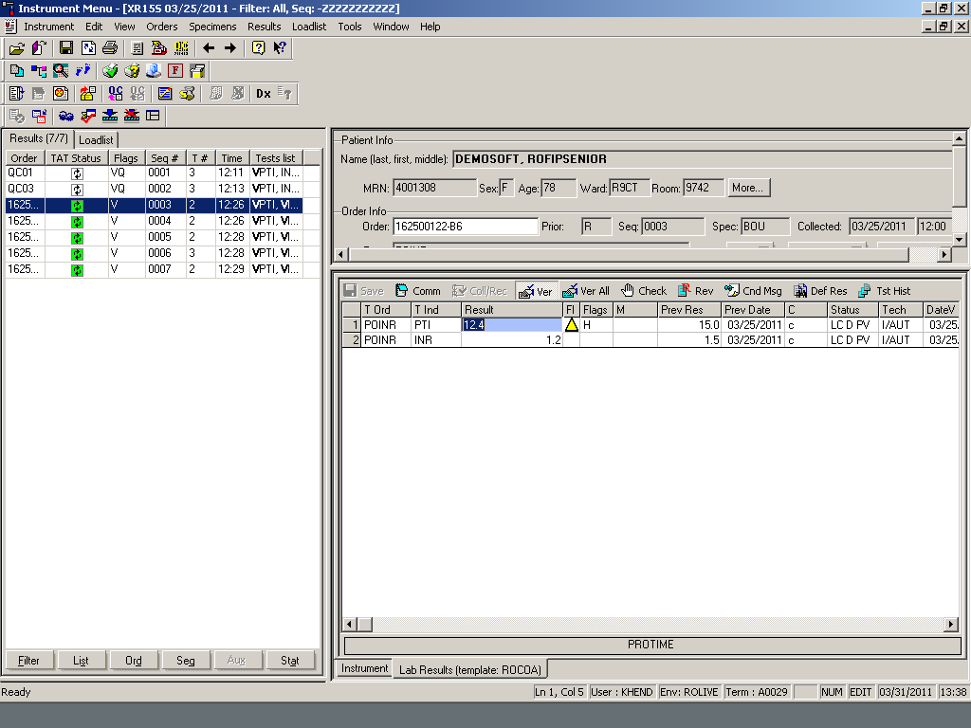

  - Type the correct result and click on Verify or Verify All. A box will appear so that the reason for the change can be documented.
  - Type the reason for the correction.

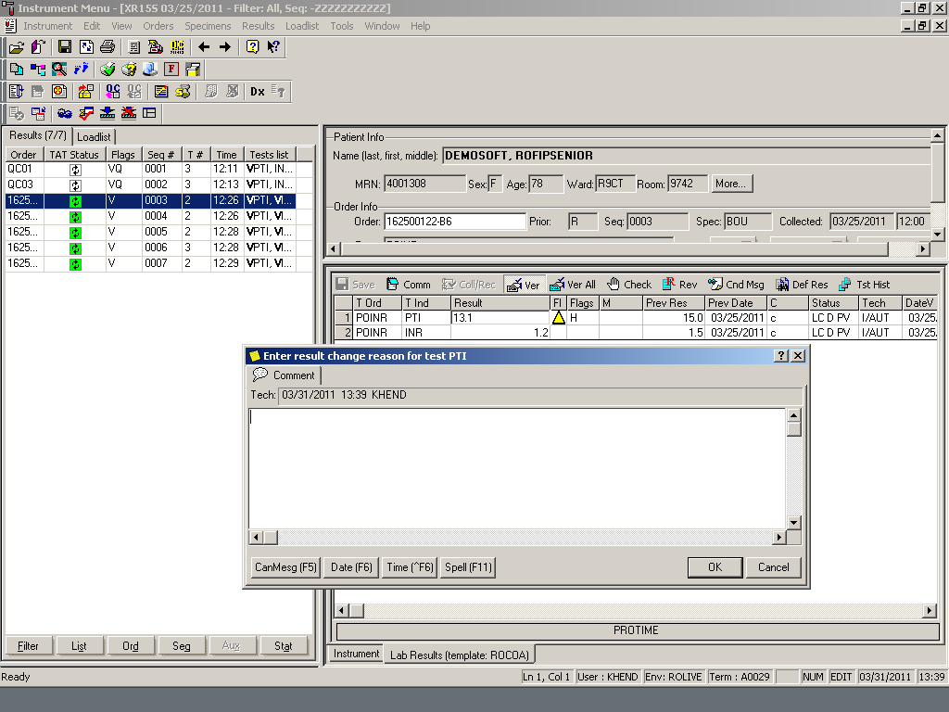

- This is an example of the instant report. It shows that the result has been corrected.

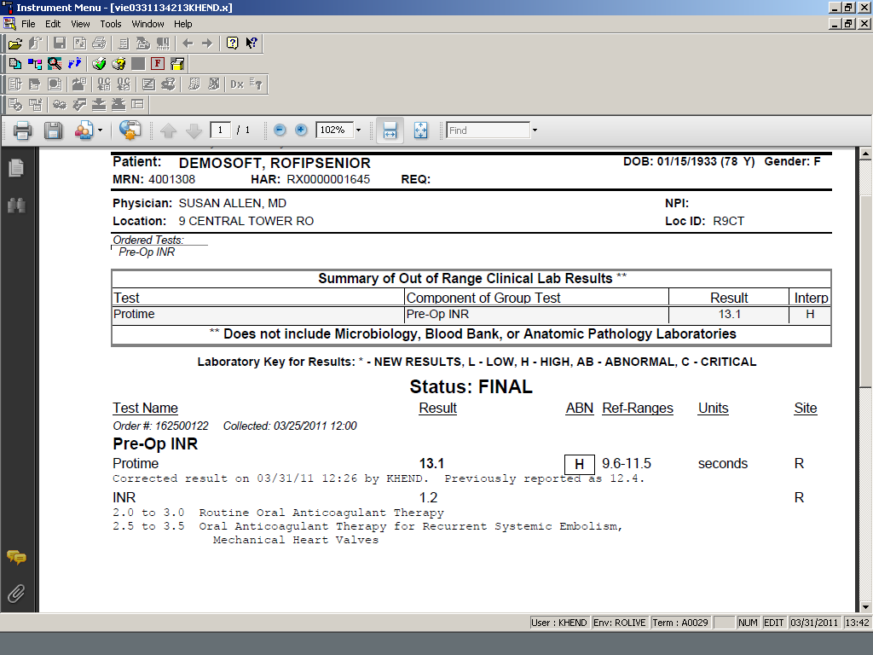

- Releasing special coagulation tests results from the IL ACL TOP® Family to the LIS.
  - From the IL ACL TOP instrument computer software select Loadlist. This brings up the test names and test results.
  - The IL ACL TOP® Family will Auto Reflex some tests requiring dilution. The reflex value is the Final result.
  - Check mark the order number from sample list to validate and up load the test(s) to the LIS.

- Normal and abnormal results will not auto result (post and verify) if no flags are present the test can be verified by selecting “Post All”. Repeat any low or questionable results and add the comment “result repeated”. the

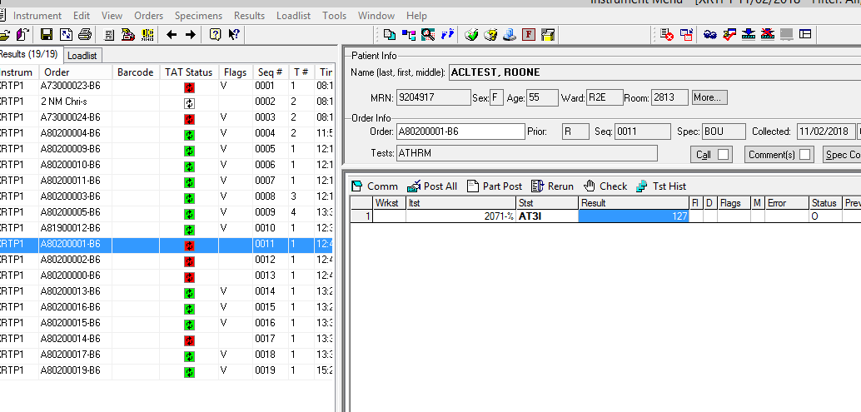

- This is an example of reporting factors:
  - For factors manually enter the appropriate result in the factor reportable field.
  - Run more dilution (example F8 MD), and result the dilution 6.25% dilution if a possible inhibitor is present.
  - Click on the comment button and add appropriate comment if a possible inhibitor is present.
  - Review results then Click “Verify All”. A box will appear that will ask if you want to save the results. Click Yes.
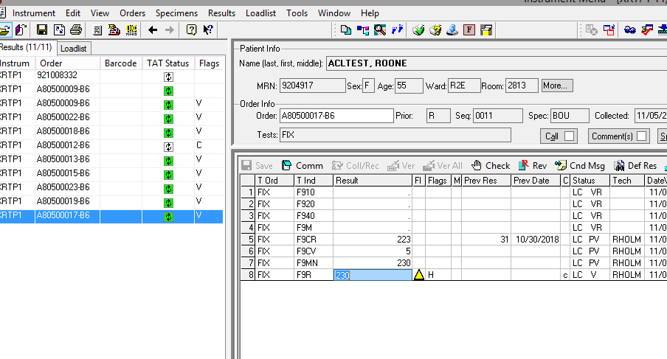

Authorized Reviewers

Chair, Pathology and Laboratory Medicine
Medical Director, Coagulation

Document Control
Location of Master: Coagulation Procedure Manual
Master electronic file stored on the Beaumont Laboratory server:
S:\HEMACOAG\Document Control\Coagulation\Procedure\Master Document\ IL ACL TOP Interface Procedure

Number of Controlled Copies posted for educational purposes: 0

Number of circulating Controlled Copies: 0

Location of circulating Controlled Copies: NA

Document History
Signature | Date | Revision # |  | Related Documents  Reviewed/  Updated
Prepared by: Tamara Sabih  MLS (ASCP) | 10/02/2018 | r00
Approved by: Marc Smith, MD
Reviewed by: (Signature) | Date | Revision # | Modification | Related Documents  Reviewed/  Updated
Marc Smith, MD | 01/29/2019 | r00 | New Procedure
Peter Millward, MD | 02/12/2019

