Purpose
To ensure the proper workflow is followed for processing specimens for routine coagulation testing and entering results in the LIS.

Performed By
Coagulation staff

Expected Performance
It is expected that this process will ensure uniform handling of routine coagulation specimens. It demonstrates how to enter results into the LIS for the following tests: D-dimer, Thrombin time, Protime, activated Partial Thromboplastin time and Fibrinogen, as well as improve turn-around times will be demonstrated by following this process.

Procedure
- Refer to attachments for IL ACL TOP workflows.
  - Attachment A
    - IL ACL TOP PT, PTT, Q.F.A, D-Dimer, and Thrombin Time
b. Attachment C
1) IL ACL TOP D-Dimer (lipemic Samples Only)
c. Attachment D
1) IL ACL TOP D-Dimer (High results)

- Refer to IL ACL TOP screens frequently to locate specimens which may have had barcode – read errors.
  - Locate specimens according to the sample rack position.
  - Correct barcode read errors in the IL ACL TOP screen or reprint label.

Note: It is not efficient nor is it recommended to review each specimen before considering a specimen complete and forwarding for archiving.

Procedure to follow when all IL ACL TOP analyzers are not operational due to instrument malfunction:

Notify client/ER of delay due to instrument problem. Inform ER that Dimer results will take longer because sample has to be sent to Troy lab for testing.

- Notify STAT lab that core lab will be sending STAT and timed PT/PTT/Dimer for testing. Inform processing team in core lab of instrument problem so they can immediately send the STAT and or timed PT/PTT samples to STAT lab upon receipt in core lab.
- Fibrinogen is performed in-house using the Start 4, samples for Thrombin time test can be stored in the -70ºC freezer for later testing.
- Notify TROY lab (x48040) that all STAT dimer tests from ER will be sent to the Troy lab for testing.
- Notify the courier of STAT transport of frozen plasma to TROY lab.
- Coag tech must hard spin specimen, transfer plasma (PPP) into plastic tube then put sample in the -70ºC freezer while waiting for transport.
- Redirect the sample to TROY (Procedure for redirection is posted behind the Special Coagulation instrument).
- Make sure frozen sample is placed on dry ice during transport.

Authorized Reviewers
Supervisor, Hematology Lab

Attachments
ATTACHMENT A – IL ACL TOP PT, PTT, Q.F.A, D-Dimer, and Thrombin Time Test Workflow

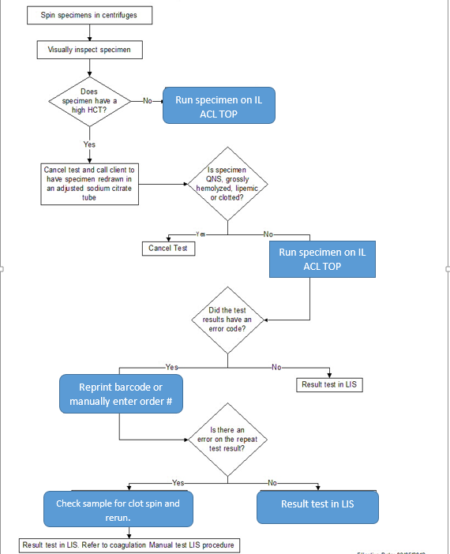

ATTACHMENT C – D-Dimer (Lipemic Specimen Only) Workflow

Specimen

Lipemic?
Yes
Cancel test
&
Request a redraw

Result test
in LIS
No
Did test have an error code?
No
Yes
Result test in LIS
Re-spin specimen @ 3400 rpm for 10 minutes
Re-run test
ATTACHMENT C – D-Dimer (High Results) Workflow

Specimen
With High D-Dimer
Yes
Result test
in LIS
No
Failed
>10000

The sample should be manually diluted 1:100 with Factor Diluent (20uL of sample + 1980 of FD)

Result test in LIS

Rerun the sample. The result must be X by 100 to correct for dilution

Did test have an error code?

Cancel test
&
Request a redraw

Document Control
Location of Master: Coagulation Workflow Manual
Master electronic file stored on the Beaumont Laboratory server:
S:\HEMACOAG\Document Control\Coagulation\Workflow\Master Documents\CA 7000 LIS Workflow.doc
Number of Controlled Copies posted for educational purposes: 1
Number of circulating Controlled Copies: 0
Location of circulating Controlled Copies: NA

Document History
Signature | Date | Revision # |  | Related Documents  Reviewed/  Updated
Prepared by: Karri Henderson, MT(ASCP) | 03/09/2012
Approved by: Noelle Procopio, MT(ASCP)SH | 03/09/2012
Reviewed by: (Signature) | Date | Revision # | Modification | Related Documents  Reviewed/  Updated
Noelle Procopio, MT(ASCP)SH | 03/27/2012 | 00 | New process
Noelle Procopio, MT(ASCP)SH | 01/20/2014 | 01 | Added D-dimer lipemic specimen workflow. | NA
Noelle Procopio, MT(ASCP)SH | 06/13/2016 | 02 | Pg. 2 Modified D-dimer lipemic specimen workflow | NA
Marc Smith, MD | 08/01/2017 | 03 | Pg.2 added the instrument downtime procedure; updated logo. | NA
Marc Smith, MD | 12/11/2018 | 04 | New instrument and workflow
Peter Millward, MD | 12/18/2018

