Purpose
Accurate counting and identification of cells by staff medical technologists is necessary for the correct diagnosis of hematologic conditions. On occasion, additional consultation by the clinical pathology staff physicians is needed when questionable cells are seen on peripheral blood and body fluid smears. Digital photographic equipment, in conjunction with imaging software, can expedite in real time the identification of these questionable cells when pathologists are not readily available on site.

Equipment
- 5-headed teaching microscope
- Digital camera (mounted on microscope)
- CellSens® Imaging software

Procedure
- Clean and perform Köehler illumination procedure on microscope.
- Using the 20x oil objective, focus on cells in the proper area of the slide.
- Using the 50x or 100x oil objective, focus on the cell(s) to be photographed.
- On the right side of the microscope head, locate the light path selector knob and push in all the way. This will allow viewing images through the microscope oculars as well as on the PC display monitor.
- Rotate the brightness adjustment knob on the microscope base to the camera symbol marking.
- Turn on the large PC display monitor (power button in the lower right corner). Move mouse and keyboard to 5-headed teaching microscope area.
- To ensure proper operation of the CellSens® software, verify that the generic user ID and password for the PC are in use. To verify this, on the PC desktop, left mouse click the “Start” button. “Wnnnnnn” should be displayed at the top of the right-hand column (where nnnnnn is the WBH Prop tag number on the PC). Any other user ID will cause conflicts with the CellSens® software. If an incorrect user ID is listed, or if in doubt, restart PC.
- Double left mouse click the “CellSens® Entry” icon on the PC desktop. Application may take some time to open. Be patient!
- To observe image on PC display monitor, left mouse click the “Live” button.
- Using the fine focus knob, refocus the cell while observing it on the PC display monitor. Note: the degree of image sharpness viewed through the microscope oculars and the display monitor may be slightly different. The image seen on the PC display monitor is the one which the software captures (not the image seen through the microscope oculars).
- When satisfied with the image on the PC display monitor, left mouse click the “Snap” button. The image has now been captured by the CellSens® software.
- The image will be auto-assigned an ID number, visible on the white tab. It will automatically be stored in the “Microscope pictures” folder of the PC in jpeg file format. It can be accessed through the icon on the desktop of the PC. Subfolders are organized and identified by the date the image was captured.
- A new “live” image will be displayed in the window with a yellow tab. To continue capturing more images, left mouse click on the “Live” button, followed by the “Snap” button, as described in step 9-12.
- The saved images in the “Microscope pictures” folder can be attached to an email and sent to the pathologist for review.

Notes
- The default setting for all images has been set to JPEG file format. All other formats will result in file sizes which may be too large to be accommodated by the email system. As with most compression methods, JPEG creates image artifacts. The more the image is compressed, the more artifacts this creates. Therefore, the “Lossless” option has been selected to compress the images without loss of quality.

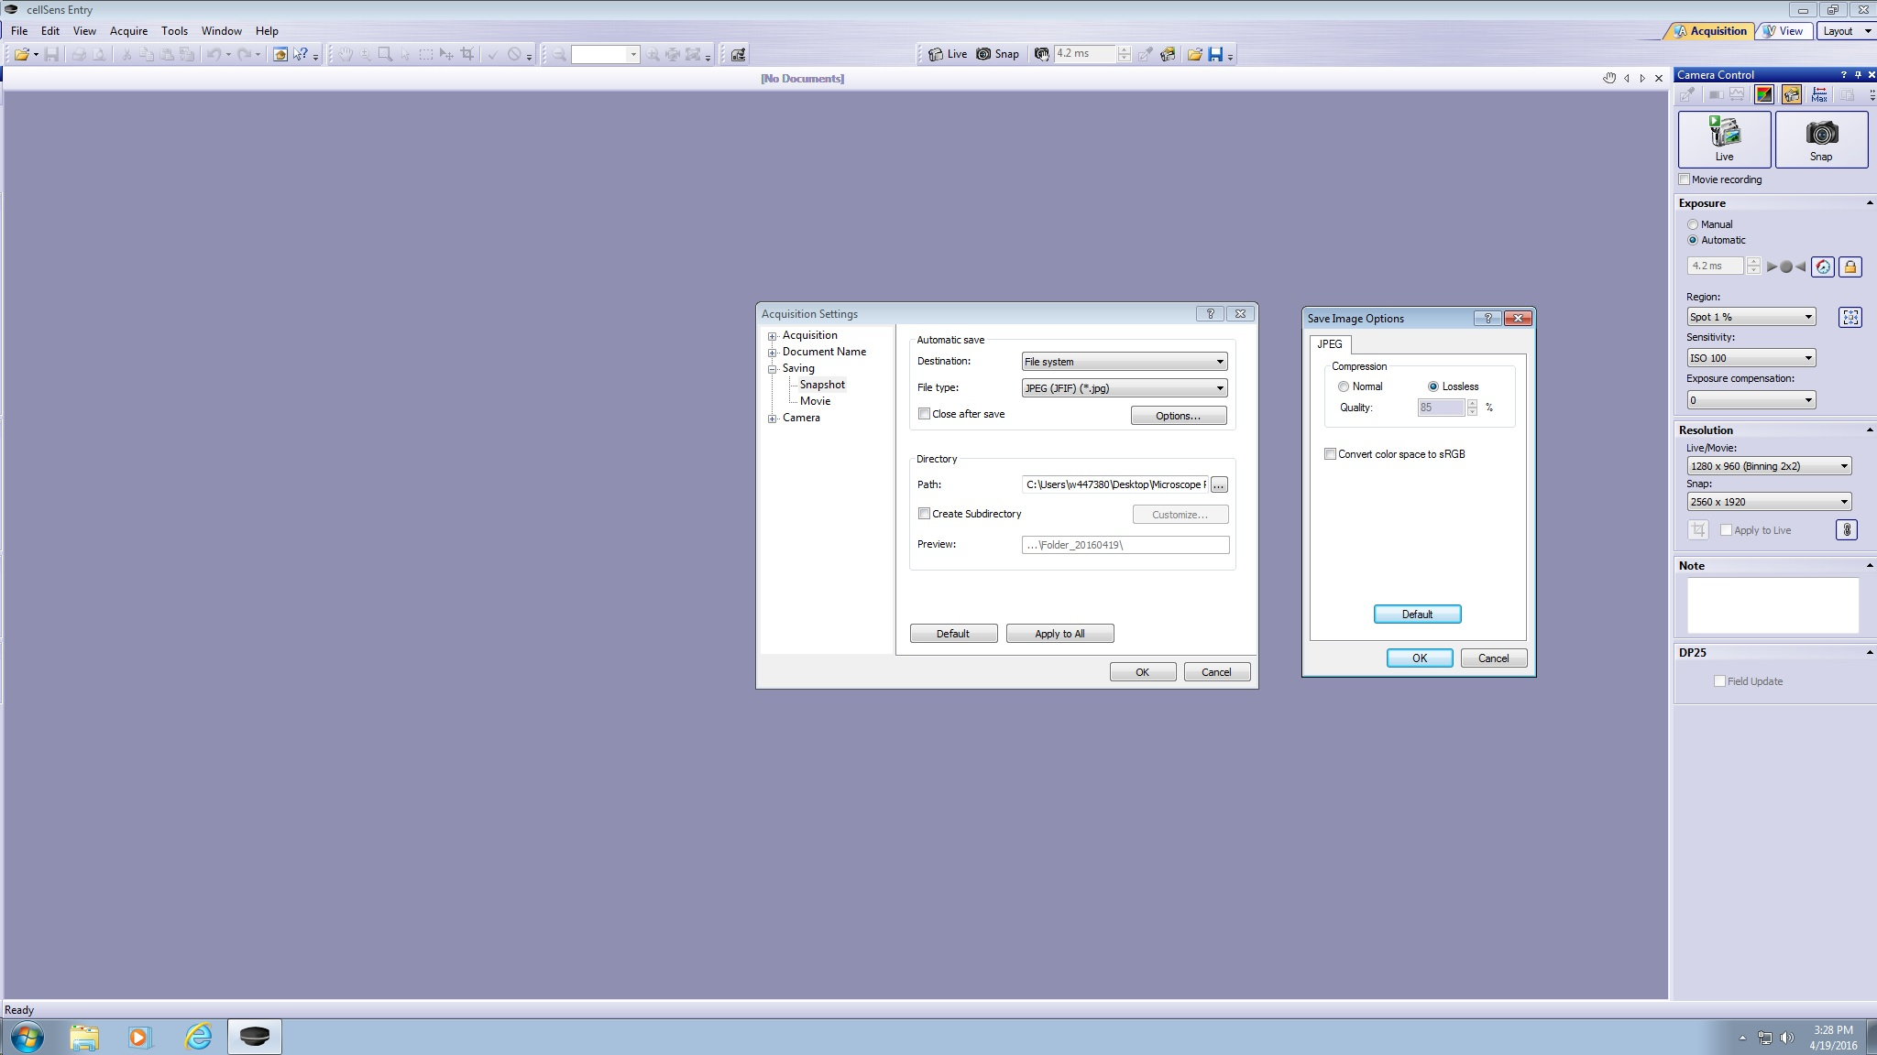

- “Automatic” exposure is the default setting. If lighting adjustments to the image are needed, this can be accomplished by changing the values for the “Region” and/or the “Sensitivity” settings.
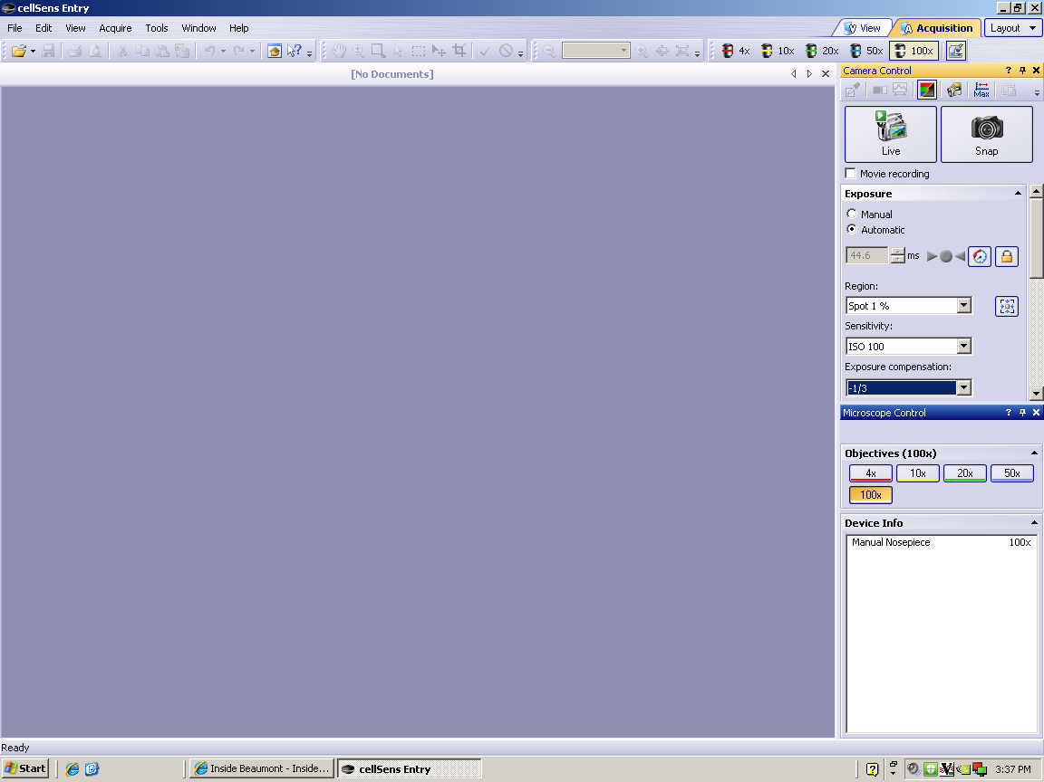

- When saving image files in the JPEG file format, a CellSens® Entry error may appear on the PC monitor screen as seen below:
“The selected file format cannot store all of the current image data. If you continue, you will irrevocably lose some of this data. This loss of data, however, will affect only the saved file but will have no effect on the current image in the memory cache. Proceed anyway?”
When this message is seen, left mouse click on “Yes”.
- Use the Acquisition Settings dialog box to change the file format and a variety of other settings for the image acquisition. To open this dialog box, click the Acquisition Settings button on the Camera Control toolbar. It may also be accessed by clicking on ToolsTool WindowCamera ControlAcquisition Settings.
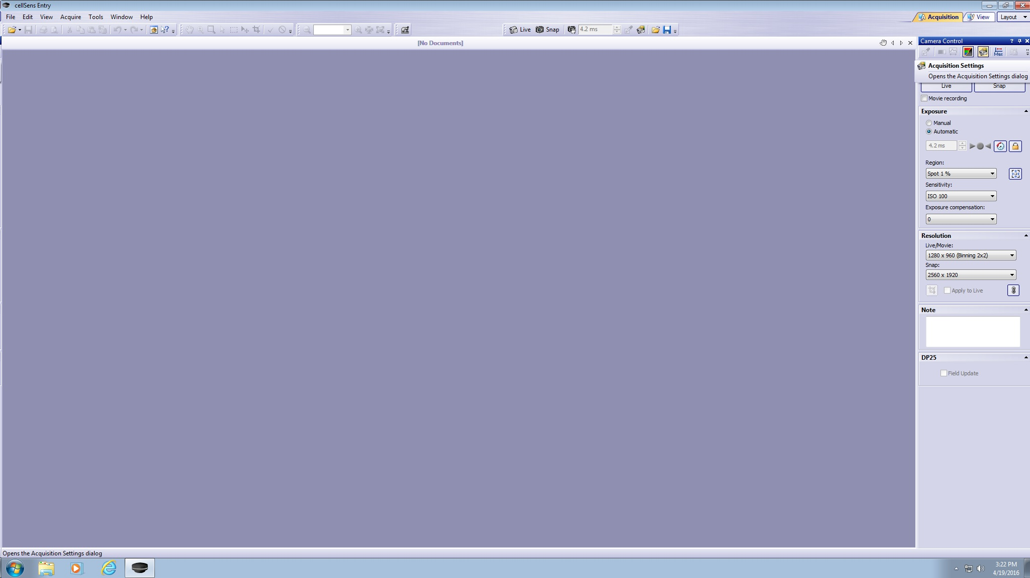

- By default, images are automatically saved to the most current subfolder in the Microscope Pictures folder found on the PC desktop. To change the default folder (i.e., at the beginning of a new year), go to Acquisition SettingsSavingDirectory PathC:\Users\wnnnnnn\Desktop\Microscope Pictures\yyyy Images. (where wnnnnnn is the WBH property tag # on the PC and yyyy is the acquisition year of images)

References
Olympus BX53 System Microscope Instructions
Olympus CellSens® Imaging Software, Ver.1.5, Online User Help Guide. Olympus Corporation, 2011

Authorized Reviewers
Chair, Pathology and Laboratory Medicine
Medical Director, Hematology

Document Control

Location of Master: Hematology Procedure Manual

Master electronic file stored on the Beaumont Laboratory server under S:/ Hemacoag/ Document Control/Hematology/Master Documents/Digital Imaging.doc
Number of Controlled Copies posted for educational purposes: 0
Number of circulating Controlled Copies: 0
Location of circulating Controlled Copies: NA

Document History

Signature | Date | Revision # |  | Related Documents  Reviewed/  Updated
Prepared by: Mary Zamboldi H(ASCP)SH | 10/03/2012
Approved by: Ann Marie Blenc, MD | 11/20/2012 |  |  | OK
Mark D. Kolins, MD | 11/20/2012
Reviewed by: (Signature) | Date | Revision # | Modification | Related Documents  Reviewed/  Updated
Ann Marie Blenc, MD | 11/20/2012 | 00 | New procedure. | OK
Mark D. Kolins, MD | 11/20/2012
Ann Marie Blenc, MD | 06/20/2014 | 01 | Changed order of steps to utilize CellSens® program. Added instruction to move mouse and keyboard. Added information about opening CellSens® program. Corrected color of tabs for “live” window and captured images. | OK
Ann Marie Blenc, MD | 04/20/2016 | 02 | Added notes describing how to access Acquisition Settings and how to change default file saving location | OK
Elizabeth Sykes, MD | 02/02/2018
Ann Marie Blenc, MD | 04/03/2018 |  | Updated logo only.
Peter Millward, MD | 01/30/2019 |  | New Medical Director

