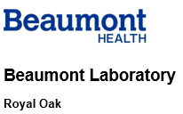

**PROCEDURE/POLICY/WORKFLOW UPDATES**

Please follow the link below to the PolicyStat website. If you are logged into the computer it should automatically log you into PolicyStat. Providing this link will always link you to the most updated version of our procedure/policy/workflow.

|  |
| --- |
| Coagulation- IL ACL TOP Operations-RO<https://beaumont-royaloak.policystat.com/policy/9178939/latest/> |

Please contact management if you have any questions or concerns after reviewing the above procedure/policy/workflow.