Purpose
To provide an update on the procedure for finding all lymph nodes within a lung lobectomy and pneumonectomy specimen for cancer and designating the station.

- Procedure
- The specimen will arrive with multiple parts including the lung lobectomy/pneumonectomy specimen and separate parts with lymph nodes from numerous zones/stations.
- After following the appropriate procedure (lung lobectomy or lung pneumonectomy) and grossing the specimen, an extensive and thorough lymph node search should be performed to find all lymph nodes within the specimen.
- If the specimen is a complete pneumonectomy, the specimen may contain lymph nodes from stations 10 (Hilar), 11 (Interlobar), 12 (Lobar), 13 (Segmental), and 14 (Subsegmental).
- If the specimen is a single lobe, it will contain lymph nodes from stations 12 (Lobar), 13 (Segmental), and 14 (Subsegmental).
- The stations increase with every branch starting with station 12 near the bronchial margin, station 13 at the next bronchial branch, and ending with station 14 at the farthest branch from the bronchial margin.
- The actual branching of the bronchi will be hard to visualize after sectioning the specimen, so the lung can be divided into radial thirds starting at the bronchial margin.
- The bronchial diameter will also decrease as you get farther from the bronchial margin and can be used for reference.
- At least one lymph node should be identified from each station (one from 12, one from 13, and one from 14). A section of lung parenchyma with bronchioles should be submitted from each station that lymph nodes are not identified.

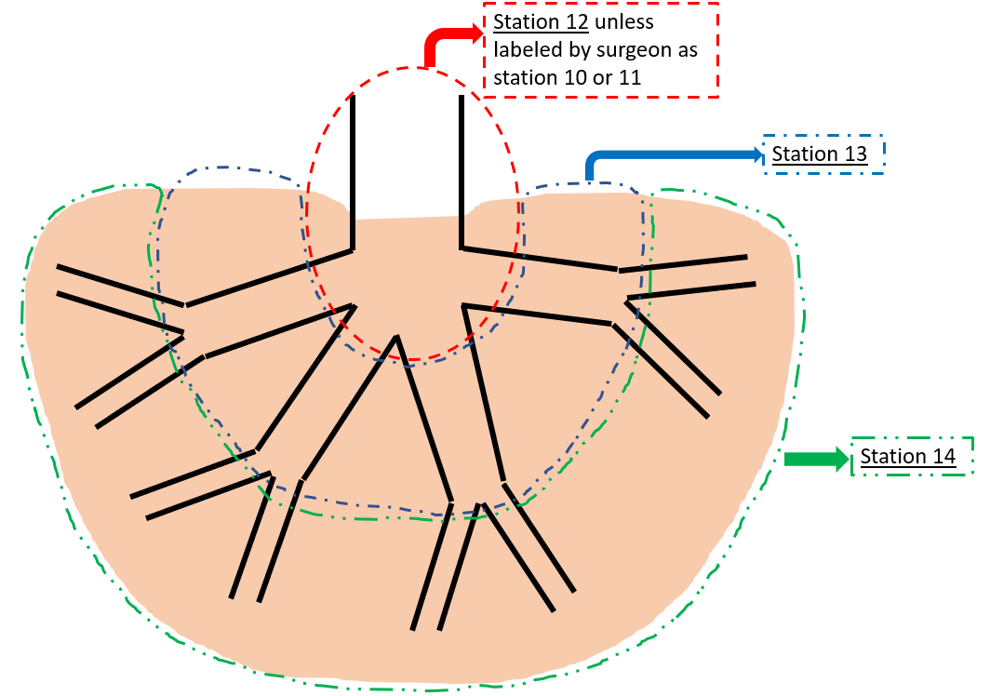
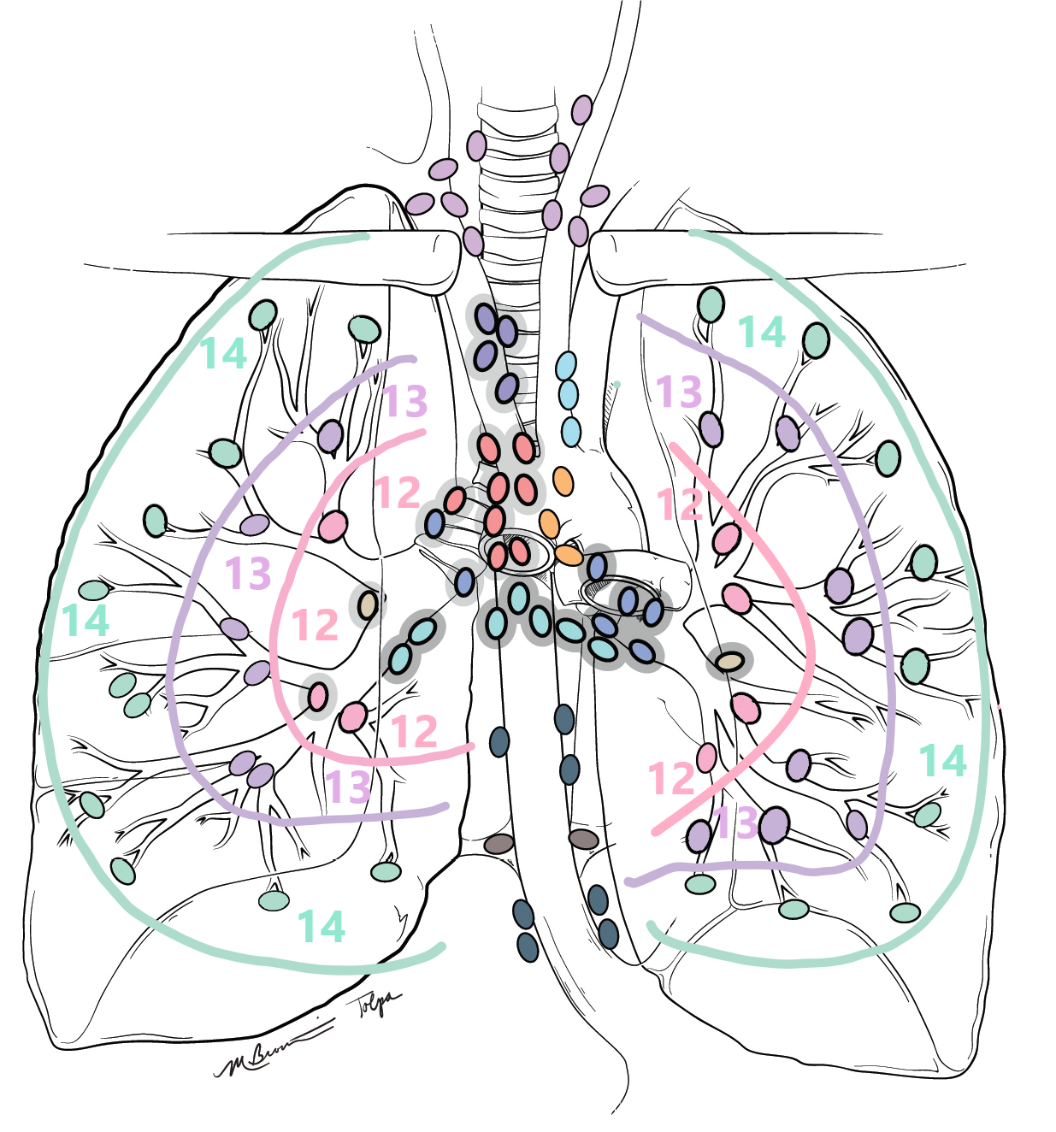

Authorized Reviewers
- Medical Director, Anatomic Pathology
- Chief, Surgical Pathology

Document Control

Location of Master: Master electronic file stored on the Beaumont Laboratory server under

S:\AP_Grossing_Manual
Number of Controlled Copies posted for educational purposes: 0
Number of circulating Controlled Copies: 1
Location of circulating Controlled Copies: Master Grossing Manual located in Surgical Pathology

Document History

Signature | Date | Revision # |  | Related Documents  Reviewed/  Updated
Prepared by: Heather Genson, HTL(ASCP)^{CM}PA^{CM} | 5/20/2021 | r00
Approved by: Kurt Bernacki,MD | 5/20/2021 | r00
Reviewed by: (Signature) | Date | Revision # | Modification | Related Documents  Reviewed/  Updated

