###### Purpose

To provide a procedure for the gross examination of a skin punch biopsy specimen submitted for alopecia.

1. **Principle**

To take histologic sections to demonstrate any possible pathologic process present so that a diagnosis can be made microscopically by a Pathologist. The goal of hair pathology is to diagnose scarring versus non-scarring alopecia, evaluate follicular morphology and counts to identify the subtypes of non-scarring alopecia, and assess disease activity in scarring alopecia.

###### Equipment

1. Ruler
2. Forceps
3. Scalpel
4. Blue biopsy sponges
5. **Safety**
6. **PPE** should be worn.
7. **FORMALIN** is a known carcinogen.
8. **Supplies and Reagents**
9. **10% NEUTRAL BUFFERED FORMALIN** (pH range 6.9 – 7.2)
10. Red Ink
11. White Distilled Vinegar
12. **Quality Control**

All tissue should be submitted.

1. **Limitations/ Notes**

The following may influence the validity of test results:

1. The specimen should be fixed in formalin.
2. **Procedure**
3. When only **ONE** punch biopsy of the scalp is received:
   1. Measure the skin punch biopsy in diameter and depth (cm.).
   2. Describe the skin surface and mention the presence or absence of hair.
   3. Bisect the skin punch in the horizontal plane, parallel to the epidermis skin surface, 1 mm above the junction between the dermis and subcutis.
   4. Ink the cut surfaces of both halves red and indicate to histology to embed red ink down.
   5. Use vinegar as a mordant for the ink.
   6. Place both fragments between blue sponges in one cassette.
   7. Make sure the protocol is correct and ordered as an alopecia
   8. Load the cassette on the appropriate medium or large processor to allow for proper fixation and processing.

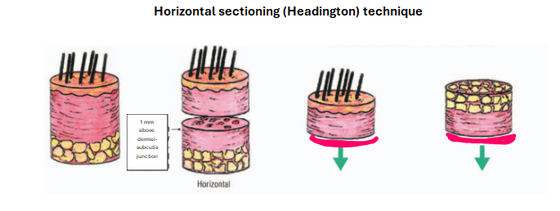

1. When **TWO** punch biopsies of the scalp are received:
   1. Measure both skin punch biopsies in diameter and depth (cm.).
   2. Describe the skin surface of both and mention the presence or absence of hair.
   3. Determine which punch is better (more intact, deeper) and horizontally bisect it, parallel to the epidermis skin surface, 1 mm above the junction between the dermis and subcutis.
   4. Vertically bisect the other punch biopsy, perpendicular to the skin surface.
   5. Ink all cut surfaces (two on each punch) red and indicate to histology to embed red ink down.
   6. Use vinegar as a mordant for the ink.
   7. Place horizontally bisected punch biopsy in one cassettes and vertically bisected punch biopsy in another cassette (total of two cassettes) between blue sponges.
   8. Make sure the protocol is correct and ordered as alopecia.
   9. Load the cassettes on the appropriate medium or large processor to allow for proper fixation and processing.



**Vertical sectioning**

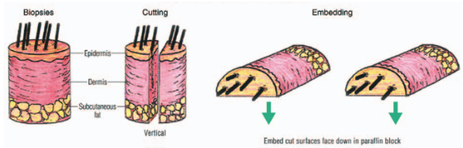



1. **References**

Hruban RH, Westra, WH, Phelps, PH, & Isacson, C: Surgical Pathology Dissection An Illustrated Guide, New York, NY, Springer-Verlag Inc., 1996.

Lester, SC: Manual of Surgical Pathology, New York, NY, Churchill

Livingstone, 2001.

1. **Authorized Reviewers**
2. Medical Director, Anatomic Pathology
3. Chief, Surgical Pathology

##### Document Control

##### Location of Master: Master electronic file stored on the Beaumont Laboratory server under

S:\AP_Grossing_Manual

**Number of Controlled Copies posted for educational purposes: 0**

**Number of circulating Controlled Copies: 1**

**Location of circulating Controlled Copies:** Master Grossing Manuallocated in Surgical Pathology

##### Document History

|  |  |  |  |  |
| --- | --- | --- | --- | --- |
| Signature | Date | **Revision #** |  | **Related Documents**  **Reviewed/**  **Updated** |
| Prepared by: *Anne Tranchida, PA(ASCP)* | 9/12/2007 | **r00** |  |  |
| Approved by: *Ali-Reza Armin, MD* | 12/6/2007 | **r00** |  |  |
|  |  |  |  |  |
| **Reviewed by: (Signature)** | **Date** | **Revision #** | **Modification** | **Related Documents**  **Reviewed/**  **Updated** |
| *Ali-Reza Armin, MD* | 10/10/2008 | **r00** |  |  |
| *Anne R. Tranchida,PA(ASCP)* | 10/20/2009 | **r00** |  |  |
| *Revised by: Heather Genson, HTL(ASCP)CMPACM* | 4/19/2011 | **r01** | Added which sections go in what cassette |  |
| Approved by: *Ali-Reza Armin,MD* | 4/19/2011 | **r01** |  |  |
| *Ali-Reza Armin,MD* | 10/20/2011 | **r01** |  |  |
| *Ali-Reza Armin,MD* | 10/4/2013 | **r01** |  |  |
| *Mitual B. Amin,MD* | 2/18/2015 | **r01** |  |  |
| *Zhenhong H. Qu, MD* | 03/21/2015 | **r01** |  |  |
| *Kurt Bernacki, MD* | 10/27/2017 | **r01** |  |  |
| *Kurt Bernacki, MD* | 10/22/2019 | **r01** |  |  |
| *Kurt Bernacki, MD* | 10/20/2021 | **r01** |  |  |
| *Jawwad Arshad, MD* | 3/20/2023 | **r01** |  |  |
| *Revised by: Heather Genson, HTL(ASCP)CMPACM* | 6/12/2024 | **r02** | Changed procedure to only horizontally bisect 1 punch. If 2 punches, horizontally bisect 1 and vertically bisect other. |  |
| Approved by: *Jawwad Arshad, MD* | 6/20/2024 | **r02** |  |  |
|  |  |  |  |  |
|  |  |  |  |  |
|  |  |  |  |  |
|  |  |  |  |  |
|  |  |  |  |  |