###### Purpose

To provide a procedure for the gross examination of a wedge of skin submitted from the eyelid.

1. **Principle**

To submit the entire specimen so that a diagnosis can be made microscopically by a Pathologist.

###### Equipment

1. Ruler
2. Forceps
3. Scalpel
4. Blue biopsy sponges
5. **Safety**
6. **PPE** should be worn.
7. **FORMALIN** is a known carcinogen.
8. **Supplies and Reagents**
9. **10% NEUTRAL BUFFERED FORMALIN** (pH range 6.9 – 7.2)
10. Blue Ink
11. Red Ink
12. White Distilled Vinegar
13. **Quality Control**

All tissue should be submitted.

1. **Limitations/ Notes**

The following may influence the validity of test results:

1. The specimen should be fixed in formalin.
2. **Procedure**
3. The specimen will arrive in a jar of formalin.
4. Measure the skin wedge in three dimensions (cm.).
5. If a suture is attached to orient the specimen, dictate the location of the suture.
6. If orientation is not provided, it is still possible to orient the eyelid wedge if the laterality and if upper or lower lid is indicated. With that information and from identifying the skin surface, the conjunctival surface, and any attached eyelashes, the specimen can be oriented.
7. Describe the skin surface and the conjunctival surface. Describe any identifiable lesions and indicate the size (2 dimensions – cm.), shape, color, and distance to the nearest margins (medial/nasal and lateral/temporal). If the lesion is raised, measure the distance that it extends from the skin surface.
8. Ink the margin blue.
9. Use vinegar as a mordant for the ink.
10. If the specimen is large enough to be trisected or sectioned:
    1. Cut the specimen by making cuts that are parallel to the medial/nasal and lateral/temporal margins.
    2. The specimen should be submitted in three (or more) cassettes.
    3. Both the medial/nasal and lateral/temporal end margins should be submitted en face in separate cassettes, indicating the margins in the cassette summary.
    4. Red ink should be placed over the blue ink on each margin and a note should be added to indicate to the histotech to embed red ink down.
    5. The central section(s) should be submitted on edge in a third cassette.
    6. No levels should be ordered.
11. If the specimen is small and can only be bisected:
    1. Bisect into medial/nasal and lateral/temporal halves.
    2. Each half should be submitted in a separate cassette to be embedded reverse en face (cut side down), indicating the margins in the cassette summary.
    3. Red ink should be placed on the inner cut surface of each half and a note should be added to indicate to the histotech to embed red ink down.
    4. Three levels should be ordered on both blocks.
12. All pieces of skin should be submitted by placing them between blue sponges.
13. The cassettes should be loaded on the appropriate processor.

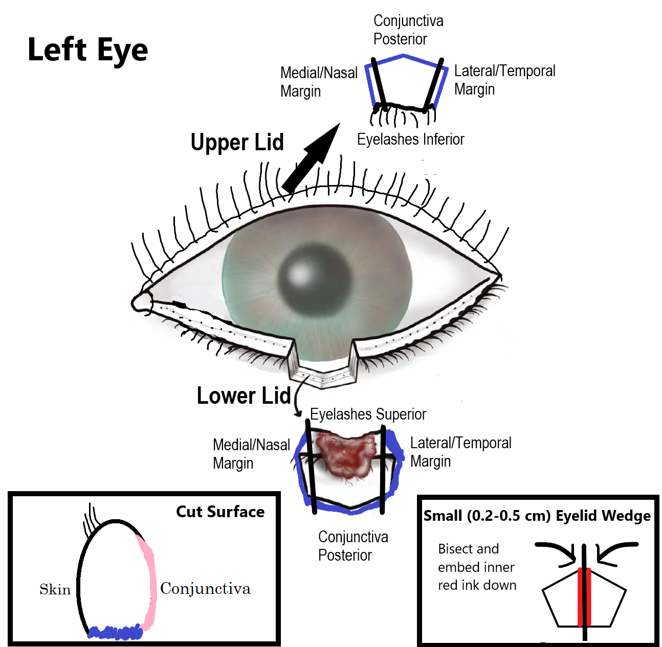

1. **References**

Hruban RH, Westra, WH, Phelps, PH, & Isacson, C: Surgical Pathology Dissection An Illustrated Guide, New York, NY, Springer-Verlag Inc., 1996.

Lester, SC: Manual of Surgical Pathology, New York, NY, Churchill

Livingstone, 2001.

1. **Authorized Reviewers**
2. Medical Director, Anatomic Pathology
3. Chief, Surgical Pathology

##### Document Control

##### Location of Master: Master electronic file stored on the Beaumont Laboratory server under

S:\AP_Grossing_Manual

**Number of Controlled Copies posted for educational purposes: 0**

**Number of circulating Controlled Copies: 1**

**Location of circulating Controlled Copies: Master Grossing Manual** located in Surgical Pathology

##### Document History

|  |  |  |  |  |
| --- | --- | --- | --- | --- |
| Signature | Date | **Revision #** |  | **Related Documents**  **Reviewed/**  **Updated** |
| Prepared by: *Anne Tranchida, PA(ASCP)* | 9/12/2007 | **r00** |  |  |
| Approved by: *Ali-Reza Armin, MD* | 12/6/2007 | **r00** |  |  |
|  |  |  |  |  |
| **Reviewed by: (Signature)** | **Date** | **Revision #** | **Modification** | **Related Documents**  **Reviewed/**  **Updated** |
| *Ali-Reza Armin, MD* | 10/10/2008 | **r00** |  |  |
| *Anne R. Tranchida,PA(ASCP)* | 10/20/2009 | **r00** |  |  |
| *Ali-Reza Armin,MD* | 10/20/2011 | **r00** |  |  |
| Revised by: *Heather Genson, HTL(ASCP)CMPACM* | 12/12/2012 | **r01** | If specimen can only be bisected, x8 on margins reverse en face |  |
| Approved by*: Ali-Reza Armin,MD* | 12/27/2012 | **r01** |  |  |
| *Ali-Reza Armin,MD* | 10/4/2013 | **r01** |  |  |
| *Mitual B. Amin,MD* | 02/18/2015 | **r01** |  |  |
| *Zhenhong H. Qu, MD* | 03/21/2015 | **r01** |  |  |
| *Kurt Bernacki, MD* | 10/27/2017 | **r01** |  |  |
| Revised by: *Heather Genson, HTL(ASCP)CMPACM* | 11/30/2018 | **r02** | If specimen can only be bisected, reverse en face x3 and changed black ink to blue ink |  |
| Approved by: *Kurt Bernacki, MD* | 11/30/2018 | **r02** |  |  |
| *Kurt Bernacki, MD* | 10/21/2019 | **r02** |  |  |
| *Kurt Bernacki, MD* | 10/20/2021 | **r02** |  |  |
| Revised by: *Heather Genson, HTL(ASCP)CMPACM* | 10/13/2022 | **r03** | Added pictures and more descriptive wording |  |
| Approved by: *Kurt Bernacki, MD* | 10/17/2022 | **r03** |  |  |
| **Reviewed by: (Signature)** | **Date** | **Revision #** | **Modification** | **Related Documents**  **Reviewed/**  **Updated** |
| Revised by: *Heather Genson, HTL(ASCP)CMPACM* | 1/10/2024 | **r04** | Added red ink and note for embedding |  |
| Approved by: *Laura Walters, MD, PhD* | 1/10/2024 | **r04** |  |  |
|  |  |  |  |  |
|  |  |  |  |  |
|  |  |  |  |  |
|  |  |  |  |  |
|  |  |  |  |  |
|  |  |  |  |  |
|  |  |  |  |  |
|  |  |  |  |  |
|  |  |  |  |  |
|  |  |  |  |  |
|  |  |  |  |  |
|  |  |  |  |  |
|  |  |  |  |  |
|  |  |  |  |  |
|  |  |  |  |  |
|  |  |  |  |  |
|  |  |  |  |  |
|  |  |  |  |  |
|  |  |  |  |  |
|  |  |  |  |  |
|  |  |  |  |  |