###### Purpose

To provide a procedure for the gross examination of a full square skin excision or peripheral margins submitted with orientation.

1. **Principle**

To take histologic sections to demonstrate any possible pathologic process present so that a diagnosis can be made microscopically by a Pathologist.

###### Equipment

1. Ruler
2. Forceps
3. Scalpel
4. Blue biopsy sponges
5. **Safety**
6. **PPE** should be worn.
7. **FORMALIN** is a known carcinogen.
8. **Supplies and Reagents**
9. **10% NEUTRAL BUFFERED FORMALIN** (pH range 6.9 – 7.2)
10. Blue Ink
11. Green Ink
12. Red Ink
13. Orange Ink
14. Yellow Ink
15. White Distilled Vinegar
16. **Quality Control**

All tissue should be submitted.

1. **Limitations/ Notes**

The following may influence the validity of test results:

1. The specimen should be fixed in formalin.
2. Place all skin margins in between sponges to prevent twisting.
3. The pins used for orientation may leave holes in the tissue. When deciding how to embed, avoid the holes.
4. The peripheral margins may be wider than 3 mm. If it is too thick, it may need to be bisected.
5. **Procedure**
6. Received already divided into cassettes by clinician between blue sponges.
7. Dictate how many blocks and how they are oriented (i.e. Margins A, B, C, D).
8. Measure each strip of skin within each block.
9. Ink the leading edge of each skin strip one color and the trailing edge a different color and include in dictation. They may be received already inked on the leading edge.
10. Place red ink on the surface to be embedded down as received in cassette.
11. Transfer each skin strip between blue sponges to printed cassettes with surgical number.
12. Include in cassette summary which margins are in which blocks.
13. Received as peripheral margins pinned to Styrofoam and oriented with accompanying diagram. Can be full peripheral margins or partial margins.
    1. Describe the skin strips and mention how it is oriented (i.e. Margins A, B, and C with a suture between A and B).
    2. Measure the margins in length, width, and depth (cm.).
    3. Divide the margins from each other.
    4. Ink the leading edge of each margin one color and the trailing edge a different color.
    5. Place red ink on the surface to be embedded down (on edge). Embed either en face or reverse en face and include in dictation.
    6. Place all skin strips in between blue sponges to prevent twisting.
    7. Include in cassette summary which margins are in which blocks.
14. Received as a full square excision in a jar of formalin pinned to Styrofoam and oriented with accompanying diagram. Can be many different shapes with numerous margins.
    1. Describe the skin excision and mention how it is oriented (i.e. Margins A, B, C, D, and E, with a suture between C and D)
    2. Measure the skin excision in length, width, and depth (cm.).
    3. Locate the lesion or re-excision site and describe the size (2 dimensions – cm.), shape, color, and distance to the nearest skin edge.
    4. Shave all peripheral margins. Ink the leading edge of each margin one color and the trailing edge a different color. Place red ink on the surface to be embedded down (on edge). Embed either en face or reverse en face and include in dictation. Place in between blue sponges to prevent twisting.
    5. Ink the remaining deep margin at least two colors, indicating how it is inked.
    6. Use vinegar as a mordant for the ink.
    7. Serially section the remaining central specimen and include orientation in cassette summary.
    8. Submit the entire specimen, including in the cassette summary which cassettes are shaved peripheral margins (between blue sponges), and which are the remaining sectioned center.

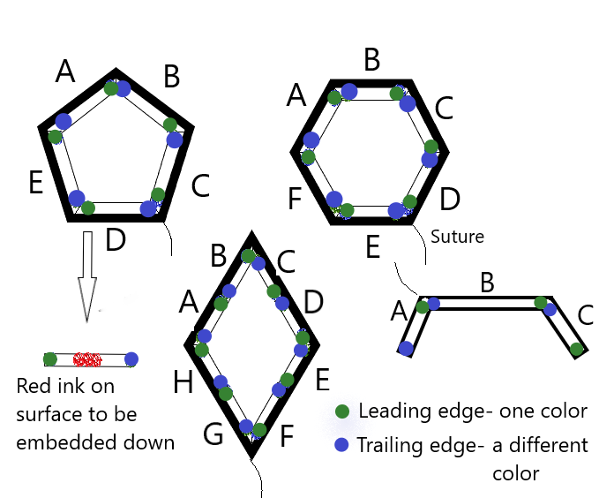

1. **References**

Hruban RH, Westra, WH, Phelps, PH, & Isacson, C: Surgical Pathology Dissection An Illustrated Guide, New York, NY, Springer-Verlag Inc., 1996.

Lester, SC: Manual of Surgical Pathology, New York, NY, Churchill

Livingstone, 2001.

1. **Authorized Reviewers**
2. Medical Director, Anatomic Pathology
3. Chief, Surgical Pathology

##### Document Control

##### Location of Master: Master electronic file stored on the Beaumont Laboratory server under

S:\AP_Grossing_Manual

**Number of Controlled Copies posted for educational purposes: 0**

**Number of circulating Controlled Copies: 1**

**Location of circulating Controlled Copies: Master Grossing Manual** located in Surgical Pathology

##### Document History

|  |  |  |  |  |
| --- | --- | --- | --- | --- |
| Signature | Date | **Revision #** |  | **Related Documents**  **Reviewed/**  **Updated** |
| Prepared by: *Heather Genson, HTL(ASCP)CMPACM* | 5/18/2023 | **r00** |  |  |
| Approved by:  *Laura L. Walters, MD, PhD* | 5/18/2023 | **r00** |  |  |
|  |  |  |  |  |
| **Reviewed by: (Signature)** | **Date** | **Revision #** | **Modification** | **Related Documents**  **Reviewed/**  **Updated** |
|  |  |  |  |  |
|  |  |  |  |  |
|  |  |  |  |  |
|  |  |  |  |  |
|  |  |  |  |  |
|  |  |  |  |  |
|  |  |  |  |  |
|  |  |  |  |  |
|  |  |  |  |  |
|  |  |  |  |  |
|  |  |  |  |  |
|  |  |  |  |  |
|  |  |  |  |  |
|  |  |  |  |  |