Purpose and Objective
This procedure gives instructions on how to perform a microhematocrit using the M24
Microhematocrit Centrifuge.
Principle
Hematocrit or Packed Cell Volume is defined as the ratio of the volume of erythrocytes to that of whole blood expressed as a percentage.
The M24 Microhematocrit Centrifuge is a high-speed centrifuge that permits the quantitative measurement of micro-hematocrits directly.

Specimen Collection and Handling

Type: | Whole blood collected in a 4 mL Vacutainer® tube.  This is the preferred sample.  OR  Capillary blood collected in a Microtainer® tube.
Anticoagulant: | K₂EDTA
Amount: | Whole blood - Minimum sample size is 2.0 mL.  - Optimum sample size is 4.0 mL.  Capillary blood - Minimum sample size is 300 µL.  - Optimum sample size is 500 µL.
Special Handling: | Specimen must be well mixed for minimum of two minutes before being analyzed.  Samples containing hemolysis may give false results (see Note #2).
Timing: | Specimen is stable for 8 hours at room temperature; 24 hours at 4°C.
Criteria for  Unacceptable  Specimens: | Specimens containing clots, hemolysis or inappropriate volume are unacceptable and must be redrawn.

Equipment
- SafeCrit™ plastic microhematocrit tubes
- Critoseal™
- M24 Microhematocrit centrifuge with microhematocrit reader disk.

Quality Control
- Quarterly checks of RPM and the timer are performed. Maximum packing time is checked annually or when there is a change in either the speed or time. (See Attachment A.)
- A microhematocrit control is performed on a normal peripheral blood sample previously analyzed on the Sysmex XN-9100. Results should agree within ±2.0%. Repeat entire run if the result is outside of that range.
- Document results on Manual HCT QC worksheet. If QC results are out of acceptability limit, document it on QC worksheet including the description of
the corrective action taken. Patient results cannot be reported until any out of range control situation is resolved.
- Controls must be run with every patient. Controls are run in duplicate with the results averaged.

Procedure
- Using well-mixed specimen, fill 2 plastic microhematocrit tubes between ½ and ¾ full. Ensuring adequate mixing is essential. Mix the sample well before filling the first tube and again before filling the second tube.
- Seal one end with critoseal.
NOTE: The interface between critoseal/blood should be flat and amount of critoseal should not go past the blue fill line on tube.
- Load the capillary tubes in a balanced fashion onto the rotating tray of the centrifuge with the sealing clay end pointed outward.
- Place the chrome cover plate over the rotating tray so that the spindle fits into
the threaded hole in the center of the cover plate.
- Tighten the cover plate securely, by hand, using the chrome thumbscrew.
DO NOT use any tools to tighten the thumbscrew.
- Close the centrifuge lid by pressing down firmly. The centrifuge will not operate unless the lid is closed.
- Set timer to 3 minutes by turning knob past desired time and then rotating back to desired time.
Line up protruded line on dial with appropriate line on centrifuge. Unit will begin spinning at full speed (12,000 rpm).
NOTE: A separate timer set for (3) minutes may be used.
- After the rotor has stopped, press down firmly on lid to open, remove the cover plate by unscrewing the chrome thumbscrew and lifting the cover plate straight up.
- Read hematocrit as soon as centrifuge stops. Instructions are as follows:
- Place the reader disk over the hematocrit tubes and adjust the disc until the 0% line is lined up with the bottom of the fluid in the tube to be read.
- While keeping the 0% line positioned at the bottom of the fluid, turn the disc until
the 100% line aligns with the top of the fluid.
- Read the separation line between the packed red cell column and the clear plasma column for your hematocrit value. Follow the same steps to read each tube.
- The two results must match within + 2.0%. If the results are outside of this range, repeat testing.
- Take the average of the two microhematocrit results. This will be the reported result.
- After all the tubes have been read, remove them from the tray. Discard
the capillary tubes safely in accordance with approved laboratory procedures.

Expected Values
Refer to Hematology Normal Values procedure for current normal ranges.

Notes
- Ensuring the sample is well-mixed is essential. Mix the sample well before filling the first tube and again before filling the second tube.
- Leakage of blood from bottom of the tube if not sealed properly will cause erroneously low values.
- Hemolyzed specimens will cause low values.
- Hematocrit values less than 2.0% are reported as “<2”.
- The RPM of centrifuge must be at least 10,000–15,000.

References
- Microtainer and Vacutainer are registered trademarks of Becton, Dickinson and Company.
- Wintrobe MM, et al. Clinical Hematology. Philadelphia: Lea & Febiger; 1974: 109-114.
- Davidsohn I, Henry JB eds.: Clinical Diagnosis and Management by Laboratory Methods. Philadelphia: WB Saunders Co.; 1984: 585-586.
- LW Scientific: M24 Centrifuge Instruction Manual.

Attachments

Attachment A – Microhematocrit Centrifuge Maintenance
Attachment B – Microhematocrit QC and patient Results Log

Authorized Reviewers
Beaumont Laboratory Medical Director, Troy
Medical Director, Hematology
Supervisor, Hematology

ATTACHMENT A

Microhematocrit Centrifuge Maintenance

QUARTERLY

RPM Check
Place a strip of reflective tape (supplied with the tachometer) on the head of the centrifuge. Turn timer clockwise to start centrifuge. Holding strobe light at an angle to the surface of the centrifuge head read tachometer scale and record results. RPM must be between 10,530–14,274.

Timer Check
Set timer for 3 and 5 minutes as indicated on centrifuge timer scale. Using stopwatch, check 3 and 5 minutes after setting timer.

YEARLY

Check Maximum Packing Time:
- Fill 12 microhematocrit capillary tubes
- Spin first pair for 1 minute.
Spin second pair for 2 minutes.
Spin third pair for 3 minutes.
Spin fourth pair for 4 minute.
Spin fifth pair for 5 minutes.
Spin sixth pair for 6 minutes.
- Record HCT results from microhematocrit readings for each pair.
- Select shortest centrifuging time where HCT results start to level off.
- Post time on face of centrifuge.

Note: Maximum Packing Time is performed annually and when there has been
a change in either the speed or time.

References
- Miale J: Laboratory Medicine. Hematology – 6th Edition. St Louis: CV Mosby Co.;
1982: 360.
- LW Scientific: M24 Centrifuge Instruction Manual.

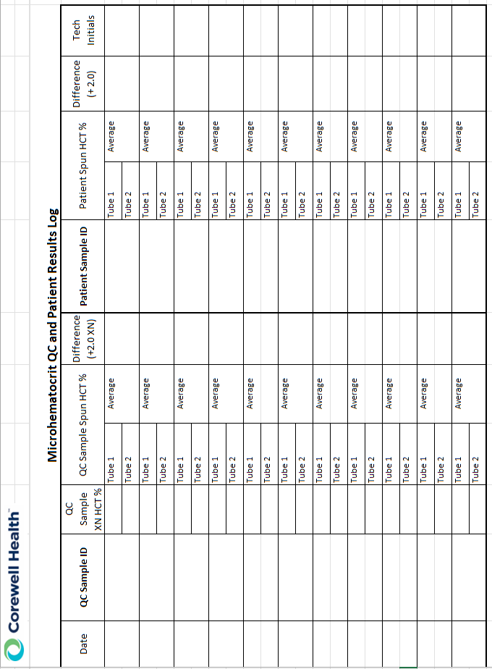

Document Control

Location of Master: Master electronic file stored on the Beaumont Laboratory server under
S:\Labs_Troy\Hematology\Document Control\Master Documents

Master printed document stored in the Hematology Department.
Number of Controlled Copies posted for educational purposes: 0
Number of circulating Controlled Copies: 0
Location of circulating Controlled Copies: NA

Document History

Signature | Date | Revision # |  | Related Documents  Reviewed/  Updated
Prepared by: Elzbieta Wystepek | 12/2010
Revised by: Mary Wyrzykowski | 05/01/2012 | r00 | New format.
Approved by: Hongwei Ma, MD | 06/25/2012
Reviewed by: (Signature) | Date | Revision # | Modification | Related Documents  Reviewed/  Updated
Hongwei Ma, MD | 06/25/2013
Revised by: Mary Wyrzykowski  Approved by: Hongwei Ma, MD | 05/01/2014  05/06/2014 | r01 | Updated with M24 centrifuge.
Approved by: Hongwei Ma, MD | 05/01/2016
Revised by: Mary Wyrzykowski  Approved by: Hongwei Ma, MD | 04/18/2018  06/19/2018 | r02 | Added note for hematocrits performed on Body Fluid samples.
Reviewed by: Vaishali Pansare, MD | 12/15/2018
Revised by: Mary Wyrzykowski  Approved by: Vaishaili Pansare, MD | 11/20/201911/20/2019 | r03 | Revised timer setting to 3 minutes for current packing time.
Reviewed by: Vaishali Pansare, MD | 03/03/2021
Reviewed by: Vaishali Pansare, MD | 01/20/2023
Revised by: Udayasree Bartley | 5/2/25 | R04 | Added QC/Patient log, updated for XN analyzers and RPM check

