Principle
Pathologist consult is ordered to evaluate hematological abnormalities that may be primary or secondary to systemic disease, or to accompany a bone marrow examination, or
to compile a retrievable archive of data for patient follow-up, scientific papers, and in-service education.
Request for hematology pathologist consult includes the following tests: CBC with differential, reticulocyte count and a pathologist interpretation.

Procedure
- All path consults must have an accompanying sign/symptom or diagnosis before the request can be processed.
- Outpatient requests must be accompanied by a copy of the patient's script when a Hematopathologist consult is ordered.
- Orders for a "Hemogram" must be clarified with the ordering physician as to what exactly is being requested, as “Hemogram” is not an acceptable order. A hemogram is a simple CBC without platelet count or differential and is not synonymous with a consult.
- EDTA sample with CBCWD, Retic, Path Con Hem label received in lab. Duplicate orders on the same label should have duplicate order canceled in Beaker before running on XN line. Ex: (CBCWD, CBC) on same label should have CBC cancelled and instrument trigger selected in Beaker prior to running on XN.
- Using the Hematology Path Consult Checklist check off items as they are done and initial the bottom of the form (All shifts).
- Run the CBC/DIFF and Retic on Sysmex. Print analyzer report.
- Print 2 labels and place one on the Hematology Path Consult Checklist. The second label will go on the final result report.
- Pathology Consults are only available more frequently than once per week if approved by a pathologist. Cancel pathologist consults that have had a pathologist consult performed within previous 7 days. Enter comment: “Hematology Path Consult cancelled – cannot be reordered within 7 days of previous order”.
- If the results autoverify with no flags from the analyzers, a peripheral smear scan is not required.
- If the results do not autoverify and have analyzer flags, a peripheral smear must be scanned. A 200 cell differential count must be performed if the instrument’s diff failed, abnormal cells are present or if there is a discrepancy between analyzer diff and slide.
- Make sure sample is completely verified in Caresphere along with any second level review performed.
- Make 2 peripheral blood smears on all pathologist’s consults and bone marrows and 2 albumin slides as necessary, labeling the slides in this manner and slide orientation. Slides must have 2 patient identifiers.

Last name, first initial, DOB or Order # and date.
Frosted End

- Stain 1 of these smears (and 1 albumin smears if made) on the SP50 and file the other unstained smears in the slide file.
- Scan or perform a manual differential (if necessary). Scan slides going to pathologist to be sure stain quality is adequate and no debris or stain precipitate is present.
- Clean slides of oil by placing in Citrisolv for 1-3 minutes and air dry.
- Print the finalized result report and affix the CBCWD, retic, path con hem label to report.
- Save specimen and place in the BM/ Path Consult rack in the back of the hematology department unless Flow cytometry is required.

- Complete the following for Path Consults:
- Dayshift – Using the Hematology Path Consult Checklist confirm all the following items are done before sending out to RO.
- All results have been verified in Caresphere and appear on the patient final
result report (CBCWD, retic).
- Final result report from Beaker with order label affixed.
- Printed copy of requisition if Outpatient.
- Analyzer results printout
- 1 stained peripheral blood smear and 1 stained albumin slide (if indicated) free of oil.
- Hematology Path Consult Checklist checked off with all required items and bottom of form initialed.
- Paperclip all forms together with the Hematology Path Consult checklist on top.
- Place all slides for patient into a slide holder. Use one slide holder per patient, do not put multiple patient slides in one slide holder.
- Create a packing list in Beaker
  - In Beaker click on “Epic” icon on top left corner and type Packing List Editor.
  - Click Create New.
  - Select CHRO HEME Ambient/Refrigerated Packing List.
  - Scan sample number at the bottom of the screen in “Add specimen or container” field/box and click “+Add”.
  - Add any other path consult orders to list as needed.
  - After all samples have been added to the packing list click “Ready”.
  - Click “Picked up”.
  - Two packing list reports will automatically print.
  - Place one packing list report, paperclipped patient reports, and slides in slide holders into a courier box. Place slides/slide holders inside the smaller boxes within the courier box so they don’t move around as much.
  - Write the courier box number on the second packing list report and place in the Packing Lists binder under path consults.
  - Confirm the card on the courier box is facing “Deliver to RO” with red tape. Zip tie courier box close.
  - Place the courier box on the sendout shelf in specimen reception.

Notes
If the Pathologist Consult is ordered on an outpatient, a copy of the doctors’ prescription/requisition or a copy of a history form is required.

- For Bone Marrow orders consisting of pathologist consults, do not proceed any further. Print instant report and give clean peripheral smears, analyzer printout and patient instant report to bone marrow tech for sendouts.

Attachments
Attachment A – Hematology Path Consult Checklist

Authorized Reviewers
Beaumont Laboratory Medical Director, Troy
Medical Director, Hematology
Supervisor, Hematology

ATTACHMENT A

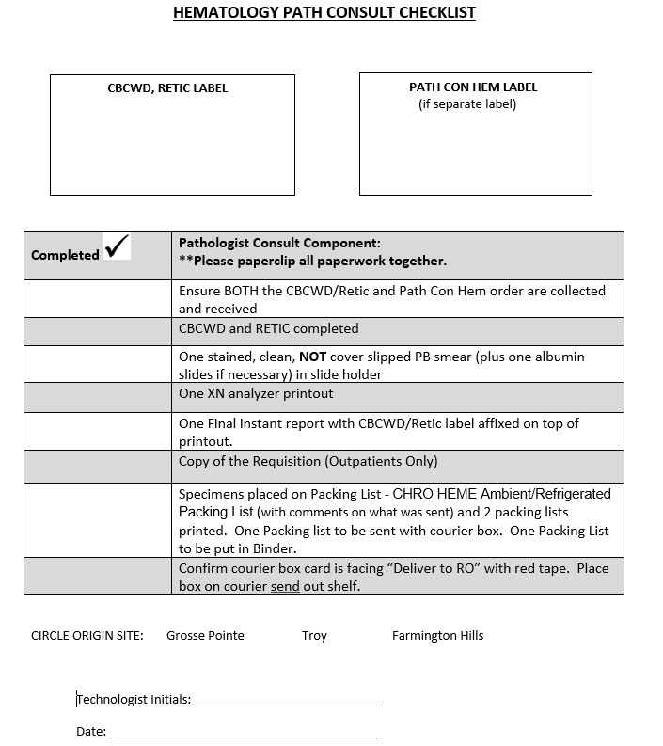

Document Control

Location of Master: Master electronic file stored on the Beaumont Laboratory server under
S:\Labs_Troy\Hematology\Document Control\Master Documents

Master printed document stored in the Hematology Department.
Number of Controlled Copies posted for educational purposes: 0
Number of circulating Controlled Copies: 0
Location of circulating Controlled Copies: NA

Document History

Signature | Date | Revision # |  | Related Documents  Reviewed/  Updated
Prepared by: Elzbieta Wystepek  Mary Wyrzykowski | 12/2008
Revised by: Mary Wyrzykowski | 12/2011 | r00 | New format.
Approved by: Hongwei Ma, MD | 01/31/2012
Reviewed by: (Signature) | Date | Revision # | Modification | Related Documents  Reviewed/  Updated
Hongwei Ma, MD | 01/24/2013
Hongwei Ma, MD | 07/30/2014
Revised by: Mary Wyrzykowski  Approved by: Hongwei Ma, MD | 10/01/2014  10/01/2014 | r01 | SoftLab and SoftPath labels required on OP scripts.
Hongwei Ma, MD | 10/01/2016
Revised by: Mary Wyrzykowski  Approved by: Hongwei Ma, MD | 08/07/2018 08/07/2018 | r02 | Removed buffy coat requirement for WBC<4.0 and Abs Neut <1.5. Added note that only to be performed by pathologist request.
Reviewed by: Vaishali Pansare, MD | 12/21/2018
Revised by: Udayasree Bartley  Approved by: Vaishali Pansare, MD | 04/02/202004/02/2020 | r03 | Revised for Bone Marrow consolidation
Reviewed by: Vaishali Pansare, MD | 12/03/2020
Revised by: Mary Wyrzykowski  Approved by: Udayasree Bartley | 03/10/202103/11/2021 | r04 | Updated for Epic Beaker LIS
Revised by: Udayasree Bartley  Approved by: Udayasree Bartley | 05/09/202205/09/2022 | r05 | Revised for Beaker changes, removed Bone Marrow CBC from procedure title
Reviewed by: Vaishali Pansare, MD | 05/15/2022
Revised by: Udayasree Bartley | 05/20/2025 | R06 | Revised for OEE

