Similar to staff competency quizzes utilized in the MTS Training Software, new documents for review will now be presented using this system.

When a new document is required to be reviewed by staff, the MTS system will generate a notification email to inform individuals that it is available and they need to log into the MTS system (http://medtraining.org/ltac3/Secure/Login.aspx ) to review.

*** PLEASE DO NOT REPLY TO THIS EMAIL. THIS EMAIL ADDRESS DOES NOT ACCEPT REPLIES ***

There is a new or revised document for your review. Please log into MTS to review. If a quiz is attached, please complete. This serves as the written portion of your competency.

Please click on the link below to begin:

http://medtraining.org/ltac3/Secure/Login.aspx?autologin=1391966752

If the link above does not work, you may sign in at http://medtraining.org/ltac3/Secure/Login.aspx with the following information:

Username:
Password:

If you have any questions, contact:

Once logged in, the new document for review will appear in your assignment list.
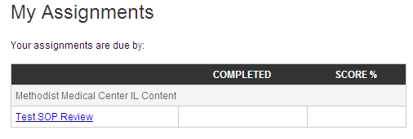

Open the assignment link, click on the link to download the new document for review. Check the box to confirm you have read the document.

A quiz may be attached to the document. If attached, select take quiz button.

