Accessing MSDS Online Tool

1. Access the UnityPoint Health Peoria Connect Me Intranet Homepage

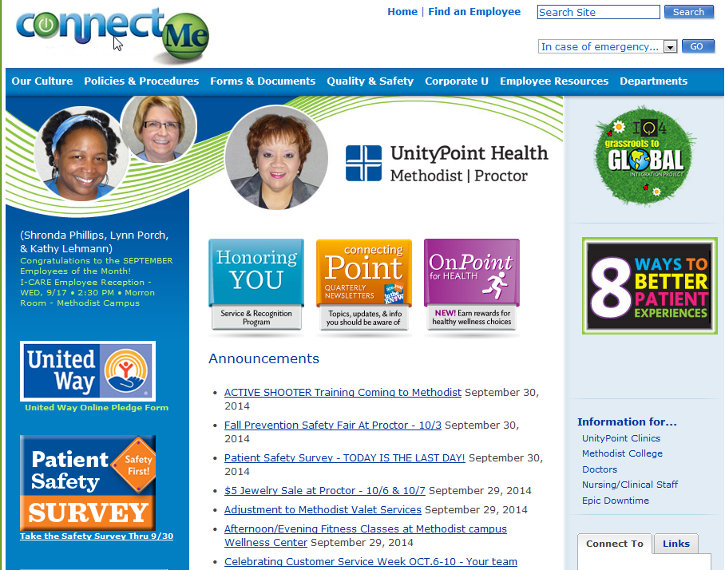

1. Locate the Connect To section, found at the right of the screen.
2. In the Connect To section, scroll down (alphabetical) until you find the MSDS Online link.

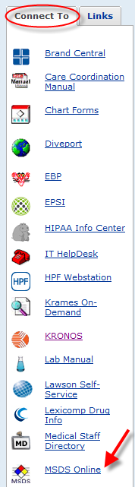

1. Click on the MSDS Online link to open the program.
2. In the MSDS Search field, type the product name to begin the search for the SDS document.

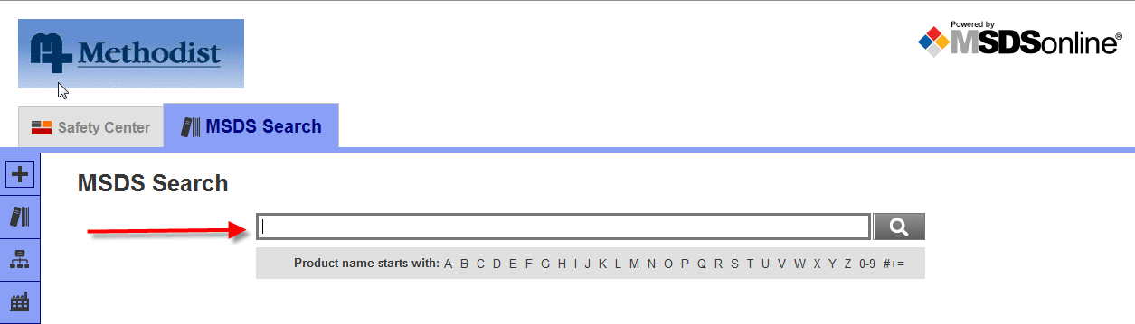

1. As you begin typing, it will list possible matches below. For example:

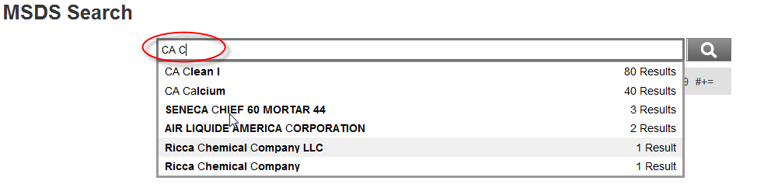

1. Once you select the product, click the magnifying glass to complete the search. The document match will then appear.

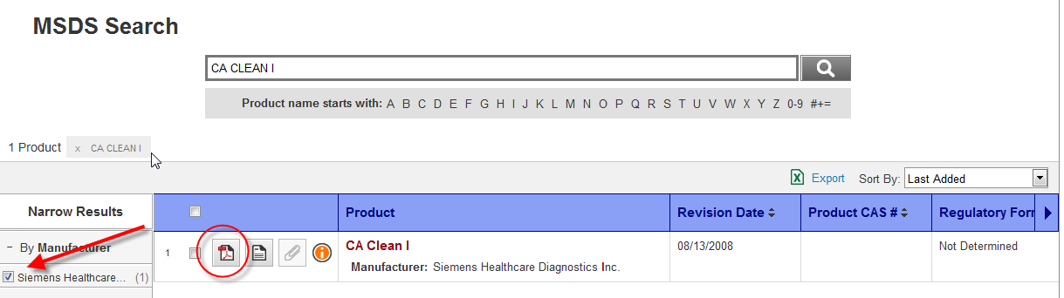

1. If multiple manufacturer’s appear, you can narrow the results by manufacturer as seen above by the arrow. Otherwise, click to open the .PDF file (shown circled above) of the document.
2. The MSDS document then opens for review.

