CHARCOAL
Microscopic Analysis

Principle

Activated charcoal is used as an agent to minimize gastrointestinal absorption after ingestion of many noncorrosive poisons and drugs. It is used as an absorbent of gases, alkaloids, and other drugs in cases of poisoning. Charcoal may also be used as an index of the rate of gastric emptying or of the passage of food residue through the bowel and to detect the presence of a fistulous tract between the GI tract and the bladder.

Clinical Significance

The presence of charcoal in the urine indicates the presence of a fistula between the GI tract and the bladder.

Specimen

Freshly voided random urine specimen (first morning specimen if possible) placed in a clean container and 2 patient identifiers: name, date of birth and hospital numer. The urine must be transported to the laboratory immediately and refrigerated if not examined within one hour. The urine can be stored for up to 24 hours at 0-10⁰C.

All urines must be saved for 24 hours and delivered to Microbiology.

Specimens must be rejected if (1) a preservative is added, (2) grossly contaminated with fecal material, (3) less than 1ml of urine in sample, (4) inadequate storage prior to laboratory arrival.

Reagents

Charcoal Powder
Normal Urine for Control

Instrumentation/Equipment

Nikon Microscope
Urine Centrifuge Tubes
Pipettes
Centrifuge

Quality Control

For a positive control, sprinkle a small amount of charcoal powder into a normal urine specimen.

Procedure

- Label two tubes; one as patient and one as control.
- Pour 10-12 mls of patient's urine into tube marked Pt; pour 10-12 mls of fresh normal urine into the tube marked Control.
- Centrifuge urine specimens for 5 minutes at 2000 rpm.
- Skim off the top of the supernate and place in appropriate marked tubes.
- Examine the skimmed portion of the urine supernate for fine black particles of charcoal.
- Discard remainder of supernate leaving the sediment.
- Examine the sediment for fine black charcoal particles.

Reporting Results

- Report results as either positive or negative using “Result Entry”Screen.
- Prior to verification, Take to pathologist on clinical for confirmation and correlation to patient history & clinical data.

If microscopic fecal material (without gross evidence of fecal contamination) is present, add footnote: "Fecal material is present, rule out physiologic contamination versus fistulous tract

Procedural Notes/Problem-Solving Tips

There must not be any gross fecal contamination, because the charcoal given to the patient should be excreted in the feces. Microscopic fecal material can be seen with a GI to urinary bladder fistula.

References

Peoria Tazewell Pathology Group

Author: Hematology SDWT Date: 9/1/92

Revised: 9/3/96; 8/31/00
Medical Director Approval: Date: 4/4/12
Change of Medical Director: __________________________________ Date: ____12/3/13___

REVISION HISTORY (began tracking 2012)
Rev | Description of Change | Author | Effective Date
1 | New Medical Director | N. Rutledge | 1/26/12
2 | New Medical Director, formatting changes, system name change. | T. Lanan/ K. Kasper | 12/3/13
3 | Updated to reflect 2 patient identifiers needed on specimens, updated to for current LIS system | R. Fitzgerald | 9/10/14

Reviewed:
Coordinator | Date | Medical Director | Date
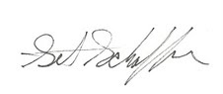 | 4/21/10 | 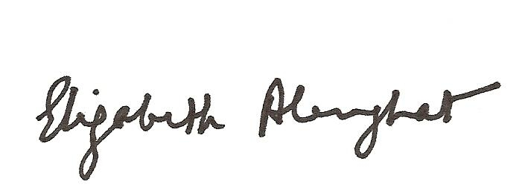 | 3/29/10
 | 10/27/11 |  | 2/1/11
 | 4/5/12 |  | 4/4/12

