HEPARIN NEUTRALIZATION

Hepzyme

Principle & Clinical Significance

Heparin is a potent and widely used anticoagulant that catalyzes the inactivation of thrombin and other serine proteases by antithrombin III. It is used therapeutically to reduce thrombotic diseases and gin indwelling catheters and extracorporeal devices.

The presence of heparin in a specimen may interfere with the interpretation of various coagulation tests. Used to rule out contamination as responsible for abnormal coagulation results of coagulation testing.

Specimen

One ml of sodium citrated plasma is needed. Mix nine parts of freshly collected blood with one part of 0.11 mol/L (3.2%) sodium citrate. Invert the tube gently three or four times immediately after venipuncture to ensure proper mixing of blood and anticoagulant. A syringe or evacuated tubes may be used with caution for collection. If an evacuated tube system is used, the coagulation sample should be the second or third tube collected. Even minimal contamination with tissue thromboplastin may produce errors. Agitation of the blood sample, air bubbles, and foaming may influence the results.

If blood is drawn from an indwelling catheter, the line should be flushed with saline and the first 5 mL of blood discarded. The citrate concentration must be adjusted in patients who have hematocrit values above 55% (greater than 3/4 of tube is red cell pack). Specimens that are clotted, collected in any tube other than sodium citrate, have visible hemolysis, have less than 90% expected fill of the collection tube, specimens improperly stored/transported, contaminated with IV fluid, or labeled incorrectly should be rejected. The whole blood specimen is checked for clot formation by gently inversion. Centrifuge the blood specimen for a minimum of 4 minutes at 4000 rpms as soon as possible after collection.. Plasma may be stored up 72 hrs of collection if stored at 2-8ºC. If testing is going to be delayed, freeze plasma at -20⁰C or lower. If immediate testing is to be done, the plasma may remain on the packed cells. To separate plasma from cells, use a plastic transfer pipet to transfer the plasma to a plastic tube; keep refrigerated until ready to test.

Reagents

Dade Hepzyme – a dried preparation of purified bacteria heparinase I with stabilizers. Store at 2-8ºC. Reagent is stable until the expiration date printed on the label. Reconstitute each vial with 1 mL of citrated patient plasma. Allow to set at room temperature for 15 minutes prior to testing.

Vials are found in coagulation refrigerator

Equipment

- Plastic tubes
- Plastic transfer pipettes
- Pipetting devices capable of accurately measuring 1 mL.

Quality Control

Use Normal Plasma - lyophilized human plasma with characteristics similar to fresh frozen
plasma that will be used as a normal control for PT, APTT, Fibrinogens. and Factor Assays.

Reconstitution Procedure:
- Prior to removing the safety seal and the vial stopper, tap the vial on the counter to ensure that the lyophilized material is concentrated on the bottom of the vial.
- Remove cap and place on bottom of vial.
- Remove rubber stopper and reconstitute with Nerl Reagent grade water.
- Replace rubber stopper and swirl the vials gently.
- Date & initial opened vials and invert 5-6 times prior to placing on instrument.

Procedure
- Add 1 ml of patient’s platelet-poor plasma to a vial of Hepzyme. Add 1 ml of reconstituted control plasma to another vial of Hepzyme.
- Perform ordered assays per SYSMEX CA 1500.
- Controls should be within the established acceptable control limit.

Reporting Results

No results will be reported. Hepzyme procedure will only be used to determine contamination.

Procedural Notes/Problem-Solving Tips

- Dade Hepzyme will neutralize up to 2 USP units of unfractionated heparin.
- If 1 ml of plasma is unavailable, volumes of between 0.5ml – 1.0 ml can be used and will not alter Dade Hepzyme neutralization.
- The presence of Tissue Factor Pathway Inhibitor (TFPI) will not be neutralized by Hepzyme and has been associated prolonged clotting times.
- If Hepzyme neutralization does not return the testing to within the normal range and high levels of heparin are suspected, add another vial of Hepzyme to the plasma/hepzyme original mixture (sequential neutralization). A plasma specimen should not be subjected to more than two vials of Hepzyme.
- Thrombin Clotting Times are subject to variation in sensitivity. Stabilizers in Dade Hepzyme can interfere with TCT results. A shift in the control specimen range may be expected and will alert you to the sensitivity. TCT cannot be performed on specimens sequentially neutralized .

References

- Dade Behring Marburg GmbH/IBEX Technologies, Inc. Hepzyme insert.
- Copyright 1998-2006 by Sysmex Corporation

Author: Judy Sutherland General Lab Manager 10/28/03
Name Title Date

Medical Director Approval : Dr. Horea Baila 2/19/09
Change of Medical Director: __________________________________ Date: __7/17/14_________

REVISION HISTORY
Rev | Description of Change | Author | Effective Date
0.1 | Changed centrifuge time and centrifuge speed. | Kathy Turpin | 7/2/14

Reviewed by
Lead | Date | Coordinator/ Manager | Date | Medical Director | Date
 |  |  | 4/20/10 |  | 3/30/10
 |  |  | 1/10/11 |  | 1/10/11
 |  |  | 4/24/12 | 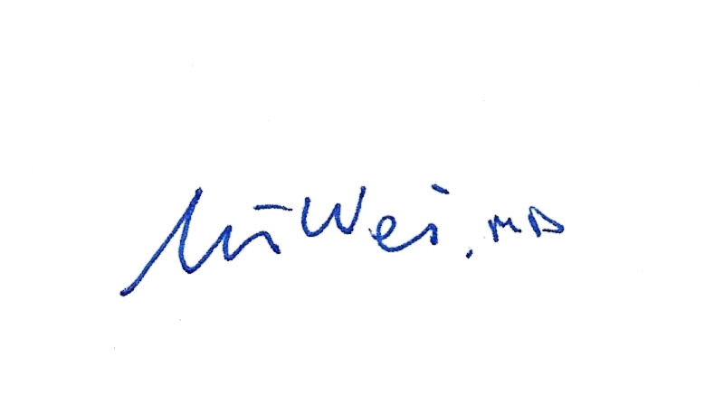 | 4/17/12
R. Fitzgerald | 5/2/14 |  | 7/10/14 |  | 7/17/14

