BLOOD TO CITRATE VOLUME

Principle

Dilution errors cause variable results. The proportion of blood to anticoagulant must be exact. Patients with a high hematocrit will have prolonged coagulation times because of the higher concentration of citrate in the plasma. Patient's samples whose hematocrit are greater than 55% are redrawn using a lesser amount of sodium citrate. A chart is used to determine the amount of sodium citrate/blood ratio.

Clinical Significance
Dilution errors may cause an increase in patient results, which will then impact patient care.

Specimen
Sodium citrate/blood volume is determined by procedure.

Reagents/Equipment
3.2% Sodium Citrate – (obtain from BD vacutainer blue top tube)
7ml Red Top Vacutainer Tube
10 ml Syringe & Needle

Quality Control - Non applicable

Procedure

1. Determine the patient's hematocrit using an EDTA sample or from the sodium citrate tube being sure to multiply the HCT by 1.1 for dilution affect.
2. Using the graph below, locate the hematocrit value on the bottom of the graph.
3. Follow the line up to graph until it intersects the 5 ml curved line.
Follow that line across to the left to determine the amount of anticoagulant solution to use.
4. Subtract that number from 5 to determine the amount of blood to mix with anticoagulant.
5. Pipette the amount of anticoagulant determined in step 3 into a 7ml red top tube.
6. Using a syringe, draw approximately 8 ml of blood. Remove needle from syringe, and dispense the amount calculated in step 4. The amount is critical so be very careful to dispense the exact amount.
7. Recap tube and gently mix 6-10 times.
8. Process specimen according to procedure performing.

Calculations

5 mls - X(Amt of Anticoagulant) = Volume of Blood to Dispense
from graph
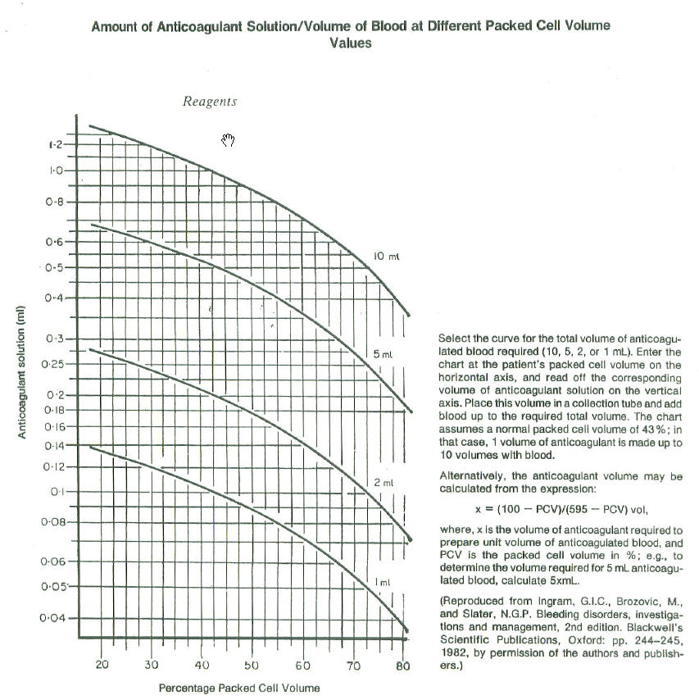

Reporting Results - Nonapplicable

References

1. NCCLS Vol 6, No. 20
2. Ingram, "The Prothrombin Time Test:Effect of Varying Citrate Concentration", Thrombosis and Hemostasis 36:230=236, 1976.

Author: Barb Chapman & Judy Sutherland Date: 10/15/92
Change of Medical Director: _________________________________ Date: ___7/17/14_____

Reviewed

Reviewed by
Lead | Date | Coordinator/ Manager | Date | Medical Director | Date
 |  |  | 4/20/10 |  | 3/29/10
 |  |  | 1/10/11 |  | 1/10/11
 |  |  | 4/24/12 |  | 4/20/12
R. Fitzgerald | 5/2/14 |  | 7/2/14 |  | 7/17/14

