**TRANSFUSION REACTION**

**Initial Workup and Extended Workup**

**Principle**

Any unexpected change in the patient's clinical condition during or following the transfusion of blood or blood components should be investigated for possible relationship to the transfusion. As outlined by the Standards of American Association of Blood Banks, three procedures are to be initiated immediately when there is a case of a suspected reaction to transfused RBC’s. These include clerical check of records and labels, pre- and post-inspection for visual hemolysis of serum, and direct coombs testing of pre- and post-transfusion samples.

If these studies show no evidence of hemolytic reaction, it may not be necessary to continue investigation. A review of the preliminary laboratory testing and the patient's clinical signs by the pathologist will determine the direction and extent of additional testing.

Transfusion reaction investigations shall proceed in all cases where the pathologist suspects a reaction may have taken place.

**IF ANY OF THE INITIAL STUDIES SHOW EVIDENCE OF A HEMOLYTIC REACTION, OR BACTERIAL CONTAMINATION, A PATHOLOGIST AND THE PATIENT'S PHYSICIAN. MUST BE NOTIFIED IMMEDIATELY.**

## Clinical Significance

|  |  |
| --- | --- |
| *Signs of a transfusion reaction to RBC’s\** | *Signs of transfusion reaction to Platelets* |
| flushing of the face | shaking |
| pain in the chest or lumbar region | lumbar pain |
| nausea | nausea |
| vomiting | vomiting |
| temperature increase ≥2°F | temperature increase ≥3°F |
| chills | chills |
| shock: hypotension/drop in blood pressure, shortness of breath (breath > 28 breaths per minute) | shock: hypotension/drop in blood pressure, shortness of breath (breath > 28 breaths per minute) |
| In a patient under general anesthetic, the only signs of a reaction may be unexplained increase in pulse, oozing, or increased bleeding. | rise or drop in systolic blood pressure>30 mmHg |
| Circulatory overload and hives (urticaria) **do not require** a transfusion reaction workup. | tachycardia >120 beats/min or >40/minute rise |

\**Or rare hemolytic reaction due to minor ABO incompatibilities in Platelets*

**Specimen**

1. Pre-transfusion specimen
2. K2 EDTA pink or lavender top tube drawn immediately after transfusion reaction called.

* Minimum Volume: Adult: 3.0 mL whole blood , Pediatric: 2 - K2 EDTA microtainers
* If stored at room temperature 15-30°C, stable for testing for 24 hours.
* If stored 2-8°C, stable for testing for 72 hours.
* Storage: 2-8°C for a minimum of 7 days after transfusion, or 10 days post crossmatch

1. Post-transfusion urine specimen upon request.

**Reagents**

Poly AHG antiserum

**Instrumentation/Equipment**

1. Tourniquet
2. Alcohol
3. Gauze
4. Vacutainer holder
5. Vacutainer Needle
6. Band-Aid
7. EDTA Tube

**Procedure**

**Suspected RBC Transfusion Reaction: Inpatient**

1. When a call comes from the floor of a possible transfusion reaction:

1. Inform the nurse to stop the blood immediately.
2. Verify the patient's physician has been notified.
3. If not, he/she should be called immediately and asked if a workup is requested.
4. When a 2-degree or greater rise in temperature is noted*, a workup is performed regardless* if the physician orders one.
5. If ordered, verify nurse has completed any pertinent forms for suspected Transfusion Reaction in either the EMR or on paper.
6. If the physician orders discontinuation of the unit, ask the RN to take the unit down, so it can be returned to Blood Bank. If the physician wants the reaction results first, have the RN return the bag to the Blood Bank when infused, if he wants the unit transfused.
7. Check all information with regards to the transfusion of this patient including:
8. Patient history documented in the transfusion service
9. Evidence of prior reactions to transfusions
10. Patient and unit identification at the bedside with correlation to the crossmatch tags from the unit the patient reacted to.
11. Information of all units transfused within the last 24 hours.
12. Take venipuncture equipment to the patient's room.
13. Verify that all information is correct:
14. Patient's name
15. Medical record number
16. Bedside type (if necessary)
17. Blood type on the unit, attached crossmatch tag
18. Unit number on the unit, attached crossmatch tag
19. Expiration date on unit
20. Check the IV solution and the surrounding conditions for anything that may explain the patient’s symptoms, such as excessive heat.
21. Verify patient identity.
22. Draw a K2 EDTA tube on the patient. Avoid hemolyzing samples.
23. Complete pertinent forms on transfusion reaction and ensure clerical check is documented in EMR (preferred) or on paper.
24. Instruct the nurse to send the first voided urine to the Blood Bank for potential workup (hemoglobin, bilirubin, and microscopy for RBCs).
25. The technologist will return to blood bank with:
26. Blood bag and IV set if doctor wants unit discontinued.
27. Any pertinent forms, either from the EMR (preferred) or on paper.
28. Any available empty bags of units transfused in the last 24 hours.
29. The transfusion reaction workup should be performed by a tech different than the one that performed the crossmatches, if possible.

**For Kindred Hospital patients**

1. When a call comes from Kindred Hospital of a possible transfusion reaction:

1. Inform nurse to stop the blood immediately.
2. Verify the patient's physician has been notified.
3. If not, he/she should be called immediately and asked if a workup is requested.
4. When a 2-degree or greater rise in temperature is noted*, a workup is performed regardless* if the physician orders one.
5. If ordered, verify the nurse has completed any pertinent forms for suspected Transfusion Reaction in either the EMR or on paper.
6. If the physician orders discontinuation of the unit, ask the RN to take the unit down, so it can be returned to Blood Bank. Have the RN return the bag to the Blood Bank when infused, if the physician wants the unit transfused.
7. Request that a K2 EDTA (purple top) tube is drawn and sent STAT.
8. Have the patient’s RN Verify that all information is correct on the Blood Bank Transfusion Record (or applicable crossmatch tag on unit):
9. Patient's name
10. Date of Birth
11. Blood Bank ID Band
12. Blood type on the unit, attached crossmatch tag
13. Unit number on the unit, attached crossmatch tag
14. Expiration date on unit
15. Kindred hospital should return the following to the Blood Bank
16. Blood bag including the IV set if doctor wanted the unit discontinued
17. Copy of Crossmatch Tag with transfusion reaction sections completed.
18. Any available empty bags of units transfused in the last 24 hours.
19. Check all information with regards to the transfusion of this patient including:
20. Patient history documented in the transfusion service
21. Evidence of prior reactions to transfusions
22. Information of all units transfused within the last 24 hours

**Resulting**

1. The initial workup includes:

|  |  |  |
| --- | --- | --- |
| Testing | Pre-Transfusion Sample | Post-Transfusion Sample |
| Direct Coombs | √ | √ |
| Hemolysis Check** | √ | √ |
| ABO and Rh |  | √ |
| ** If there is a question as to whether the phlebotomy technique caused hemolysis, a second sample should be drawn immediately. | | |

1. If the initial testing is negative and there are no clerical errors, no further workup is necessary unless specifically requested.
2. Phone floor to inform nurse that no evidence of a hemolytic transfusion reaction is found, especially if the physician wants to continue the transfusion after the investigation. This will minimize the delay in completing the transfusion and allow nurse to notify physician with preliminary results.
3. Skip to step 6.
4. If there are any positive reactions or any clerical errors, call a pathologist **IMMEDIATELY** , the Blood Bank Supervisor, and patient's physician.
5. **EXTENDED WORKUP:** If discrepant/positive results are found in the initial workup, it may be necessary to perform further testing as determined by the pathologist and/or the patient’s physician. Testing may include any of the following:
6. Antibody Screen (room temperature, 37ºC, and AHG / GEL testing) on pre- and post-samples. Method used depends on whether a known antibody already has been ID’d and its best reactivity. If it is a room temperature antibody, use the tube method. If it is an AHG antibody, use GEL.
7. Perform crossmatches at room temperature, 37ºC, and AHG/ gel.

• Major crossmatch - patient serum / donor cells

• Minor crossmatch - patient cells/ donor serum (only if path requests)

1. Re-type the donor unit(s), segment, and/or blood remaining in the bag.
2. Evaluate urine for hemoglobin, bilirubin, and microscopic examination for RBCs.
3. Repeat antigen typing of donor, if patient has antibody.
4. Bacteriology testing such as gram stain and culture of blood and/or IV solution.
5. BUN and Bilirubin drawn immediately and 5-7 hours post reaction.
6. Examination of the patient plasma for free hemoglobin and serum for haptoglobin.
7. Additional testing in extended workup should be added in the LIS
8. Save the results.
9. Deliver Transfusion Reaction results to Pathologist for review and resulting.
10. When the pathologist returns the forms, store a blood bank copy in Blood Bank Transfusion Reaction File. Put one copy in the pathologist’s billing box.
11. Ensure all tests are resulted out in LIS.

## Suspected Plateletpheresis Transfusion Reactions

1. When the nurse notifies blood bank, verify the following:
2. Transfusion has been stopped, if not stop immediately.
3. Physician has been notified and has ordered reaction workup.
4. If physician has not ordered workup, rise in temperature of >3 degrees warrants workup.
5. Nurse has completed any pertinent forms for suspected Transfusion Reaction in either the EMR (preferred) or on paper.
6. Plateletpheresis transfusion may cause severe hemolytic transfusion reactions through minor ABO incompatibility (1 in 3,000 to 1 in 10,000 in the US) 3. Consult with pathologist in order to determine whether a transfusion reaction should be worked up if platelets given are ABO incompatible and symptoms resemble that of a hemolytic transfusion reaction (see signs of Transfusion Reaction to RBCs).
7. The platelet unit should be returned to blood bank.
8. Take unit to microbiology for culture, and fill out Suspected Platelet Transfusion Reaction Review Form (see attachment A).
9. If the patient needs more platelets, another product can be ordered.
10. Document reaction in LIS.
11. When the final culture results are reported, document in LIS and take report to the pathologist on clinical for an interpretation.
12. When the pathologist has resulted out the interpretation, file original in Blood Bank Transfusion Reaction Folder (by year), and put one copy in the pathologist’s billing box.
13. If the culture is positive, notify ARC by sending a Suspected Post Transfusion Infection Case Notification Form.

## Suspected FFP/CRYO Transfusion Reactions

* Allergic transfusion reactions for FFP/CRYO do not require any work up by the blood bank.
* Reactions to FFP and CRYO may be an anaphylactic shock reactions or TRALI(Transfusion Associated Acute Lung Injury). If these types of reactions are reported to the Blood Bank, contact the Blood Bank Medical Director, clinical pathologist, or the pathologist on call. Save all of the patient lab samples and blood product bags for a potential investigation. The physician may want to assess the patient for IgA deficiency.
* If a patient has this type of reaction to FFP/CRYO document on patient profile in the LIS.

**Procedural Notes/Problem-Solving Tip**

1. DELAYED ANTIGEN - ANTIBODY REACTIONS**:** These delayed reactions may not show up for 7 days to several weeks after transfusion. They should be investigated the same as acute reactions, as far as possible and as appropriate.
2. **All Fatal Transfusion reactions must be immediately reported to the Bureau of biologics (301) 827-6220 (voicemail); (301) 827-6748 (Fax); Fatalities2@cber.fda.gou. (E-mail).**

When the only symptoms of a suspected transfusion reaction are fever, in the absence of a positive DAT and no evidence of hemolysis, additional testing is usually non-contributory. Cultures may be performed if required.

When the symptoms of a suspected transfusion reaction are pain, (chest, arm, or flank) additional investigation should include ruling out hemolysis, once hemolysis is ruled out, additional testing is usually non-contributory. Clinical correlation is also required.

Clinical correlation is required in many adverse reactions to transfusion and many are not readily classified, and could be idiosyncratic reactions. Considerations should include patient’s disease state, environmental factors, new additives, or new processing procedures.

### Additional Evaluation of Transfusion Reactions

|  |  |
| --- | --- |
| **Reaction Considered/Documented** | Additional Investigation |
| Acute Hemolytic Transfusion Reaction | * Plasma Free Hemoglobin * Haptoglobin * LDH * Urine Hemoglobin and Bilirubin |
| Anaphylactic reaction | * IgA deficiency * TRALI * Septic shock |
| Septic Shock | * Product culture, from bag if possible * Culture from patient |
| Severe Acute Shortness of Breath | * TRALI or circulatory overload   If TRALI is suspected: notify ARC so they can investigate donor(s) if indicated. |
| Non-immune hemolysis | Consider infusion pumps, administration with fluid other than saline, thermal conditions (malfunctioning blood warmer) |
| Delayed Transfusion Reaction | * Plasma free hemoglobin * In absence of positive DAT, consider sending the patient blood to reference lab for more sensitive or complex testing. Future transfusions with phenotypically matched blood may be recommended. |
| Post Transfusion Purpura | Anti PlA1 testing |

**References**

*1. AABB Technical Manual*, Sixteenth Edition, 2008, pages 723.

*2. AABB Standards*, 26th Edition, 2009, pages 78-79.

*3.* Mair B, Benson K. Evaluation of changes in hemoglobin levels associated with ABO-incompatible plasma in apheresis platelets. Transfusion. 1998;38:51-55.

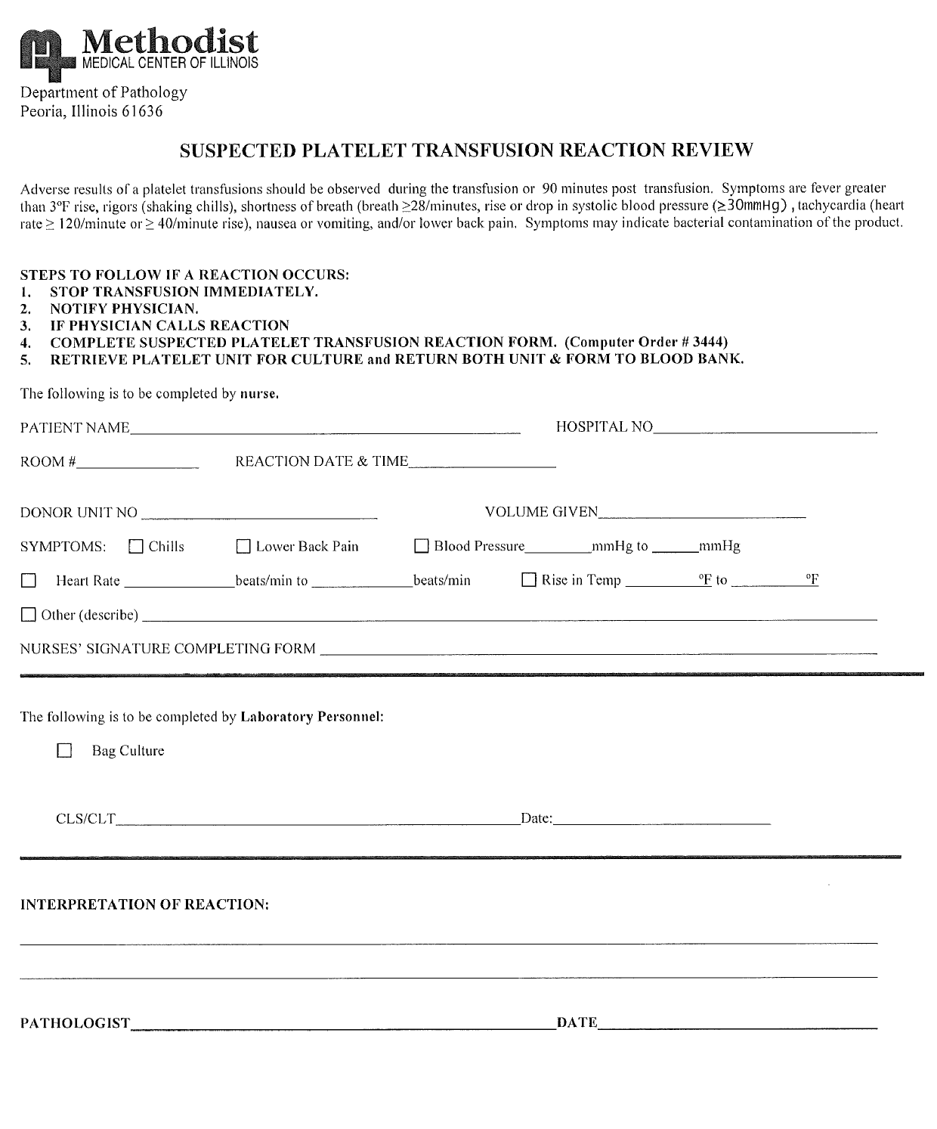

Attachment A

Author: Mary McCallister 06/2003

Medical Director Approval: Douglas McGrady, M.D. 10/28/2005

|  |  |  |  |
| --- | --- | --- | --- |
| **REVISION HISTORY** | | | |
| **Rev** | **Description of Change** | **Author** | **Effective Date** |
| 1 | Updated to reflect new LIS changes. Minor formatting, added Document ID to header. | T. Mikolajczyk | 12/06/2010 |
| 2 | Updated for Kindred Hospital processes | Seth Schaffer | 10/18/11 |
| 3 | Added use of Path Review stamp on TRXN Description and Treatment form, to include time in Step 20. | Kathy Turpin | 4/7/14 |
| 4 | Removed LIS specific references. Updated to reflect changes with Sunquest. Added ABO incompatible pltph note regarding minor incompatibility. | Vincent Strow | 2/10/2016 |

Reviewed

|  |  |  |  |  |  |
| --- | --- | --- | --- | --- | --- |
| **Reviewed by** | Date | **Coordinator** | **Date** | **Medical Director** | **Date** |
| K. Maher | 6/6/12 |  | 6/6/12 |  | 6/6/12 |
|  |  |  | 4/7/14 |  | 4/15/14 |
| V. Strow | 7/1/16 |  |  |  | 7/1/16 |
|  |  |  |  |  |  |
|  |  |  |  |  |  |