GRAM STAIN

Principle

The Gram stain is a DIFFERENTIAL STAIN which allows most bacteria to be divided into two groups, Gram-positive bacteria and Gram-negative bacteria. The technique is based on the fact that the Gram positive cell wall has a stronger attraction for crystal violet when Gram's iodine is applied than does the Gram negative cell wall. Gram's iodine is known as a MORDANT. It is able to form a complex with the crystal violet that is attached more tightly to the Gram-positive cell wall than to the Gram-negative cell wall. This complex can easily be washed away from the Gram-negative cell wall with ethyl alcohol. Gram-positive bacteria, however, are able to retain the crystal violet and therefore will remain purple after DECOLORIZING with acetone or the acetone alcohol mix. Since Gram-negative bacteria will be colorless after decolorizing with the decolorizer,, COUNTERSTAINING with safranin will make them appear pink. The procedure was discovered by Christian Gram in 1884.

Gram positive organisms are thought to retain the crystal violet dye because of the increased number of cross-linked teichoic acids and the decreased permeability of their cell walls to organic solvents, since they contain little lipid. Gram-negative organisms, because of higher lipid content associated with the cell wall, show increased permeability to decolorize and lose the crystal violet dye.

Clinical Significance

The Gram stain is used for the identification of bacterial morphotypes in clinical specimens and classifying these morophotypes as Gram positive (purple) or Gram negative (pink). Gram stain results can have dramatic effect on patient care. Hospitalization may be required when the Gram stain results indicate bacteria are present in a normally sterile body fluid. The initial choice of antibiotic therapy is guided by the Gram stain results in many cases. The Gram stain results are extremely important to the bench technologist interpreting cultures. The correlation of Gram stain results with organisms isolated on culture media can be invaluable in determine the significance of certain isolates. The number of various other cellular components including white blood cells and epithelial cells can shed light on whether an infectious process is present or if specimen used for culture was inadequate. Some specimens such as sputum are screened prior to actually setting up the culture and rejected if inadequate.

Specimen

- BioSafety Level 2 – Specimen Processing is performed inside a biological safety cabinet or behind a biosafety shield.
- Gram stains can be performed on any clinical microbiology specimen in which a Gram stain provides immediate useful information in the decision of empirical therapy to the patient. [(e.g. Sputum, Wound, Body fluid, Urine (special request not routine)]
- Gram stains can be performed on both cultures and colonies growing on solid media.

Reagents – stored at room temperature
- Gram's Crystal Violet
- Gram's Iodine prepare by adding iodine concentrate to the diluent. Mix well. Stable for 3 months, after preparation.
- Acetone or decolorizer prepared by mixing 1 part 95% ethyl alcohol with one part acetone.
- Safranin

Instrumentation/Equipment

Microscope - 10X,100X objectives
Microscope slide
Slide warmer (heat fix smear)

Quality Control
- All Gram stain reagents are quality controlled by lot # as they are received in the laboratory.
- Gram stain reagents in use are checked on a daily basis.
- Staff that perform stains infrequently should run a gram positive and gram negative control each day of testing.
- To perform QC, stain a prepared smear of Escherichia coli and Staphylococcus aureus. The results of the staining procedure should show Gram negative bacilli (red-pink) and Gram positive cocci (blue-purple). The slide background serves as a negative control.
- Gram stain QC results are logged on the appropriate daily/monthly QC chart at the workbench or online.
- Do not report patient results if quality control is not acceptable.
- Annual proficiency testing is performed by all staff responsible for testing to assure consistent reporting.
- When reading cultures direct gram stain results are reviewed to guide work ups. Every attempt is made to isolate all morphotypes observed in the gram stain.

Procedure
- Heat fix smear on slide warmer for 5 minutes.
- Flood smear with Gram's Crystal violet and let stain for at least 15 seconds to 1 minute. Drain off excess stain.
- Flood smear with Gram's Iodine and let stain for at least 15 seconds to 2 minutes.
- Wash smear briefly with tap water and drain off excess water.
- Decolorize smear with decolorizer until the solvent flows colorlessly from the slide. (Time depends on thickness of smear.)
- Wash with tap water and drain off excess water.
- Counterstain with safranin for at least 15-30 seconds.
- Wash with tap water and blot dry.
- Examine the smear microscopically using the 10X objective to quantitate the number of inflammatory and epithelial cells. These are quantitated as follows:
Few = 0-10/lpf Moderate = 10-25/lpf Many = >25/lpf
10. Quantitate and identify bacterial morphologies and Gram stain reactions using the 100 X objective (oil immersion) as follows:
Few = Organisms not in every field Moderate = <10 organisms/oif Many = >/=10 organisms/oif
11. Morphologies reported include:
- Gram positive cocci
- Gram positive diplococcic
- Gram negative bacilli
- Gram negative coccobacilli
- Gram negative diplococcic
- Gram positive bacilli (large, small)
- Gram positive coccobacilli
- Gram negative cocci
- Gram variable bacilli
- Gram variable coccobacilli
- Yeast
12. Modifiers are added as needed. e.g. In clusters, In chains, intracellular, etc.

Note 1: Gram stains of expectorated sputum specimens for routine culture are used to
determine the acceptability of the specimen prior to culturing. Sputum Gram
stains are screened using low power. Specimens with greater
than 25 squamous epithelial cells/low power field are rejected and the culture is
canceled. Proceed as follows:

- Report the Gram stain using the Phrase “SALV”. The following report will be generated:
“Specimen microscopically resembles saliva, not cultured”."
- Go to Culture Entry tab and hit semi-colon once then type HIDE. Final the culture and credit.
- Credit culture with retain results.

- Notify and document the appropriate nursing unit regarding rejected sputum culture testing.

Note 2: Any Surgery Specimen Gram stain with equivocal results should be brought to
the attention of a Pathologist. The Pathologist will in turn contact the surgeon
involved in the case, discuss the situation and determine how the technologist is
to report the results.

Note 3: Urine Gram Stain Procedure – Urine Gram stains are not performed routinely. When
specifically requested by a physician perform as follows:
a. Mix unspun urine well.
b. Obtain a microscope frosted end slide, mark a circle in the middle of the clear
section of slide using a black China marker or red Gram stain marker. Label frosted
end with 2 patient identifiers.
c. Pipet one drop of urine inside the marked area on the slide.
- Allow the drop to dry without spreading.
- Fix smear for 1 minute with methanol or heat fix on slide warmer for 5 minutes.
- Stain following Gram Stain Procedure.
- Scan smear using the 100X oil immersion objecting.
- Record the number of bacteria observed per oil immersion field along with the morphology and Gram reaction. Numbers over ten should be reported as > 10 bacteria/oif. (e.g. 3 Gram negative bacilli/oif; > 10 Gram positive cocci/oif)
- Report the number of WBCs observed per oil immersion field. Numbers over ten should be reported as >10 WBCs/oif.

Reporting Results

See Note 2 prior to resulting Gram stains performed on Surgery cultures.

.

Procedural Notes/Problem-Solving Tips

For Methodist Campus Only

- When reporting “NURFGS” (Normal Upper Respiratory Flora) in a gram stain, the following criteria should be used:
Presence of a mixture of gndc (Neisseria sp.) and gpc in pairs with chains (Alpha Strep). With this mixture, you can have a mixture of other organisms including: yeast, gnb gpb, gpc in clusters, etc. In these instances, nothing is in predominance.

NOTE: If the above is not present, do not report as “NURFGS”. List the morphotypes rather than listing as “NURFGS”.

References
- Murray, Patrick R., Baron, Ellen Jo, Pfaller, Michael A., Tenover, Fred C., Yolken, Robert H., Manual of Clinical Microbiology, 6th edition, pp.39-44.
- Clinical Microbiology Procedures Handbook, section 1.5 ASM, 1994.
- Baily and Scotts Diagnostic Microbiology 12th edition, 2007 page 80-83.

UnityPoint Health Methodist Laboratory is a CAP accredited facility, as of 7/1/11 the responsibility of new and/or substantially revised policies and procedures will be restricted the Laboratory Director whose name appears on the CLIA certificate, whose signature appears below. The biennial review will be completed by the Administrative Director.

Author: Terry A. Smith Lab Manager Date: 2/2/96
Name Title
Medical Director Approval: D. McGrady, M.D. Date: 2/11/96
Name

MEDICAL DIRECTOR
DATE | NAME | SIGNATURE
February 12, 2017 | Elizabeth A. Bauer-Marsh, M.D.
SECTION MEDICAL DIRECTOR
September 4, 2015 | Lori Racsa, DO

REVISION HISTORY
Rev | Description of Change | Author | Effective Date
 | Reviewed and signed | T. Smith | 5/23/11
1 | LIS updates, added Note 1, # 4, test comment area of the reports | T. Smith | 4/23/12
2 | Updates to meet 2012 CAP regulations | T. Smith | 6/13/12
3 | Update from weekly QC to daily QC include safranin as a counterstain. Include notification and documentation for rejected sputum specimens included stability of prepared iodine mordant | J. Corpus | 8/31/15
4 | Removed HLAB order # and HLAB resulting instructions | T Nuese | 2/3/16
5 | Alcohol changed, basic fuchsin removed, sputum rejection changed, Gram Stains for vaglurethral specimen removed results reporting on surgical specimens changed. | M. Bishoff | 8/14/17

Reviewed by
Lead | Date | Coordinator/Manager | Date | Medical Director | Date
 |  | 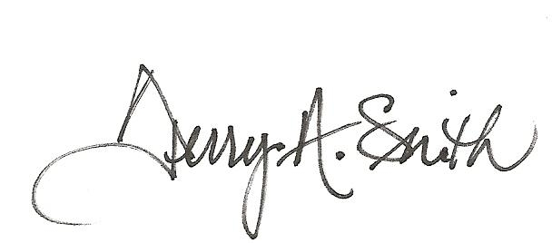 | 5/23/11 | 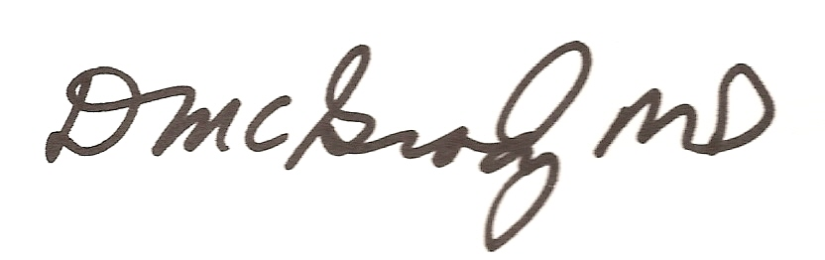 | 5/24/11
 |  |  | 4/23/12 |  | 5/5/12
 |  |  | 6/13/12 |  | 6/26/12
E Penning | 4/9/14 | 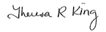 | 4/18/14 |  | 4/22/14
 |  |  | 8/31/15 |  | 8/31/15
 |  |  | 2/4/16 |  | 2/4/16
Marsha Bishoff | 8/14/17 |  | 8/16/17 |  | 8/23/17

