Methodist Health Services Corporation & UnityPoint Health Methodist |  | Page # 1 of 2 | Section: UPM MIC | Policy: 009.5
 | Laboratory | Approved by: see signature block at end of document |  | Date: 8/23/17
 | Laboratory | Date Revised: 6/2/06, 8/24/00, 5/25/11, 4/5/12, 6/13/12, 3/9/15, 8/23/17
 | Laboratory | Policy/Revision Submitted by: Jan Corpus, MT
 | Laboratory | JCAHO Standard: NA
SUBJECT: Biological Safety Cabinet Operation

- POLICY:
The Biological Safety Cabinets should be operated safely to insure that infectious aerosols are not release into the work environment.

- PURPOSE:
To insure a safe work environment.

- GENERAL INFORMATION:
The Biological Safety Cabinet is utilized to process clinical specimens in the Microbiology laboratory. The cabinet is designed to provide a marked degree of protection for personnel and the product within from airborne contaminants. Both cabinets the CCI and Baker are Class II, Type A2 cabinets. HEPA filtered air descends uniformly through the work zone. Air is pumped from the work zone to the HEPA filters where 30% is eliminated through the exhaust HEPA filter and approximately 70% is recirculated through the supply HEPA into the work area. The air re-entering the work area is better than Class 10 air. Since the cabinet must draw make-up air to replace the air exhausted through the exhaust filter, the same volume of air enters the system from the room environment through the front access opening. This air, which never enters the work zone, completes the air barrier at the unit face and is primarily responsible for the containment properties of the unit. Because room air enters through the intake grille at the front, work in the unit must be performed beyond it and onto the work tray. Any blockage of the perforated intake grill of the cabinet disrupts airflow, causes increased turbulence, promotes cross-contamination within the cabinet and generally results in an outward flow of air from the cabinet.

- PROCEDURE
- CCI Hood – Main Microbiology Laboratory
- Start Up Procedure:
- Turn white light switch to on.
- Insure that front of hood or glass section is latched.
- Place equipment to be used on work tray.
- Push blower switch on. Allow several minutes before utilization of the cabinet.
- Shut Down Procedure:
- Remove all equipment and materials from work zone.
- Wipe down interior and related equipment with suitable cleansing agent. (Cavicide)
- Turn off lights and blower.
- UV light can be turned on while no work is being done in the hood. (This does not replace cleaning the cabinet.)
- Baker Steril Gard III Hood – General Lab Microbiology Bench (Operation manual on side of hood)
- Start Up Procedure:
- Turn white light switch to on. (Will not operate unless UV light is off.)
- Insure that view screen is placed so the opening is 8-10”. The sash alarm will activate whenever the sash is raised or lowered from this level.
- Place equipment to be used on work tray.
- Turn blower on.

- Shut Down Procedure:
- Remove all equipment and materials from work zone.
- Wipe down interior and related equipment with suitable cleansing agent. Cavicide)
- Turn off lights and blower
- UV light can be turned on while no work is being done in the hood. (This does not replace cleaning the cabinet.)
- Labconco Purifer class II Safety Cabinet (Used for FilmArray Biofire testing)
- Start up Procedure:
- Turn light switch to on
- Turn blower switch to on
- Allow cabinet to run 15 minutes before
- Shut Down Procedure:
- Remove all equipment and materials from work zone.
- Wipe down interior and related equipment with suitable cleansing agent (Cavicide)
- Turn off lights and blower.
- UV light can be turned on while no work is being done in the hood (This does not replace cleaning the cabinet)
- Maintenance:
- Biological Safety Cabinets are certified annually by Clean Air Flow, Inc. (847-945-9393)
- UV light should be replaced every 6 months.
- Caution:
- Do not overload cabinet with unnecessary equipment.
- Do not block front air intake grille or rear exhaust grille.
- Do not perform any work with blower off.
- V. MAINTENANCE AND STORAGE
  - All policies and procedures are reviewed every two years, (except for Safety procedures which are yearly) by Laboratory Administration and or the Medical Director of the Laboratory or designee. There are changes in practice standards, or requirements.
  - All policies and procedures are reviewed every two years (except for Safety procedures which are yearly) by staff or at the time new or revised ones are put in effect.
  - All policies are retained 8 years after being discontinued or revised.
  - All procedures are retained 2 years after being discontinued or revise

MEDICAL DIRECTOR
DATE | NAME | SIGNATURE
February 12, 2017 | Elizabeth A. Bauer-Marsh, M.D.
SECTION MEDICAL DIRECTOR
September 30, 2015 | Lori Racsa, DO

REVISION HISTORY
Rev | Description of Change | Author | Effective Date
1 | Updates to meet CAP 2012 regulations | T. Smith | 6/13/12
2 | Update to the cleansing agent list to include Cavicide | J Corpus | 3/9/15
3 | Added Labconco Purifier safety cabinet | T Nuese | 8/11/17

Reviewed by
Lead | Date | Coordinator/Manager | Date | Medical Director | Date
 |  | 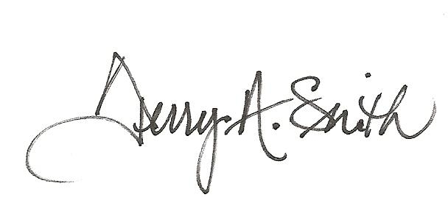 | 5/25/11 | 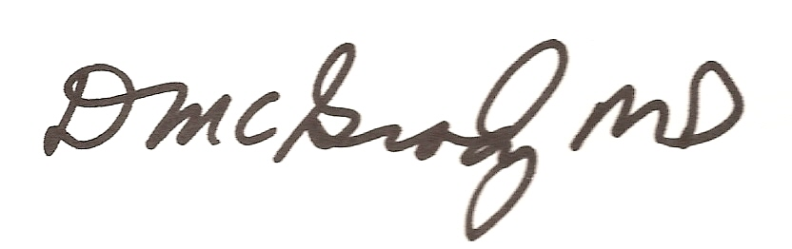 | 6/9/11
 |  |  | 4/5/12 |  | 5/5/12
 |  |  | 6/13/12 |  | 6/13/12
 |  |  | 3/9/15 |  | 3/9/15
Marsha Bishoff | 7/20/17 |  | 8/11/17 |  | 8/23/17

