MALARIA SMEAR
Thin & Thick Smear

PRINCIPLE
Part of the malarial parasite's cycle takes place in the erythrocyte. By making thin and thick smears and staining with Giesma stain, the parasites can be observed microscopically.

- CLINICAL SIGNIFICANCE
Malaria parasites when found on thin and/or thick smears are diagnostic of malaria.

SPECIMEN
Peripheral blood from a fingerstick is preferred but EDTA anticoagulated blood is acceptable. Blood smears should be prepared as soon as possible after collection (delay can result in changes in parasite morphology and staining characteristics). Specimen stability (from collection to initiation) is 24 hours at ambient temperature. Blood should be drawn between paroxysms for a least three successive days to indicate absence of infection.

- REAGENTS
- Fisher brand Modified Wright-Giemsa Stain Pak
- Positive parasite control slides

V. INSTRUMENTATION/EQUIPMENT
- Slides
- Applicator sticks or hematocrit tubes
- Hema-Tek 2000 slide stainer

PROCEDURE
- For preparation of thin smears, prepare four (4) wedge smears according to Blood Smears Preparation Procedure.
- Make three (3) thick smears:
- Place one large drop of blood in the middle of a glass slide
- Spread to about a 10mm circle.
- If the drop is from a finger stick, mix with applicator stick until fibrin has been removed.
- Air dry all drops thoroughly.
- Stain two (2) thin smears and one (2) thick smears, and (1) control slide. Leave the remaining smears unstained. The latter will prove useful if a problem occurs during the staining process and/or if the smears need to be sent to a reference laboratory.
- E. Stain the smears using the Hema-Tek 2000 slide stainer. This stain pak consists of a modified Wright’s /Giemsa stain, 6.8 ph buffer and a rinse solution.
- Scan thin smears under the light microscope scanning at least 300 microscopic fields for the presence of parasites.
- Deliver thin and thick stained smears to a pathologist for confirmation.
- All malaria smears, negative, suspicious, or positive must be confirmed by a pathologist.

- REPORTING RESULTS

Negative | “no malarial parasites seen”
Positive | malarial parasites are reported as % of infected RBC’s per 100 RBCs counted (ex. 0.5%, 1.0% , etc.)
Both positive and negative results must be confirmed by pathologist. Positive results must be phoned to the physician and/or nursing staff immediately. The Peoria Country Health Department must be notified within 7 days (see IDPH Policy).

VII. PROCEDURAL NOTE/PROBLEM-SOLVING TIP
- Thick smears need to dry thoroughly or parasites may be washed off in staining procedure, preferable 2-3 hours.
- Ocular Micrometer is available for sizing of parasites if needed; located in Dr. Bauer-Marsh’s office.

VIII. REFERENCES
- Finegold, Baron, "BAILEY & SCOTT'S DIAGNOSTIC MICROBIOLOGY, 9th Edition, 1994
- Leventhal R. ,"MEDICAL PARASITOLOGY:A SELF INSTRUCTIONAL TEXT", 4th Edition, 1996
- NCCLS. Laboratory diagnosis of bloodborne parasite diseases; approved guidline M-15_A. Wayne, PA: NCCLS, 2000
- Centers for Disease Control and Prevention

POLICY CREATION :
Author: Nancy Rutledge, CLS | August 26, 1996
Medical Director: Horea Baila, MD | August 31, 2010

MEDICAL DIRECTOR
DATE | NAME | SIGNATURE
February 11, 2017 | Elizabeth A. Bauer-Marsh, M.D.
SECTION MEDICAL DIRECTOR
February 3, 2011 | Wei Liu, M.D., PhD | 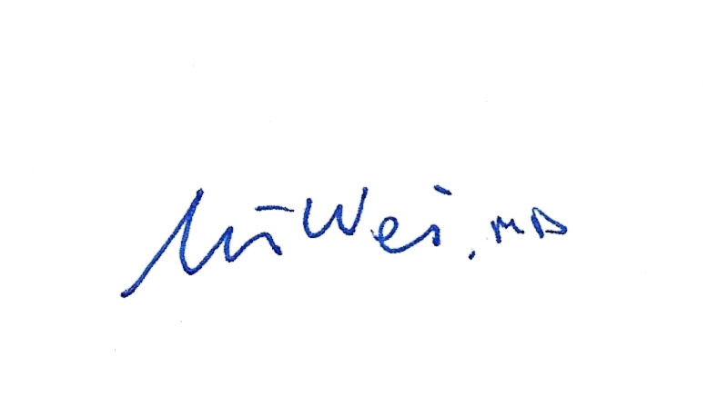
July 1, 2014 | Julia Adams, M.D.

REVISION HISTORY
Rev | Description of Change | Author | Effective Date
1 | Minor formatting changes. Removed LIS specific instructions. Added location of available micrometer. | T. Mikolajczyk | 8/31/10
2 | Removed Wright Stain. Added staining of slide to be performed in Histology. | Ron Fitzgerald | 1/26/16
3. | Change location of slide staining back to Hematology. Must be done on the Hema-Tek 2000 slide stainer. Added reagents and instrumentation. Roman numerals for different sections. | Kim Paige | 9/12/17

Reviewed by
Lead | Date | Coordinator/Manager | Date | Medical Director | Date
 |  |  | 8/30/10 |  | 8/31/10
 |  |  | 6/3/11 |  | 6/3/11
 |  |  | 11/8/11 |  | 12/11/11
 |  |  | 1/21/14 |  | 2/4/14
 |  |  | 8/22/16 |  | 9/16/16
Kim Paige | 9/12/17 |  | 9/13/17 |  | 9/20/17

