GRAM STAIN

PRINCIPLE
The Gram stain is a DIFFERENTIAL STAIN which allows most bacteria to be divided into two groups, Gram-positive bacteria and Gram-negative bacteria. The technique is based on the fact that the Gram positive cell wall has a stronger attraction for crystal violet when Gram's iodine is applied than does the Gram negative cell wall. Gram's iodine is known as a MORDANT. It is able to form a complex with the crystal violet that is attached more tightly to the Gram-positive cell wall than to the Gram-negative cell wall. This complex can easily be washed away from the Gram-negative cell wall with ethyl alcohol. Gram-positive bacteria, however, are able to retain the crystal violet and therefore will remain purple after DECOLORIZING with acetone or the acetone alcohol mix. Since Gram-negative bacteria will be colorless after decolorizing with the decolorizer,, COUNTERSTAINING with safranin will make them appear pink. The procedure was discovered by Christian Gram in 1884.

Gram positive organisms are thought to retain the crystal violet dye because of the increased number of cross-linked teichoic acids and the decreased permeability of their cell walls to organic solvents, since they contain little lipid. Gram-negative organisms, because of higher lipid content associated with the cell wall, show increased permeability to decolorize and lose the crystal violet dye.

CLINICAL SIGNIFICANCE
The Gram stain is used for the identification of bacterial morphotypes in clinical specimens and classifying these morophotypes as Gram positive (purple) or Gram negative (pink). Gram stain results can have dramatic effect on patient care. Hospitalization may be required when the Gram stain results indicate bacteria are present in a normally sterile body fluid. The initial choice of antibiotic therapy is guided by the Gram stain results in many cases. The Gram stain results are extremely important to the bench technologist interpreting cultures. The correlation of Gram stain results with organisms isolated on culture media can be invaluable in determine the significance of certain isolates. The number of various other cellular components including white blood cells and epithelial cells can shed light on whether an infectious process is present or if specimen used for culture was inadequate. Some specimens such as sputum are screened prior to actually setting up the culture and rejected if inadequate.

SPECIMEN
- BioSafety Level 2 – Specimen processing is performed inside a biological safety cabinet or behind a biosafety shield.
- Gram stains can be performed on any clinical microbiology specimen in which a Gram stain provides immediate useful information in the decision of empirical therapy to the patient. [(e.g. Sputum, Wound, Body fluid, Urine (special request not routine)]
- Gram stains can be performed on both cultures and colonies growing on solid media.

REAGENTS – stored at room temperature
- Gram's Crystal Violet
- Gram's Iodine prepare by adding iodine concentrate to the diluent. Mix well. Stable for 3 months, after preparation.
- Acetone or decolorizer prepared by mixing 1 part 95% ethyl alcohol with one part acetone.
- Safranin

INSTRUMENTATION/EQUIPMENT
Microscope - 10X, 100X objectives Slide warmer (heat fix smear) Microscope slide

QUALITY CONTROL
- All Gram stain reagents are quality controlled by lot # as they are received in the laboratory.
- Gram stain reagents in use are checked on a weekly basis.
- Staff that perform stains infrequently should run a gram positive and gram negative control each day of testing.
- To perform QC, stain a prepared smear of Escherichia coli and Staphylococcus aureus. The results of the staining procedure should show Gram negative bacilli (red-pink) and Gram positive cocci (blue-purple). The slide background serves as a negative control.
- Gram stain QC results are logged on the appropriate daily/monthly QC chart at the workbench or online.
- Do not report patient results if quality control is not acceptable.
- Annual proficiency testing is performed by all staff responsible for testing to assure consistent reporting.
- When reading cultures direct gram stain results are reviewed to guide work ups. Every attempt is made to isolate all morphotypes observed in the gram stain.

PROCEDURE
- Heat fix smear on slide warmer for 5 minutes.
- Flood smear with Gram's Crystal violet and let stain for at least 15 seconds to 1 minute. Drain off excess stain.
- Flood smear with Gram's Iodine and let stain for at least 15 seconds to 2 minutes.
- Wash smear briefly with tap water and drain off excess water.
- Decolorize smear with decolorizer until the solvent flows colorlessly from the slide. (Time depends on thickness of smear.)
- Wash with tap water and drain off excess water.
- Counterstain with safranin for at least 15-30 seconds.
- Wash with tap water and blot dry.
- Examine the smear microscopically using the 10X (low power) objective.
a. Evaluate the quality of the smear and staining.
b. Observe for presence of WBCs and epithelial cells. Quantitate as follows with the average of 20 to 40 fields:
Rare-<1/LPF Few: 1-9/LPF Moderate: 10-25/LPF Heavy: >25/LPF
10. Examine the smear using the 100X (high power/oil) objective. .
a. Observe organism morphology and Gram reaction and quantitate as follows:
Rare: <1/HPF Few: 1-5/HPF Moderate: 6-30/HPF Heavy: >30/HPF
11. Morphologies reported include:
- Gram positive cocci
- Gram positive diplococcic
- Gram negative bacilli
- Gram negative coccobacilli
- Gram negative diplococcic
- Gram positive bacilli (large, small)
- Gram positive coccobacilli
- Gram negative cocci
- Gram variable bacilli
- Gram variable coccobacilli
- Yeast
12. Modifiers are added as needed. e.g. In clusters, In chains, intracellular, etc.

REPORTING RESULTS

See Note 2 prior to resulting Gram stains performed on Surgery cultures.

PROCEDURAL NOTES
- Gram stains of expectorated sputum specimens for routine culture are used to determine the acceptability of the specimen prior to culturing. Sputum Gram stains are screened using low power. Specimens with greater than 10 squamous epithelial cells/low power field are rejected and the culture is canceled, unless there are moderate to heavy white blood cells and/or moderate to heavy quantitation of one predominant organism. Proceed as follows:
  - Report the Gram stain using the Phrase “SALV”. The following report will be generated: “Specimen microscopically resembles saliva, not cultured”."
  - Go to Culture Entry tab and hit semi-colon once then type HIDE. Final the culture and credit.
  - Credit culture with retain results.
  - Notify and document the appropriate nursing unit regarding rejected sputum culture testing.
- Any Surgery Specimen Gram stain with equivocal results should be brought to the attention of a Pathologist. The Pathologist will in turn contact the surgeon involved in the case, discuss the situation and determine how the technologist is to report the results.
3. For Methodist Campus ONLY: When reporting “NURFGS” (Normal Upper Respiratory Flora) in a gram stain, the following criteria should be used: Presence of a mixture of gndc (Neisseria sp.) and gpc in pairs with chains (Alpha Strep). With this mixture, you can have a mixture of other organisms including: yeast, gnb gpb, gpc in clusters, etc. In these instances, nothing is in predominance.
NOTE: If the above is not present, do not report as “NURFGS”. List the morphotypes rather than listing as “NURFGS”.

REFERENCES
Jorgensen, James H, Michael A. Pfaller, and Karen C. Carrol. Manual of Clinical Microbiology. Washington, DC: ASM Press, 2015.Leber, Amy L. Clinical Microbiology Procedures Handbook. Washington, DC: ASM Press, 2016.
Baily and Scotts Diagnostic Microbiology 12th edition, 2007 page 80-83.

UnityPoint Health Methodist Laboratory is a CAP accredited facility, as of 7/1/11 the responsibility of new and/or substantially revised policies and procedures will be restricted the Laboratory Director whose name appears on the CLIA certificate, whose signature appears below. The biennial review will be completed by the Administrative Director.

POLICY CREATION :
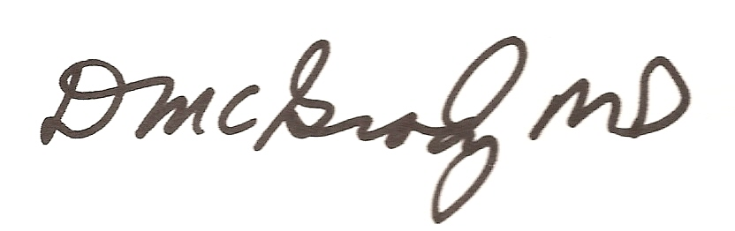  Author: Terry A. Smith | February 2, 1996
Medical Director: Douglas McGrady, M.D. | February 11, 1996

MEDICAL DIRECTOR
DATE | NAME | SIGNATURE
February 12, 2017 | Elizabeth A. Bauer-Marsh, M.D.
SECTION MEDICAL DIRECTOR
September 4, 2015 | Lori Racsa, DO

REVISION HISTORY
Rev | Description of Change | Author | Effective Date
 | Reviewed and signed | T. Smith | 5/23/11
1 | LIS updates, added Note 1, # 4, test comment area of the reports | T. Smith | 4/23/12
2 | Updates to meet 2012 CAP regulations | T. Smith | 6/13/12
3 | Update from weekly QC to daily QC include safranin as a counterstain. Include notification and documentation for rejected sputum specimens included stability of prepared iodine mordant | J. Corpus | 8/31/15
4 | Removed HLAB order # and HLAB resulting instructions | T Nuese | 2/3/16
5 | Alcohol changed, basic fuchsin removed, sputum rejection changed, Gram Stains for vaglurethral specimen removed results reporting on surgical specimens changed. | M. Bishoff | 8/14/17
6 | Changed Gram stain quantitation. Removed urine Gram stain. General formatting revisions. Updated references | A. Davis | 01/03/18

Reviewed by
Lead | Date | Coordinator/Manager | Date | Medical Director | Date
 |  | 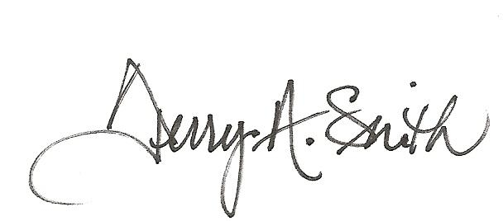 | 5/23/11 |  | 5/24/11
 |  |  | 4/23/12 |  | 5/5/12
 |  |  | 6/13/12 |  | 6/26/12
E Penning | 4/9/14 | 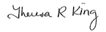 | 4/18/14 |  | 4/22/14
 |  |  | 8/31/15 |  | 8/31/15
 |  |  | 2/4/16 |  | 2/4/16
Marsha Bishoff | 8/14/17 |  | 8/16/17 |  | 8/23/17
Marsha Bishoff | 1/11/18 |  | 1/8/18 |  | 1/22/18

