MONOSPOT
CLEARVIEW MONO- (RAPID TEST)

Principle
The Clearview Mono test is a qualitative membrane strip based immunoassay for the detection of IM heterophile antibodies in whole blood. In this test procedure, bovine erythrocyte extracted antigen is coated on the test line region of the device. The sample reacts with bovine erythrocyte extracted antigen coated particles that have been applied to the label pad. This mixture migrates chromatographically along the length of the strip and interacts with the coated bovine erythrocyte extracted antigen. If the sample contains IM antibodies, a colored line will appear in the test line region indicating a positive result. If the sample does not contain IM heterophile antibodies a colored line will not appear in this region indicating a negative result. To serve as a procedural control, a colored line will always appear at the control line region, indicating that proper volume of specimen has been added and membrane wicking has occurred.

Clinical Significance
A positive Monospot is indicative of Infectious Mononucleosis. Some patients remain persistently negative for IM heterophile antibody even though there may exist other hematological and clinical evidence of Infectious Mononucleosis. In some of these patients, serological evidence for diagnosis of cytomegalovirus infection, toxoplasmosis, viral hepatitis, and others have been found.

Specimen
Specimen | EDTA K2 whole blood
Storage/Retention | 2-8° C for 7 days
Sample Stability | EDTA K2 whole blood: 2-8 ⁰C for up to 2 days
Rejection Criteria | Clotted specimens or those containing fibrin strands.  Improperly labeled samples.  Hemolysis  Samples suspected of intravenous fluid contamination.  Samples exceeding stability requirements or stored at room temperature for prolonged amount of time.

Reagents/Equipment
- Individually pouched test devices, each containing one disposable transfer pipette. Store at room temperature.
- Developer Buffer
- Negative Control – (Diluted human plasma, 0.09% sodium azide)
- Positive Control – (Diluted human plasma containing IM heterophil antibodies, 0.09% sodium azide)
- Timer

Note: Since reagents contain sodium azides, dispose of reagents in red/gray plastic bag. Do not interchange reagents from different kit lots or use beyond the expiration date.

Quality Control
Internal Controls | Verified/Documented with each patient analysis:  - Control Window: colored control band must appear in the window proves validity of testing.  - Test Window: clear background must be present
External Controls | Two levels included with kit (positive and negative) performed with each new lot and/or shipment.
If controls do not appear according to expected results, repeat on new test device, open new controls, and if needed, contact Technical Service at 877-441-7440, option 2.
New reagent lots and/or shipments are checked against old reagent lots or with suitable reference material before or concurrently with being placed in service.

Procedure
- Remove test device from sealed pouch.
- Label device with the patient’s information or control title.
- Dispense 2 drops of well mixed whole blood (about 50ul) to device sample well using transfer pipette provided.
- Hold buffer dropper bottle in a vertical position above the lower end of the “sample well” and dispense one drop into the well. Do not touch the tip of the sample buffer bottle to device.
- Wait for the red line(s) to appear. The results should be read at 5 minutes, but not after 10 minutes. Background should be clear before the result is read.

Interpretation of Results
POSITIVE | One red line in control region, one red line in test region.  Faint lines report as borderline, comment to “recommend retesting in 5-7 days.” | C  T
NEGATIVE | One red line appears in the control region, no apparent line in test region. | C  T
INVALID | No line appears in control region, with or wthout line in test region. | C  T

Reporting Results
Verify controls have been performed and found acceptable. Enter results in LIS in the “Manual Hematology Result Entry” screen. Modify the results, hit the << arrow to put all patients to the left, hit the result button, scan the barcode, hit the tab key, check 2 patient identifiers prior to saving the results, save and accept. Remember to document the Lot # of the kit, expiration date and QC ok on the line below the results.

Procedural Notes/Problem-Solving Tips
- Although most patients will have a detectable heterophile level within three weeks of infection, occasionally a patient with strong clinical signs of IM may take as long as three months to develop a detectable level. If further testing is desired, collect additional specimens every few days and retest.
- Some segments of the population who contract IM do not produce measurable levels of heterophile antibody. Approximately 50% of children under 4 years of age that have IM may test as IM heterophile negative. EBV-specific laboratory diagnosis may be helpful in these cases
- Microstick whole blood is processed/tested in the same manner as whole blood collected from a venipuncture, and should be tested immediately.

References
- Pediatric Clin North Am 1997 Dec; (6) 1541-56
- Omori, M. 2002 Mononucleosis.
- Alere San Diego, Inc. San Diego, CA 92121 USA 2013.

Author: Nancy Rutledge M.T. (ASCP) Date: 8/5/2007

MEDICAL DIRECTOR
DATE | NAME | SIGNATURE
February 11, 2017 | Elizabeth A. Bauer-Marsh, M.D.
SECTION MEDICAL DIRECTOR
June 10, 2011 | Wei Liu, M.D., PhD | 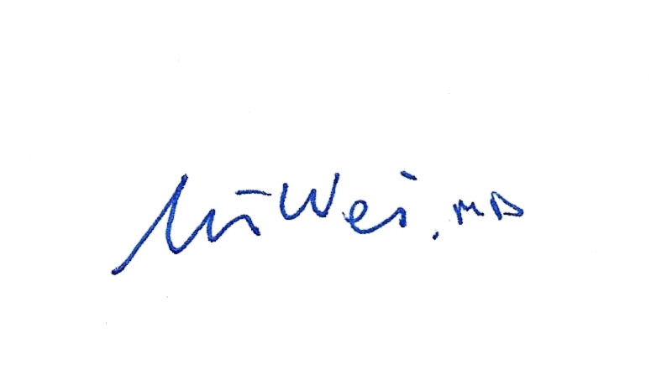
July 17, 2014 | Julia Adams, M.D.

REVISION HISTORY
Rev | Description of Change | Author | Effective Date
1 | Minor formatting changes. Added result interpretation detail | T. Mikolajczyk | 8/31/10
2 | Removed Developer Buffer composition. Added reagent cross-checking under QC. Minor word changes. Changed name of Reference. | Kathy Turpin | 7/10/14
3 | Changed acceptable specimen type to comply with IQCP | Kathy Turpin | 12/2/15
4 | Changed the storage/retention to 7 days | Kim Paige | 10/15/17
5 | Added the manual result entry procedure | Kim Paige | 1-9-18

Reviewed by
Lead | Date | Coordinator/  Manager | Date | Medical Director | Date
 |  | 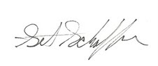 | 3/31/10 | 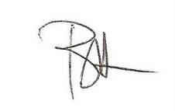 | 4/6/10
 |  |  | 8/31/10 |  | 8/31/10
 |  |  | 6/10/11 |  | 6/10/11
 |  |  | 6/21/12 |  | 6/20/12
R. Fitzgerald | 5/12/14 |  | 7/10/14 |  | 7/17/14
R. Fitzgerald | 12/3/15 |  | 12/2/15 |  | 12/18/15
Kim Paige | 10/15/17 |  | 11/13/17  11/7/17 |  | 11/8/7

