Erythrocyte Sedimentation Rate
STAT Plus

Principle
The ESR STAT analyzer uses centrifugation and photometric principles to measure Erythrocyte sedimentation rate (ESR). A specimen is placed in a calibrated capillary tube, and spun at approximately 2000 RPM’s for 3 minutes. The interface between the cells and the plasma is tracked by an infra-red laser and up to 100 measurements are taken. The measurements are plotted against time. An algorithm in the software identifies the portion of the curve that is linear, and the gradient is calculated and converted to the ESR (mm/hr) via a calibration curve.

Clinical Significance
Measurement of the erythrocyte sedimentation rate (ESR) is performed widely as a primary screening test in medicine. Although non-specific it is indicative of the presence of infectious, inflammatory, degenerative, or neoplastic conditions. The increased rate of red cell sedimentation in disease is mainly associated with qualitative and quantitative changes in the plasma proteins.

Specimen
Preferred Specimen | EDTA anticoagulated whole blood from routine venipuncture  or capillary blood from fingertip puncture.
Storage/Retention | 2-8° C for 4 days
Sample Stability | 8 Hours at Ambient 18-25 ° C
Sample Stability | 12 Hours at 2-8° C; return sample to room temperature prior to analysis.
Rejection Criteria | Clotted specimens or those containing fibrin strands.  Improper volume collected.  Improperly labeled samples.  Grossly hemolyzed.  Samples suspected of intravenous fluid contamination.  Samples exceeding stability requirements.

Reagents

ESR control material
Water-based wipes

Instrumentation/Equipment

ESR STAT ™ Plus Analyzer
Hematechnologies mylar wrapped, lithium heparinized calibrated analysis tubes.

Calibration
Calibration is done internally by the analyzer

Quality Control
R&D Systems controls (2 level Sed. rate controls)
Storage/Stability | Unopened: 2-8°C until expiration date
Storage/Stability | Opened: 2-8°C for 30 days
Preparation | Prior to use:  - Remove from refrigerator, let stand 25 minutes.  - Once at room temperature, mix for 3 minutes.  - Analyze and return to refrigerator within 60 minutes.
Run Frequency | 2 levels once per day of use

Procedure
- Verify specimen is at room temperature prior to analysis.
- Thoroughly mix the whole blood specimen in the EDTA collection tube.
- Fill the calibrated coated analysis tube to the black fill line using capillary action. DO NOT OVERFILL by more than 1 mm.
- Place the EDTA blood tube in a rack, and recap.
- Invert the calibrated capillary tube so that the fluid can reach the sealed end.
- Wipe around the tube outside edges of the tube with water based wipe to remove any blood from the outside of the analysis tube. Once the tube is wiped clean do not touch the wiped surfaces.
- Hold tube upright for 5 seconds.
- Verify an empty tube is in the “O” slot.
- To begin analyzing press 1 for ESR Test
- Insert the prepared analysis tube into slot 1 of the rotor and press 0.
- Input the patient identifier (Accession number i.e. 04-294-0123 = 2940123)
- For additional samples: insert tube into next slot, press 0, repeat step 11.
- Fit rotor lock and close lid.
- Press E to start.
- Results will be available in 4 minutes
- Open the lid on the ESR STAT PLUS; confirm that the blood sample(s) have not seeped out of the sample tubes. If blood is present around the inside of the instrument you must re-run the sample.
- Remove samples from instrument, close and lock lid.

Reporting Results
- If you have run only one sample, the screen will present result and at the bottom of the screen it will read (C=standby).
- Press E to display the results for the second sample run in this cycle.
- Press E to display the results for the third sample run in this cycle.
- Retrieving results from prior cycles:
- The instrument retains results for the prior 4 cycles. If the instrument is turned off, all prior results are lost.
- At the standby screen, press C to retrieve prior results.

Reference Range
Age | Range
0-17 years | 0-15 mm/hr
Adults ≥18y | Male: 0-15 mm/hr
Adults ≥18y | Female: 0-20 mm/hr
ESR Linearity Range | 1-145 mm/hr

Enter results in to the LIS in the “Hematology Manual Result Entry” screen. Modify the results, hit the << arrow to put all patients to the left, hit the result button, scan the barcode, hit the tab key, check 2 patient identifiers prior to saving the results. Remember to document the Lot # of the kit, expiration date and QC ok on the line below the results.

Procedural Notes/Problem-Solving Tips
- If testing is to be performed on a short draw specimen, it is better to run the ESR before running the CBC, as sampling from a blood collection tube with only a small amount remaining may be a poor representation of the original blood sample.
- When testing more than 1 sample at a time, it is important that the first sample not sit in the analyzer more than 5 minutes before initiating the analysis.
- Poor mixing is the most frequent cause of erroneous results.
- Even small clots in a specimen make the sample unacceptable for ESR analysis by this method.
- The sample tubes used in this system are of a patented design. The material at the closed end is permeable to air, however once it comes in contact with the blood the material becomes impenetrable to the forces of the spin, thus not allowing the blood to spin out of the tube during analysis. The analyzer will also wait 30 seconds before initializing the spin, so that this contact time can occur.
- The ESR STAT PLUS automatically warms up periodically whenever the instrument is turned on and whenever the instrument remains idle for more than 10 minutes. This automatic equilibration takes 1 minute and may be interrupted by pressing the stop button.
- When not in use – The lid must be closed and locked (locking is confirmed by an audible click).
- Whenever you remove the plastic rotor lock, always put it on the shelf near the lid hinge. This will prevent running the analyzer without the rotor lock in place.
- If for any reason, the ESR STAT PLUS is not available for use, call Proctor Hematology at 691-1060. Create a batch list-of all of the container ID numbers that will be going over to Proctor. Send with courier every 2 hours or call a cab after hours.to them for delivery to Proctor. After hours call a cab for transport to Proctor. Report Proctor reference range with the result.

References:

Hema Technologies, Inc User Manual

Author: Mary McCallister (MT ASCP) November 15, 2004
Name Title Date

MEDICAL DIRECTOR
DATE | NAME | SIGNATURE
February 11, 2017 | Elizabeth A. Bauer-Marsh, M.D.
SECTION MEDICAL DIRECTOR
April 3, 2012 | Wei Liu, M.D., PhD | 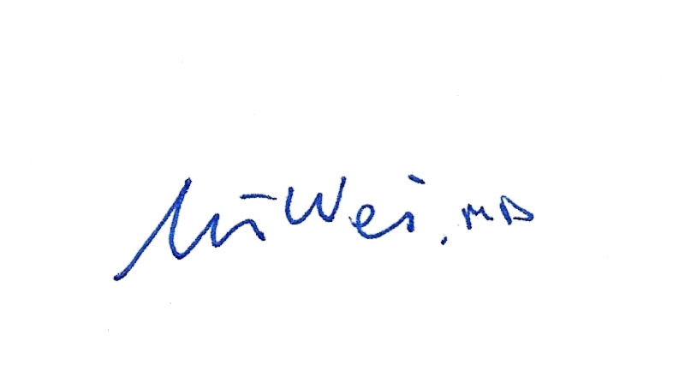
July 16, 2014 | Julia Adams, M.D.

REVISION HISTORY (began tracking 2010)
Rev | Description of Change | Author | Effective Date
1 | Minor formatting changes, updated specimen stability | T. Mikolajczyk | 8/31/10
2 | Added Linearity range; mail out procedure to OSF Hematology. | N. Rutledge | 11/8/11
3 | Changed order of two steps in procedure | R. Fitzgerald | 7/6/14
4 | Changed referral lab and phone number to Proctor. Added how to transport. | Kim Paige | 6-30-16
5 | Added manual entry procedure | Kim Paige | 1-9-18

Reviewed
Coordinator | Date | Medical Director | Date
 | 3/31/10 |  | 3/30/10
 | 08/30/10 |  | 08/31/10
 | 12/5/11 |  | 4/3/12
 | 7/6/14 |  | 7/6/14

