SICKLE CELL SCREEN
Solubility Methodology

Principle
Hemoglobin S forms elongated tactoids when deoxygenated which are then insoluble in concentrated phosphate solution. Under the same conditions, hemoglobin A, as well as most other hemoglobins are soluble. The Sickle Screen Kit is a modified Nalbandian procedure based upon this differential solubility. Red cells are lysed by a surfactant and the released hemoglobin is reduced by sodium hydrosulfite in a concentrated phosphate buffer. The released HbS when reduced in the phosphate buffer forms a turbid solution which is easily visualized. Normal HbA, as well as most other hemoglobins, remains as clear solution.

Clinical Significance
A positive sickle cell screen indicates the presence of sickling hemoglobin, usually hemoglobin S. Both sickle cell disease & sickle cell trait can be detected with this procedure.

Specimen
Preferred Specimen | whole blood in EDTA
Storage/Retention | 2-8° C for 7 days
Sample Stability | 7 days
Rejection Criteria | Clotted specimens or those containing fibrin strands.  Improper volume collected.  Improperly labeled samples.  Grossly hemolyzed.  Samples suspected of intravenous fluid contamination.  Samples exceeding stability requirements.

Reagents/Equipment
1. Pacific Hemostasis Sickle Screen Kit
a. Phosphate Buffer - a concentrated solution containing surfactant. Store at room temperature prior to reconstitution.
b. Sodium Hydrosulfite Vials (store at room temperature prior to reconstitution.)
- Reconstitute buffer by pouring the entire contents of one sodium hydrosulfite vial into one phosphate buffer bottle. Do not use sodium hydrosulfite powder if it is not free flowing.
- 2) Cap bottle, mix and let stand 15 minutes to dissolve sodium hydrosulfite.
- 3) Date and initial bottle at time of reconstitution. Keep tightly capped.
4) Store phosphate/hydrosulfite solution at 2-8°C. Use within 28 days of reconstitution.
2. 50 µl pipette
- Tube Reading Rack
- Clear 12x75 test tubes
- Pacific Hemostasis Control Set - One bottle of AS (positive control), one bottle of AA (negative control).
- Reconstitute the positive and negative controls by adding 0.5 ml of Reconstitution Fluid.
- Let vials set undisturbed for 30 minutes, then mix by vortexing.
- Store at 2-8°C. Reconstituted controls are stable for up to 21 days.

Quality Control
1. Run a positive and negative control with each group of patient samples.
2. Vortex controls prior to each use.

Procedure
- Label 12X75mm tubes (+ control, = control, & patient) and place into the Tube Reading Rack.
- Pour 4 ml of reconstituted phosphate buffer/sodium hydrosulfite to each tube.
2. Allow solution to come to room temperature for 15 minutes.
- Add 50 ul of mixed whole blood and 50 ul of each control to properly labeled tubes.
- Severe anemia can cause a false negative.
- Once mixed, if solution appears light in color, check hemoglobin.
- If hemoglobin is less than 8 grams, use 100 ul of blood instead of 50 ul.
4. Cover each tube and invert 3-4 tubes to thoroughly mix solution.
5. Incubate tubes at room temperature in the Reading Rack for a minimum of 10 minutes and a maximum of 20 minutes.
6. Read by observation:
Negative | viewing the black lines embossed on the reading rack through solution.
Positive | no lines observed when looking through solution

- Repeat all positive results using saline suspended patient's red cells to eliminate false positives due to lipemia and dysglobulinemias.
- Centrifuge an aliquot of blood.
- Remove the plasma and replace by saline.
- When test is completed, dilute tubes with running water before pouring down drain due to azide contents of buffer.
- Flush with large volumes of water to prevent buildup in metal piping.

Reporting Results
Verify controls were performed and found acceptable on day of testing. Proceed to enter results in the LIS in the “Hematology Manual Result Entry” screen. Modify the results, hit the << arrow to put all patients to the left, hit the result button, scan the barcode, hit the tab key, check 2 patient identifiers prior to saving the results. Remember to document the Lot # of the kit, expiration date and QC ok on the line below the results.

Procedural Notes/Problem-Solving Tips

1. Samples from infants less than 6 months of age may give false negative results. Perform the procedure and if negative footnote “high concentrations of hemoglobin F may give a false negative result; samples from infants less than 6 months of age are incompatible with this procedure".
2. Samples from patients recently transfused with blood containing HGB S may give false positive or false negatives.
3. Rare hemoglobin variants such as hemoglobin C Harlem or C Georgetown may also give positive sickling screens.
4. It is recommended that all positive results be confirmed by electrophoresis. A footnote to this effect is automatically charted on every positive result.

References
1. Pacific Hemostasis Sickle Screen Kit Insert (2503 Rev. 10-95)
2. McKenzie, "TEXTBOOK OF HEMATOLOGY", Williams & Wilkins, 1996

Author: Hematology SDWT Date: 8-13-96 Date: 04/06/06
Revised : 4/06/06

Medical Director Approval:  Date: 8/31/10

MEDICAL DIRECTOR
DATE | NAME | SIGNATURE
February 11, 2017 | Elizabeth A. Bauer-Marsh, M.D.
SECTION MEDICAL DIRECTOR
July 11, 2011 | Wei Liu, M.D., PhD | 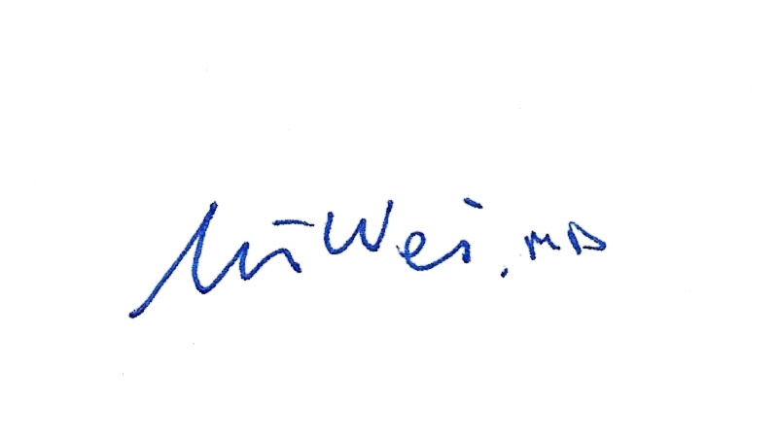
July 2, 2014 | Julia Adams, M.D.

REVISION HISTORY
Rev | Description of Change | Author | Effective Date
1 | Grammar changes. Added storage temp of reagents. Changed when to run QC. | Kathy Turpin | 7/17/2013
2 | Added to clinical significance: both sickle cell disease & trait can be detected. | R. Fitzgerald | 10/8/15
3 | Added the manual result entry procedure. Changed storage requirements. | Kim Paige | 1-18-18

Reviewed by
Lead | Date | Coordinator/ Manager | Date | Medical Director | Date
 |  | 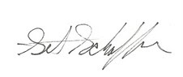 | 3/31/10 |  | 4/6/10
 |  |  | 8/19/10 |  | 8/31/10
 |  |  | 7/11/11 |  | 7/11/11
 |  |  | 7/19/13 |  | 7/19/13
R. Fitzgerald | 9/9/15 |  | 10/8/15 |  | 2/1/16

