  METHODIST |  |  | Page 1 of 3 | Section: UPM BBPRO | Policy #: 02.036
 | BLOOD BANK |  | Approved by: see signature block at end of document |  | Date: 3/5/18  Review by: 3/5/20
 | LABORATORY |  | Supersedes: 6/20/11, 7/16/13, 2/10/16, 3/5/18  Date Revised: 3/5/18
Primary Responsible Parties: Leah Miller
Secondary Responsible Parties: June Bembenek
 |  |  | CAP Standard:
SUBJECT: |  | RECEIVING BLOOD FROM AMERICAN RED CROSS

- PRINCIPLE
Ensuring the safety of the Blood Bank Inventory is essential to operate and effective Transfusion Service. Units of blood received from outside sources must be stored at the appropriate temp throughout the transport and delivery process.

POLICY SCOPE
The scope of this policy applies to all Laboratory staff that prepares or performs testing on laboratory specimens at UnityPoint Methodist.

- TRANSPORT STABILITY
The American Red Cross has validated each of the following containers and has found them to be sufficient for storage of all products for up to 24 hours.

RBC’s
24 Hr. storage
Small Box—1-12 units
7 lbs. of wet ice

Large Box—13-27 units
9 lbs of wet ice

Platelets
24 Hr. storage
1-5 units (volume maximum requirements of 1.950 mL or less)
Pack with 4 TSP’s (temperature stabilizing packs)

Plasma
24 Hr. storage
Small Box—1-5 FFP
6 lbs. of dry ice

Large Box—6-14 FFP
9 lbs. of dry ice

Cryo
24 Hr. storage
Small Box—1-9 cryo singles or 1-5 cryo pools
6 lbs. of dry ice on bottom and top of box

Large Box—30 cryo singles or 6-14 cryo pools
9 lbs. of dry ice on bottom and top of box

- PROCEDURE
- Remove units from the ARC packing container as soon as possible.
- Write the date and time you unpacked the container along with your initials on the packing list.
- Ensure number of units ordered matches the number of units in the delivery.
- Enter units into the computer and place in the proper storage.
  - Place RBC Units on the shelf labeled “Unprocessed” in the blood bank refrigerator. Units need to remain on the shelf until they are recorded into the blood bank inventory (in the LIS) and confirmation testing is completed.
  - After performing ABO confirmation on RBC units, place into appropriately labeled shelves in the right blood bank refrigerator.
  - Place platelets in the platelet incubator
  - FFP and Cryo are stored in the blood bank freezer.

- PROCEDURAL NOTES/PROBLEM-SOLVING TIPS
Refer to procedure Verifying ABO and RH on Blood Received from and outside source for confirmation testing procedure.

- REFERENCES:
American Red Cross
Horizon Blood Bank
POLICY CREATION :
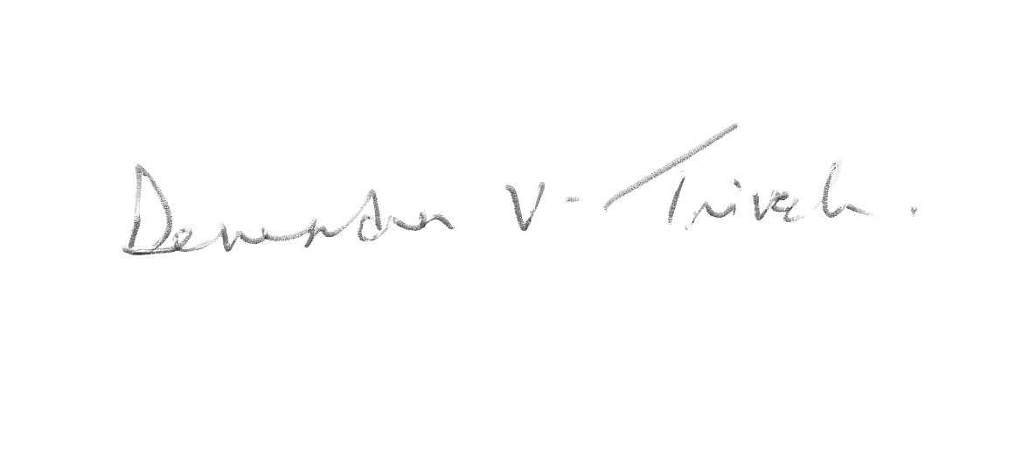  Author: Seth Schaffer | June 20, 2011
Section Medical Director: Devendra Trivedi, MD | July 19, 2011

REVISION HISTORY
Rev | Description of Change | Author | Effective Date
0 | New Procedure | S. Schaffer | 6/20/11
1 | Added references | K. Turpin | 7/16/13
2 | Removed LIS specific references | V. Strow | 2/10/16
3 | Removed wording under procedure as to where to store units. | L. Miller | 12/20/17

Reviewed by
Lead | Date | Coordinator/  Manager | Date | Medical Director | Date
Kathy Maher | 7/11/11 | 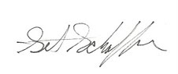 | 7/7/11 |  | 7/7/11
K.athy Maher | 7/22/13 |  | 7/17/13 |  | 8/8/13
Vincent Strow | 10/19/15 |  | 12/30/15 |  | 12/30/15
Leah Miller | 12/20/27 |  | 12/21/17 |  | 3/5/18

