Ordering/Shipping Thin Prep Pap Smear Specimens

PRINCIPLE
The physician’s order for Thin Prep pap smears should be properly ordered and shipped.

CLINICAL SIGNIFICANCE
Not applicable.

SPECIMEN
Any gynecologic specimen in a thin prep vial accompanied with the appropriate test orders.

REAGENTS
Not applicable.

INSTRUMENTATION/EQUIPMENT
Not applicable.

CALIBRATION
Not applicable.

QUALITY CONTROL
Not applicable.

PROCEDURE
- Thin Prep vials received from clinicians’ offices must be sent to ARUP Laboratory for processing.
- Register case into Epic
- Accession case in PowerPath
- Fill out ARUP requisition, including preferred HPV testing (if any)
- Specimen and requisition are placed in a biohazard bag and put in the ARUP refrigerator in the storeroom.

REPORTING RESULTS

- Print the final report from ARUP Connect at aruplab.com

- Scan the report, physician requisition, and ARUP requisition into PowerPath and the report into Epic.
- Copy of report will be faxed or sent via courier to clinician’s office.

MMCI Laboratory is a CAP accredited facility, as of 7/1/11 the responsibility of new and/or substantially revised policies and procedures will be restricted the Laboratory Director whose name appears on the CLIA certificate, whose signature appears below. The biennial review will be completed by the Administrative Director.

POLICY CREATION :
Author: Shea N. Cox, CT (ASCP) | August 21, 2012
Medical Director: Devendra Trivedi, MD | August 21, 2012

MEDICAL DIRECTOR
DATE | NAME | SIGNATURE
February 11, 2017 | Elizabeth A. Bauer-Marsh, M.D.
SECTION MEDICAL DIRECTOR
August 21, 2012 | Devendra Trivedi, MD

REVISION HISTORY (began tracking 2011)
Rev | Description of Change | Author | Effective Date
1 | Initial Release | S. Cox | 8/21/12
2 | Changed from manual log to PowerPath | S. Cox | 4/30/14
3 | Change of title (HPVs no longer sent out), included scanning instructions, change where specimens are left | S. Cox | 3/10/16

Reviewed by
Lead | Date | Coordinator/Manager | Date | Medical Director | Date
 | 8/21/12 | 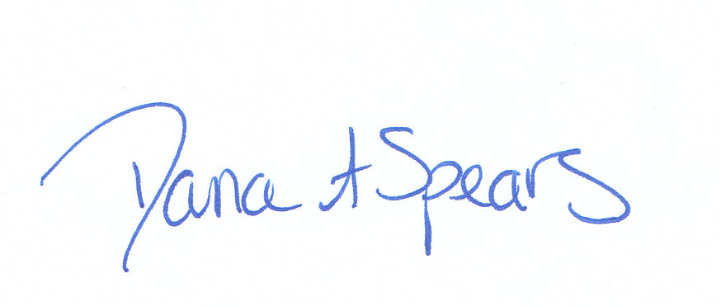 | 8/21/12 |  | 8/21/12
 | 4/30/14 |  | 5/8/14 |  | 5/8/14
 | 3/10/16 |  | 3/11/16 |  | 3/18/16

