  METHODIST |  |  | Page 1 of 3 | Section: UPM CYTO | Policy #: 14
 | CYTOLOGY |  | Approved by: see signature block at end of document |  | Date: 3/1/18  Review by: 3/1/20
 | LABORATORY |  | Policy Created: 10/11/94 Date Revised: 3/1/18  Supersedes:8/3/12, 5/8/14, 3/18/16
Primary Responsible Parties: Shea Moore
Secondary Responsible Parties: Deb Deeb
 |  |  | CAP Standard: CYP.0600, COM.06100
SUBJECT: |  | CYTOLOGY SPECIMEN COLLECTION AND TEST ORDERING ACCURACY STANDARD

- POLICY:
Policy in place to provide consistent guidelines for cytology specimen and submission to this laboratory.

- PURPOSE:
To define the proper techniques for ordering tests, specimen collection, handling, labeling, and transporting
specimens to the laboratory.

- POLICY SCOPE:
The scope of this applies to any staff collecting non-gynecological specimens.

- GENERAL INFORMATION:
Cytology instructions are included in the Guide to Laboratory Services which is available in all clinics and offices.
An updated and changed policy may be sent to the clients periodically prior to revising this manual.

IV. PROCEDURE:
- Criteria
- Collection and submission - Specimens are collected, handled, labeled, and transported according to
established procedures in the cytology instructions of the Guide to Laboratory Services.
- Ordering accuracy
  - Test ordered by qualified individual
  - Test order agrees with type of specimen sent
  - Test requisition is complete and accurate
- Accuracy of specimen identification
  - Patient's name is clearly written on slide (for prepared slides) or specimen container (for fluids). Note: test requisition wrapped around unidentified slide or specimen container is not sufficient identification.
  - Name on specimen/slide matches that on test requisition.

- Monitoring
    - Gross Inspection
A rejection letter is sent and a copy retained for all specimens that do not meet ordering accuracy and specimen submission criteria. Discrepancies are referred to the pathologist in charge of cytology if necessary. When possible, a cytology employee will call and get any information which is missing (LMP, age, client, etc...).

    - Unlabelled specimens
Slides and requisitions are returned to the requesting physician's office. A rejection letter is sent and a copy retained for all specimens that do not meet the above criteria.
    - Microscopic evaluation of specimen adequacy
Unsatisfactory Specimens - Specimens that are unsatisfactory due to low cellularity, poor preservation, obscuring inflammation, etc. will monitored and included in the monthly GYN and Non-GYN statistics.
- Threshold for evaluation
- If greater than 10% of specimens from any one physician are incorrectly submitted, that physician will be investigated.
NOTE: Threshold may be lower depending on the type of discrepancy. This will be monitored as necessary.
- All unlabeled specimens will be returned to the source for proper labeling before processing.
A frequency of greater than 10% unlabeled specimens of the total receipts from each physician will be investigated.
- QC studies will be conducted as necessary for physicians with a large number of Pap smears showing no endocervical/transformation zone component.
4. Evaluation and correction
- Remedial action is noted on requisition (e.g., phone call to include date, time, parties involved) and on the Specimen Rejection Letter.
b. Rejection Letter Folder is reviewed periodically by the Cytology Coordinator.
c. Trends are identified.
d. Plan of action is formulated when determined to be necessary by the Cytology Laboratory Director.
V. MAINTENANCE AND STORAGE
  - All policies and procedures are reviewed every two years, (except for Safety procedures which are yearly) by Laboratory Administration and or the Medical Director of the Laboratory or designee.
  - The Laboratory Administration and Medical Director review policies and procedures when there are changes in practice standards, or requirements.
  - All policies are retained 8 years after being discontinued or revised.
  - All procedures are retained 2 years after being discontinued or revised

POLICY CREATION :
Author: Devendra Trivedi, MD | October 11, 1994
Medical Director: Devendra Trivedi, MD | October 11, 1994

MEDICAL DIRECTOR
DATE | NAME | SIGNATURE
February 11, 2017 | Elizabeth A. Bauer-Marsh, M.D.
SECTION MEDICAL DIRECTOR
October 11, 1994 | Devendra Trivedi, MD
October 7, 2017 | Katherine Kasper, MD

REVISION HISTORY (began tracking 2011)
Rev | Description of Change | Author | Effective Date
1 | Updated system name | T. Lanan | 5/8/14

Reviewed by
Lead | Date | Coordinator/Manager | Date | Medical Director | Date
 | 8/3/12 | 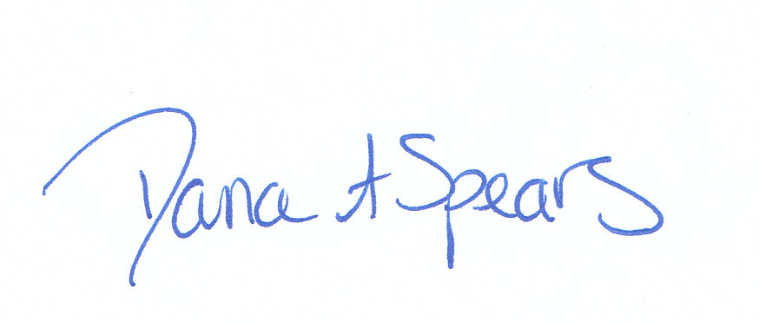 | 8/3/12 |  | 8/3/12
 | 4/30/14 |  | 5/8/14 |  | 5/8/14
 | 3/10/16 |  | 3/11/16 |  | 3/18/16
Shea N. Moore, CT (ASCP) | 2/26/18 |  | 3/13/18 |  | 3/1/18

