  METHODIST |  |  | Page 1 of 2 | Section: UPM CYTO | Policy #: 10
 | CYTOLOGY |  | Approved by: see signature block at end of document |  | Date: 3/1/18  Review by: 3/1/20
 | LABORATORY |  | Policy Created: 10/17/1994 Date Revised: 3/1/18  Supersedes:5/23/12, 4/4/14, 3/16/16, 3/1/18
Primary Responsible Parties: Shea Moore
Secondary Responsible Parties: Deb Deeb
 |  |  | CAP Standard: CYP.03800
SUBJECT: |  | CRITERIA FOR REJECTION OF PAP SMEAR SPECIMENS
- POLICY:
To outline criteria for the rejection of Pap smear specimens.

II. PURPOSE:
To provide guidelines on criteria for the rejection of Pap smear specimens.

III. POLICY SCOPE:
The scope of this applies to any staff collecting non-gynecological specimens.

III. GENERAL INFORMATION:
All rejected Pap smear specimens are unsuitable for diagnostic interpretations.

IV. PROCEDURE:
- The specimens under the following conditions will be considered for rejection:
1. Unlabelled or improperly identified as to the patient.
- The slides are received broken beyond repair.
- Name on the requisition does not match name on specimen container.

B. The submitting physician will receive a letter along with the specimen explaining why the specimen is being rejected. (See form letter) A copy of this letter will be made and put in a file marked “rejection letter sent to Physician office”.

V. MAINTENANCE AND STORAGE
  - All policies and procedures are reviewed every two years, (except for Safety procedures which are yearly) by Laboratory Administration and or the Medical Director of the Laboratory or designee when there are changes in practice standards, or requirements.
  - All policies and procedures are reviewed every two years (except for Safety procedures which are yearly) by staff or at the time new or revised ones are put in effect.
  - All policies are retained 8 years after being discontinued or revised.
  - All procedures are retained 2 years after being discontinued or revised

MMCI Laboratory is a CAP accredited facility, as of 7/1/11 the responsibility of new and/or substantially revised policies and procedures will be restricted the Laboratory Director whose name appears on the CLIA certificate, whose signature appears below. The biennial review will be completed by the Administrative Director.

POLICY CREATION :
Author: Shea Cox, CT (ASCP) | May 23, 2012
Medical Director: Devendra Trivedi, MD | May 23, 2012

MEDICAL DIRECTOR
DATE | NAME | SIGNATURE
February 11, 2017 | Elizabeth A. Bauer-Marsh, M.D.
SECTION MEDICAL DIRECTOR
May 23, 2012 | Devendra Trivedi, MD
October 7, 2017 | Katherine Kasper, MD

REVISION HISTORY (began tracking 2011)
Rev | Description of Change | Author | Effective Date
1 | Reviewed and signed, changed maintenance statement to reflect new CAP guidelines for every 2 year review. | T. Lanan | 5/23/12
2 | Changes made to rejection letter, specimens are rejected due to missing cervical brush | S. Moore | 2/9/18

Reviewed by
Lead | Date | Coordinator/Manager | Date | Medical Director | Date
 | 5/23/12 | 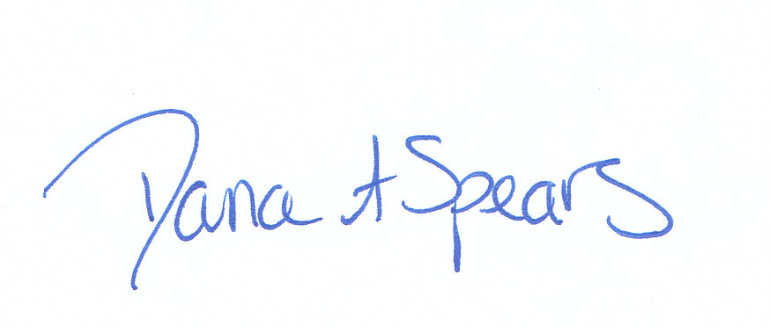 | 5/23/12 |  | 5/23/12
 | 3/20/14 |  | 4/4/14 |  | 4/4/14
 | 3/10/16 |  | 3/10/16 |  | 3/16/16
Shea N. Moore, CT (ASCP) | 2/9/18 |  | 3/13/18 |  | 3/1/18

