  METHODIST |  |  | 1 of 3 | Section: UPM HEMO | Policy #: 07
 | HEMATOLOGY |  | Approved by: see signature block at end of document |  | Date: 3/20/18  Review by: 3/20/20
 | LABORATORY |  | Policy Created: 10/20/97  Supersedes: 1/19/10, 8/2/12, 7/17/14, 7/25/16, 3/20/18
Primary Responsible Parties: Kim Paige
Secondary Responsible Parties: June Bembenek
 |  |  | CAP Standard: NA
SUBJECT: |  | MALARIA SMEARS SUBMITTED TO IDPH

I. POLICY
Positive malaria smears must be submitted to IDPH.

II. PURPOSE
IDPH will identify the malaria species and send the information to the Center of Disease Control.

III. POLICY SCOPE
Hematology Technologists.

VI. GENERAL INFORMATION
All positive malarial smears must be sent to IDPH for speciation. Send 2 - 4 Wright stained smears. Giemsa stained smears are optional. In addition to sending the smears to IDPH, the Peoria County Health Department must be notified.

V. PROCEDURE
- First, notify Peoria County Health Department at 679-6022. For all inpatients also notify the UnityPoint Health Methodist Infection Control Nurse.
- Notify the State Department of Public Health by calling the Parasitology Laboratory at (312)793-5466.
- Mail smears to IDPH:
  - Place smears in plastic or cardboard mailing containers.
  - Place plastic/cardboard holders in mailing envelope (get from path secretaries).
  - Fill out IDPH Information Form (Forms may be found in "Malaria Folder" in black filing cabinet in Hematology).
  - Copy form and place the copy in Malaria file for our record.

  - Place the original form in mailing container and mail to:

Illinois Department of Public Health
Parasitology Laboratory
825 N. Rutledge St
Springfield, IL 62702
(217)782-6562

- When the green report from IDPH comes back with result, order a malaria confirmation test (MISCLB) on the same accession # as original malaria test. Free text "Illinois Department of Public Health reports the malaria to be__________". IDPH performs this testing at no charge.
- Staple green slip to IDPH Malaria Smear Information Form and re-file in "Malaria Folder".

VI. MAINTENANCE AND STORAGE
  - All policies and procedures are reviewed every two years, (except for Safety procedures which are yearly) by Laboratory Administration and or the Medical Director of the Laboratory or designee when there are changes in practice standards, or requirements.
  - All policies and procedures are reviewed every two years (except for Safety procedures which are yearly) by staff or at the time new or revised ones are put in effect.
  - All policies are retained 8 years after being discontinued or revised.
  - All procedures are retained 2 years after being discontinued or revised

MEDICAL DIRECTOR
DATE | NAME | SIGNATURE
February 11, 2017 | Elizabeth A. Bauer-Marsh, M.D.
SECTION MEDICAL DIRECTOR
July 17, 2014 | Julia Adams, M.D.

REVISION HISTORY
Rev | Description of Change | Author | Effective Date
 | Initial release | Judy Sutherland | 10/20/97
1 | Added# 1 in front of order number Added revision history table and reviewed by table. | Kathy Turpin | 08/02/12
2 | Added Scope | Kathy Turpin | 7/2/14
3 | Updated verbiage to include UnityPoint Health Methodist; minor wording corrections; updated IDPH information. | June Bembenek | 03/16/18

REVIEWED BY
Lead | Date | Coordinator/Manager | Date | Medical Director | Date
 |  |  | 8/2/12 | 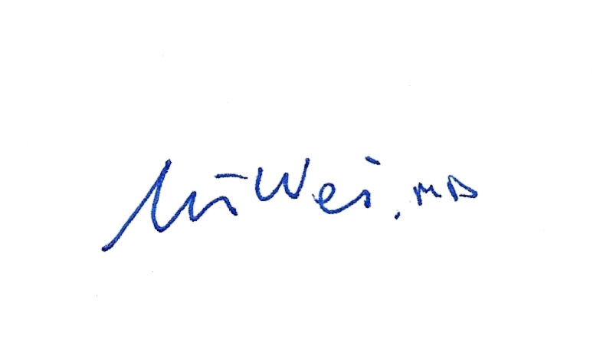 | 8/8/12
R. Fitzgerald | 5/29/14 |  | 7/2/14 |  | 7/17/14
 |  |  | 7/19/16 |  | 7/25/16
Kim Paige | 3/19/18 |  | 3/16/18 |  | 3/20/18


IDPH MALARIA SMEAR INFORMATION FORM

PATIENT NAME:
ADDRESS:

GENDER:

DATE OF BIRTH:

DATE OF ONSET:

TRAVELED OUT OF COUNTRY? YES When? Where?

ATTENDING PHYSICAN:

STATUS OF PATIENT:

FROM: Department of Pathology & Laboratory Medicine
Hematology Section
Methodist Medical Center of Illinois
221 N.E. Glen Oak
Peoria, Illinois 61636

